Why Dll? To share your methods across different projects

We use Class Library template , when we build it , we get dll

Can we run it ? No

How do we use functions / methods in this project?

We add reference to the project

Then we create object of that class

Dll could be

Private

Public / Global

Private Assembly: It is stored in project folder / bin / debug folder

How do we make a dll global?

We have to store that dll in a particular location (GAC)

Global assembly cache

C:\Windows\Microsoft.NET\assembly\GAC_MSIL

How do we make a dll global??

We have to create and attach a strong name key to that dll

How do we create and attach a strong name key to a dll

using System;

using System.Collections.Generic;

using System.Linq;

using System.Text;

using System.Threading.Tasks;

namespace Functions

{

public class NumericFunctions

{

public int add (int x, int y)

{

return x + y;

}

public int subtract(int x, int y)

{

return x - y;

}

}

}

When we built it, we get Private Assembly

Now ,, we want to make it global

Steps.

1. We need to create strong name key (either by using command prompt / or we can use wizard)
2. 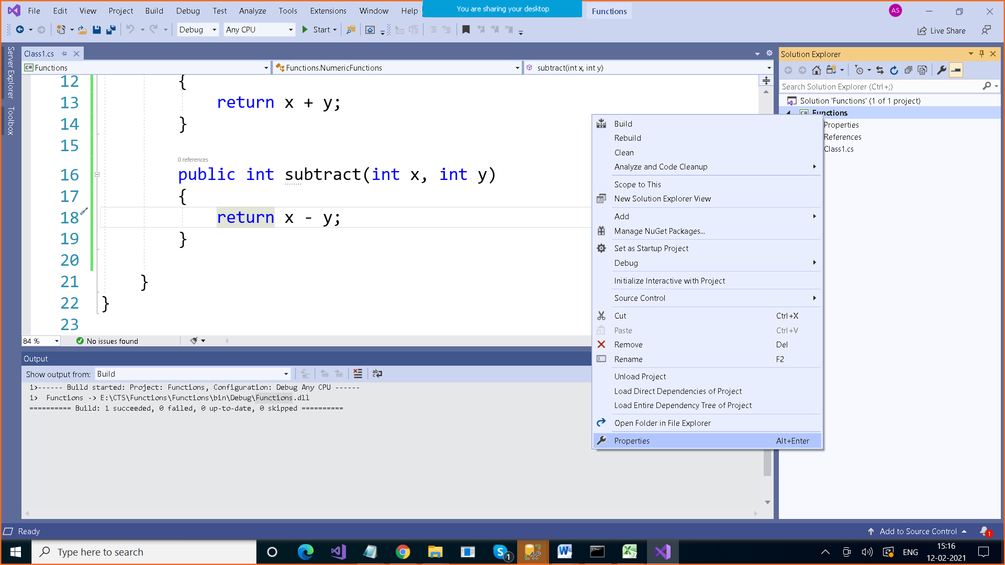

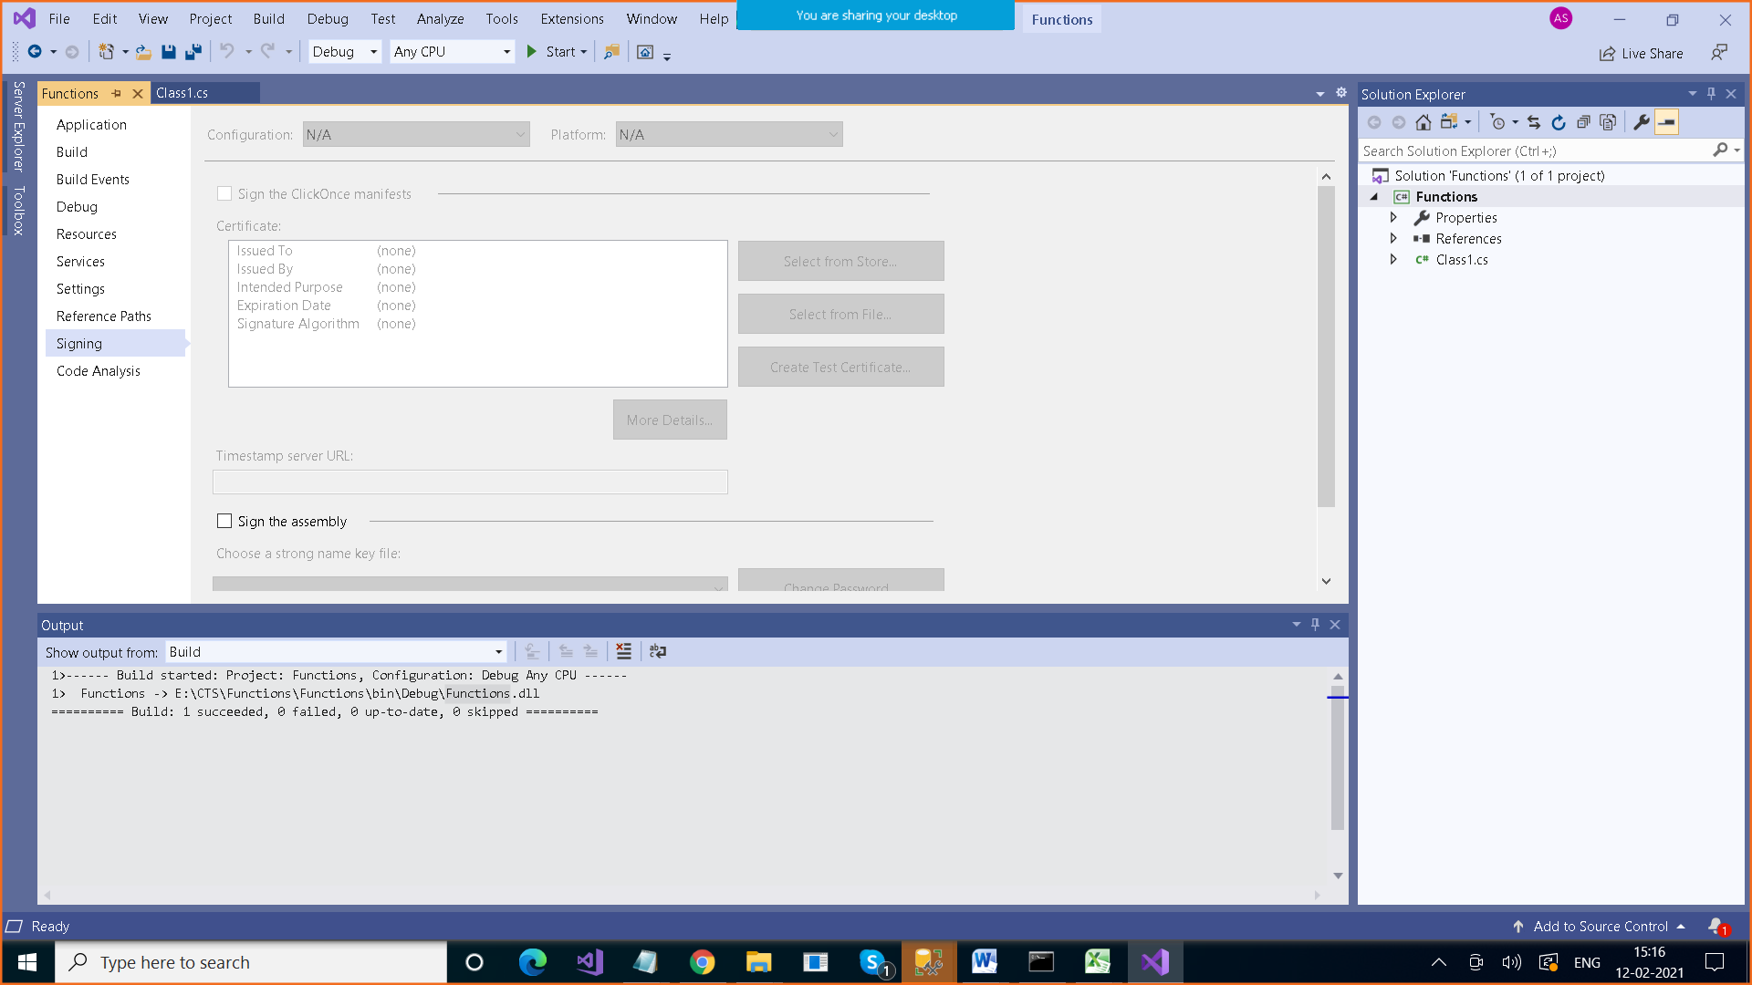

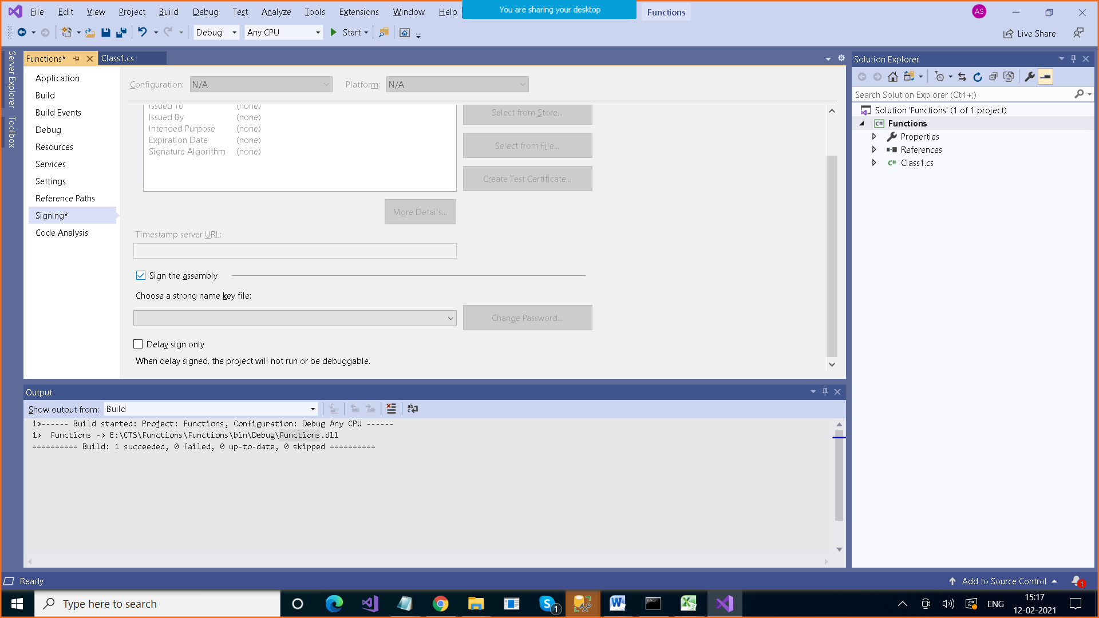

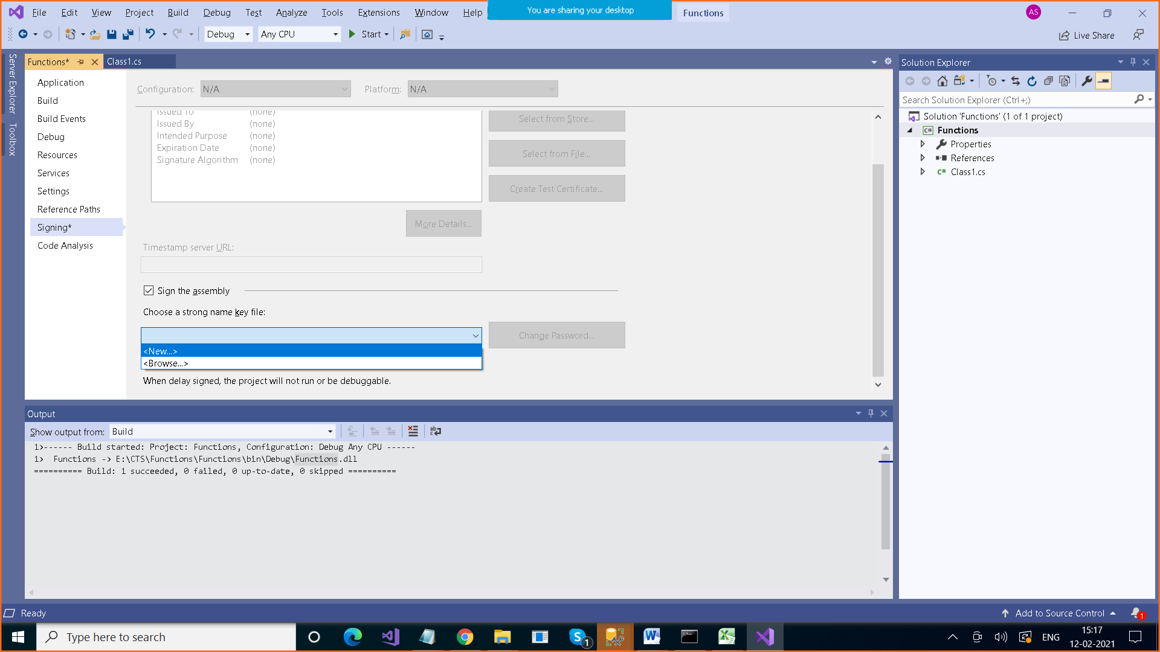

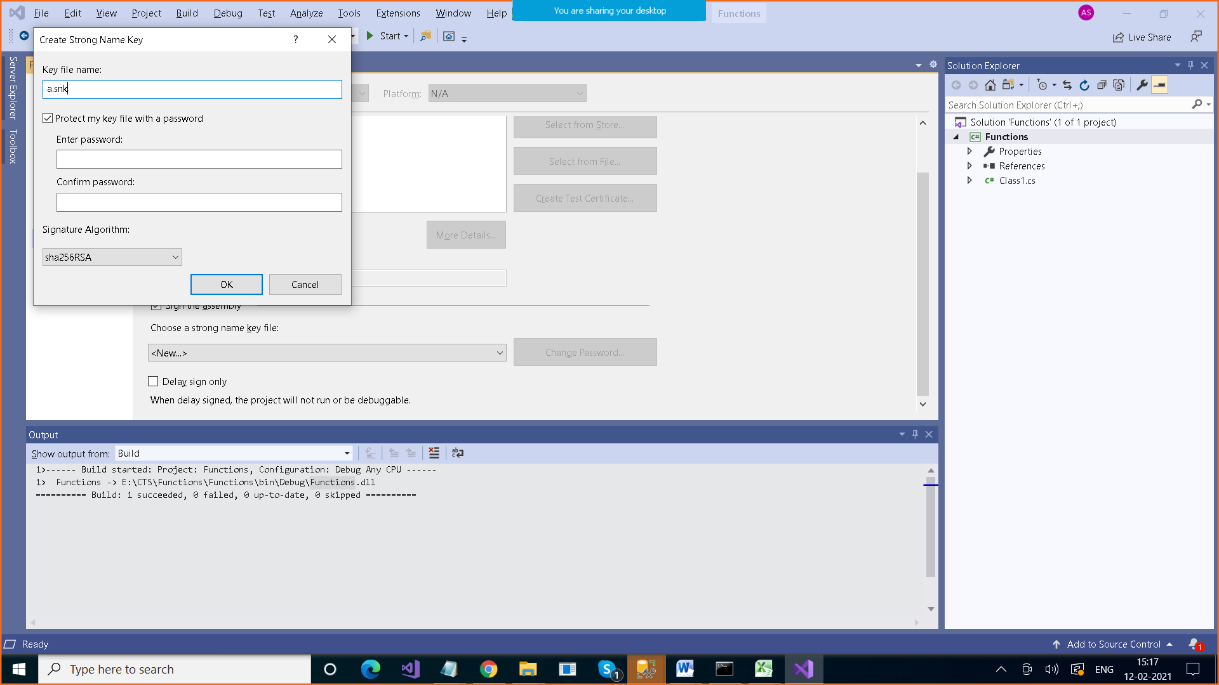

OR

Use command prompt in admin rights

**C:\Windows\System32>sn -k b.snk**

**Step 2:**

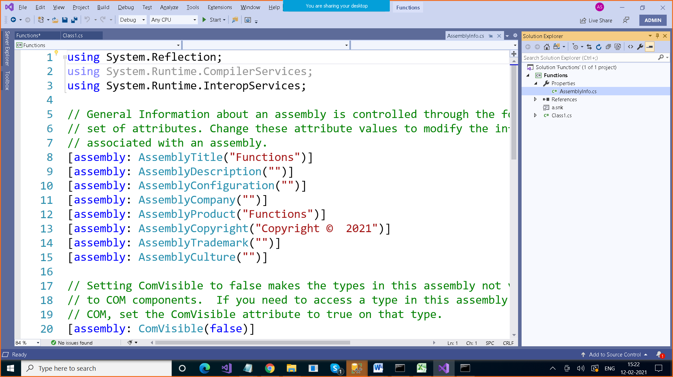

[assembly:AssemblyKeyFile("a.snk")]

We have to make this entry in AssemblyInfo.cs file which is Properties folder

Step 3: Build this project

Step 4: Now we can add this dll which has got strong name key with it to GAC

For this we have to go the command prompt

And use gacutil command

**E:\CTS\Functions\Functions\bin\Debug>gacutil -i Functions.dll**

C:\Windows\Microsoft.NET\assembly\GAC_MSIL\Functions\v4.0_1.0.0.0__af094818138a5804

Why namespace is required?

Namespace is a collection of logically related classes or subnamespaces

#include<string.h>

#include<math.h>

Namespaces ??

1. We can create other class with same name in one project
2. using System;
3. using System.Collections.Generic;
4. using System.Linq;
5. using System.Text;
6. using System.Threading.Tasks;
7. class Pogram
8. {
9. static void Main()
10. {
11. ConsoleApp34.Class1 x = new ConsoleApp34.Class1();
12. two.Class1 y = new two.Class1();
13. }
14. }
15. namespace ConsoleApp34
16. {
17. class Class1
18. {
19. }
20. }
21. namespace two
22. {
23. class Class1
24. {
25. }
26. }

Second use : Logically related classes can be grouped together in one namespace

using System;

using System.Collections.Generic;

using System.Linq;

using System.Text;

using System.Threading.Tasks;

class Pogram

{

static void Main()

{

ConsoleApp34.Class1 x = new ConsoleApp34.Class1();

two.Class1 y = new two.Class1();

}

}

namespace Payroll

{

class Employee

{

}

class Salary

{

}

}

class Product

{

}

class Customer

{

}

class Bill

{

}

---------------------

Inheritance