You can set a specific page to be run during start-up within your Application through the following steps :

* **Right-click your Project** within the Solution Explorer.
* Choose **Properties**.
* Select the **Web** tab on the left-hand side.
* Under the **Start Page**section, define the **Specific Page** you would like to default to when the application is launched.
* Save your changes.

[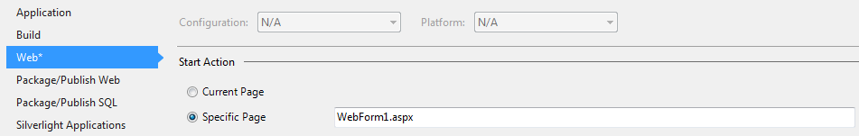](http://imgur.com/i4cbnh1)

**Targeting IIS / Web Server Method**

You can also handle this through adding the following <defaultDocument> section into the <system.webServer> section of your web.config, although it does target the Web Server / IIS :

<system.webServer>

<defaultDocument>

<files>

<clear />

<add value="YourDefaultPage.aspx" />

</files>

</defaultDocument>

</system.webServer>

Install IIS 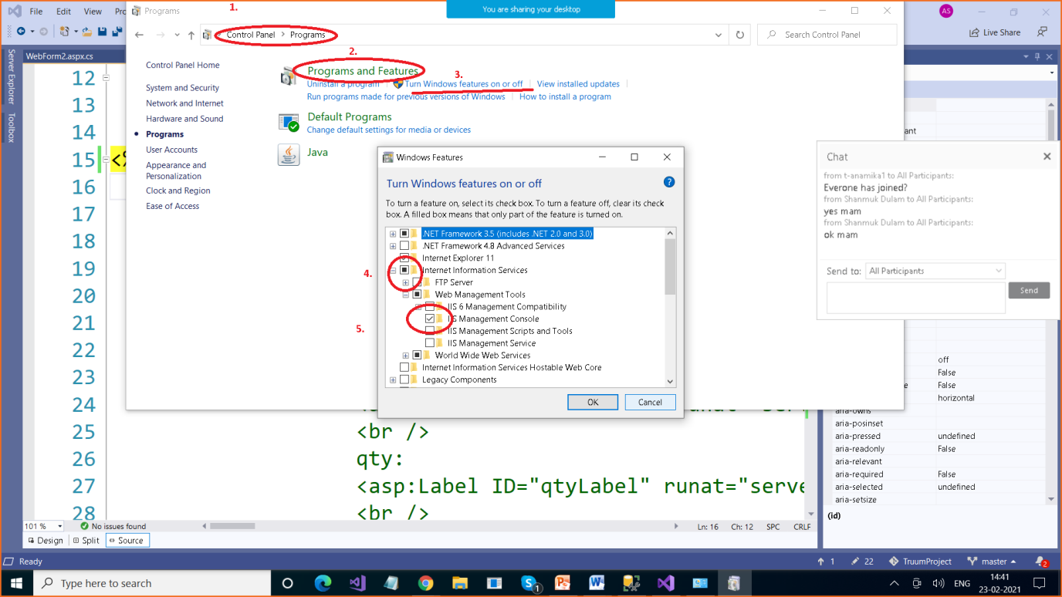

To check type inetmgr in Search pane