HTML

CSS  
Javascript

JQuery

Sql

C#

Programming Language

Language: Means of Communication between two person

Language : character Set , Grammer

A-Z,

Grammer

Programming Language : Means of Communication between machine & user

C , C++ , java , C# , PHP

character Set , Grammer

SDLC : System Development Life cycle

1. Problem Identification (Analyse existing system) : **The most imp or critical stage**
2. Give some solutions to the client
3. Select some solution out of the proposed solutions
4. Analyse proposed system
5. Design system
6. Code
7. Testing
8. Implement
9. Post-Implementation Review
10. Maintainance **(The longest Phase)**

Different approaches that we use to start creating systems

1. **Procedural Approach ( You develop system in procedure / steps)**
2. **Object Oriented Approach**

**Procedural Approach**

1. **Students will come for enquiry**
2. **Counsellor will handle the enquiry**
3. **Student take admission**
4. **Trainetrtakes classes**
5. **Students come for classes**
6. **Trainer give tests**
7. **Students give tests**
8. **Trainers evaluates tests**
9. **Counsellor give certificate to students**

**Its not easy to understand system in this way**

**Not easy to maintain**

**Object Oriented Approach**

**How many entities are involved**

**Student**

**Trainer**

**Counsellor**

**What Student will do :**

**Students will come for enquiry**

**They take admission**

**They come for classes**

**They give tests**

**They collect certificate**

**Trainer**

**They wil take classes**

**\They wil gi tesrt**

**They will check test**

**Counsellor**

**They will handle enquiry**

**They will give certificate**

**C is procedural language**

**C++ , C# , Java , Python : They all follows concepts of OOPS**

**Concepts of OOPS**

**Class**

**Objects**

**Encapsulation**

**Abstraction**

**Polymorphism**

**Inheritance**

**If you want to write programs in C# , what do we need for that**

**Any Ediitor , Notepad , Notepad++ , Visual Studio Code , Visual Studio 2019**

**Why VStudio ?? Because it provide IDE , Integrated Development Environment**

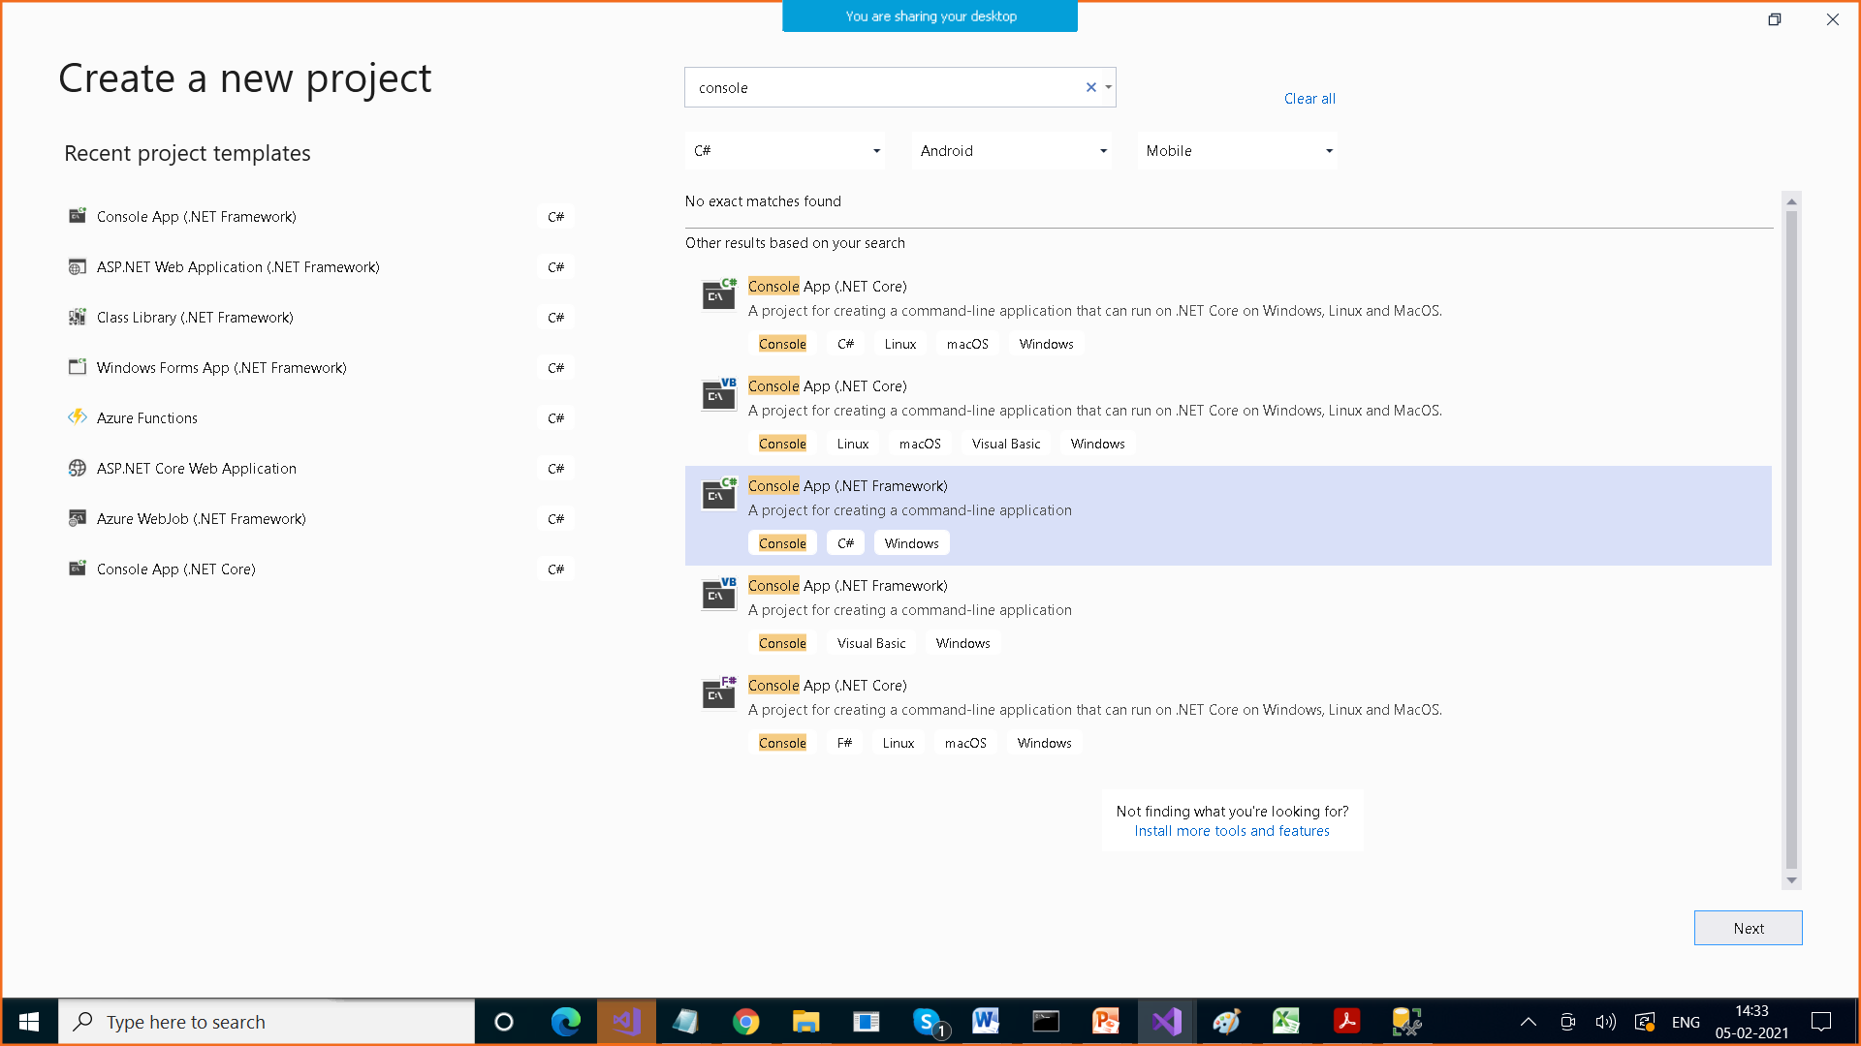

**C:\Users\Anamika\source\repos : Default Path where projects are stored**

**Solution is a container which can contain multiple projects**

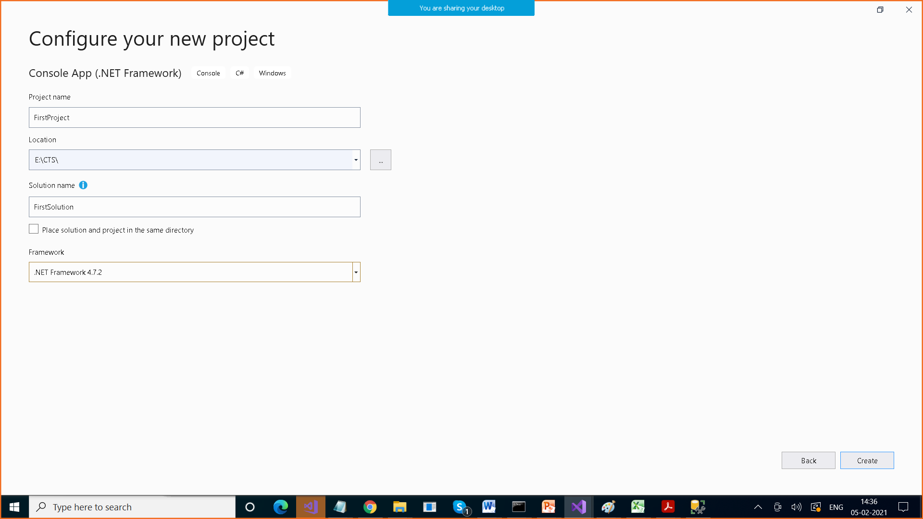

**By default , ,we get following structure**

using System;

using System.Collections.Generic;

using System.Linq;

using System.Text;

using System.Threading.Tasks;

namespace FirstProject

{

class Program

{

static void Main(string[] args)

{

}

}

}

//#include<stdio.h>

using System; // namespaces

// Namespace : Logical collection of related classes / sub namespaces

class Program

{

static void Main(string[] args)

{

}

}

Program to print Hello Message

//#include <stdio.h>

using System;

class Program

{

static void Main(string[] args) // Entry & Exit point of program

{

Console.Write("Hello");

Console.Read();

// Console is a class , Write is a Method

// Console class is present in System namespace

// To run program F5, ctrl+F5

// F5 > We can not see the output , so which means that we should write

// Console.Read() at the end

}

}

using System;

class Program

{

static void Main()

{

Console.Write("Hello");

Console.Write("Hi");

}

}

-----------------------------------------------

using System;

class Program

{

static void Main()

{

Console.WriteLine("Hello");

Console.WriteLine("Hi");

}

}

using System;

class Program

{

static void Main()

{

Console.Write("Hello\n");

Console.Write("Hi\n");

}

}

What are variables : Memory allocated to store some value

How do we declare variables

Data type variable name;

Type indicates that what we can store and what is the range , also it allocates memory

Int x ;

Allocates 2 bytes , 16 bits

Char x; 1 byte

Short long unsigned int , signed int

Where short long unsigned signed are known as qualifiers

Int > 2 bytes -65356 to +65356

Short int > 1 byte

long int > 4 bytes

C , C++ , they use ASCII Code , according to that char takes 1 byte

We can not use these languages to create web applications which could be multilingual.

Web application cud be in multiple languages,

For that C#, Java use UNICODE

According to that char takes 2 bytes

2 bytes , 16 bits 2^16 >

Int takes 4 bytes

using System;

class Program

{

static void Main()

{

// declare variable and initialze it

int x=10;

int y = 20;

Console.WriteLine("Sum of x and y is " + (x+y));

Console.WriteLine("Sum of " + x + " and " + y + " is " + (x + y));

// printf("%d + %d = %d", x, y, x + y);

// Positional Parameters

Console.WriteLine("Sum of {0} and {1} is {2}", x, y , (x+y) );

Console.WriteLine("Difference of {0} and {1} is {2}", x, y, (x - y));

Console.WriteLine("Product of {0} and {1} is {2}", x, y, (x * y));

Console.WriteLine("Quotient of {0} and {1} is {2}", x, y, (x / y));

Console.WriteLine("Remainder of {0} and {1} is {2}", x, y, (x % y));

}

}

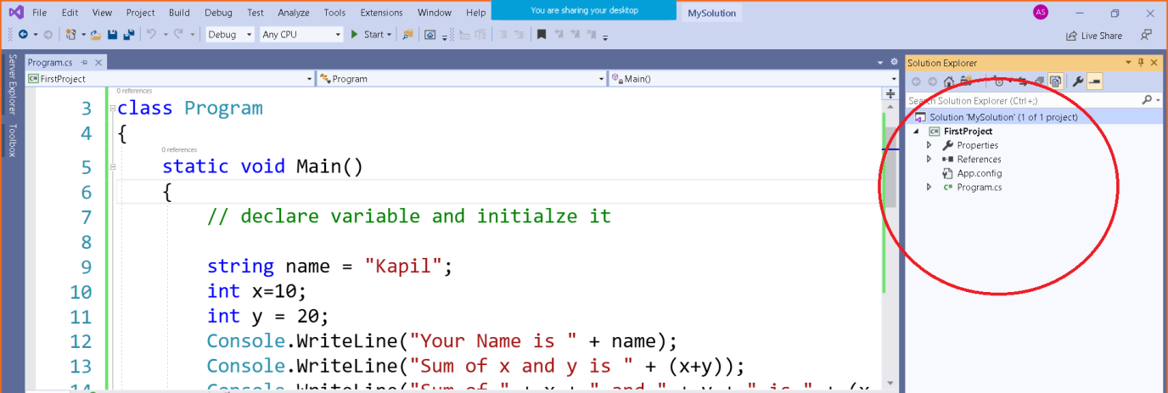

Solution Explorer : It contains / display information about your solution

Properties > Contains Assemblyinfo.cs fie which contains information about your project , version etc

References Folder > Lists all the libraries added to the project

App.config fie > it is in XML form (Extensible Markup Language)

Config file is used to store configuration about your project

Program.cs > It is file which contains our code