using System;

using System.Collections.Generic;

using System.Linq;

using System.Text;

using System.Threading.Tasks;

namespace project1

{

class Employee

{

int Empid;

string name;

String dept;

String Manager;

double BasicSalary;

int Exp;

double DA, HRA, PF, NetSalary;

public void GetEmployeeDetails()

{

Console.WriteLine("Enter Employee ID");

Empid = Convert.ToByte(Console.ReadLine());

Console.WriteLine("Enter Name of the employee");

name = Console.ReadLine();

Console.WriteLine("Enter Department name");

dept = Console.ReadLine();

Console.WriteLine("Enter Manager name");

Manager = Console.ReadLine();

Console.WriteLine("Enter Basic Salary");

BasicSalary = Convert.ToDouble(Console.ReadLine());

Console.WriteLine("Enter Experience of the employee");

Exp = Convert.ToByte(Console.ReadLine());

}

public void CalculateNetsalary()

{

if (Exp <= 5)

{

DA = (1.9 \* BasicSalary) / 100;

HRA = (2.0 \* BasicSalary) / 100;

PF = 1200;

}

else if (Exp > 5 && Exp <= 7)

{

DA = (4.1 \* BasicSalary) / 100;

HRA = (3.8 \* BasicSalary) / 100;

PF = 1800;

}

else if (Exp > 7 && Exp <= 10)

{

DA = (7 \* BasicSalary) / 100;

HRA = (6.5 \* BasicSalary) / 100;

PF = 4100;

}

else if (Exp > 10)

{

DA = (10 \* BasicSalary) / 100;

HRA = (8.5 \* BasicSalary) / 100;

PF = 6200;

}

NetSalary = (BasicSalary + DA + HRA) - PF;

}

public void DisplayEmployeeDetails()

{

Console.WriteLine("Employee ID : " + Empid);

Console.WriteLine("Employee Name : " + name);

Console.WriteLine("Basic Salary is" + BasicSalary);

Console.WriteLine("DA is" + DA);

Console.WriteLine("HRA is" + HRA);

Console.WriteLine("PF is" + PF);

Console.WriteLine("Net salary is" + NetSalary);

}

}

class assclasses

{

static void Main()

{

Employee employee1 = new Employee();

employee1.DisplayEmployeeDetails();

employee1.CalculateNetsalary();

employee1.DisplayEmployeeDetails();

Employee employee2= new Employee();

employee2.DisplayEmployeeDetails();

employee2.CalculateNetsalary();

employee2.DisplayEmployeeDetails();

Employee employee3 = new Employee();

employee3.DisplayEmployeeDetails();

employee3.CalculateNetsalary();

employee3.DisplayEmployeeDetails();

Employee employee4 = new Employee();

employee4.DisplayEmployeeDetails();

employee4.CalculateNetsalary();

employee4.DisplayEmployeeDetails();

Employee employee5 = new Employee();

employee5.DisplayEmployeeDetails();

employee5.CalculateNetsalary();

employee5.DisplayEmployeeDetails();

}

}

}

Array of Objects

using System;

using System.Collections.Generic;

using System.Linq;

using System.Text;

using System.Threading.Tasks;

namespace project1

{

class Employee

{

int Empid;

string name;

String dept;

String Manager;

double BasicSalary;

int Exp;

double DA, HRA, PF, NetSalary;

public void GetEmployeeDetails()

{

Console.WriteLine("Enter Employee ID");

Empid = Convert.ToByte(Console.ReadLine());

Console.WriteLine("Enter Name of the employee");

name = Console.ReadLine();

Console.WriteLine("Enter Department name");

dept = Console.ReadLine();

Console.WriteLine("Enter Manager name");

Manager = Console.ReadLine();

Console.WriteLine("Enter Basic Salary");

BasicSalary = Convert.ToDouble(Console.ReadLine());

Console.WriteLine("Enter Experience of the employee");

Exp = Convert.ToByte(Console.ReadLine());

}

public void CalculateNetsalary()

{

if (Exp <= 5)

{

DA = (1.9 \* BasicSalary) / 100;

HRA = (2.0 \* BasicSalary) / 100;

PF = 1200;

}

else if (Exp > 5 && Exp <= 7)

{

DA = (4.1 \* BasicSalary) / 100;

HRA = (3.8 \* BasicSalary) / 100;

PF = 1800;

}

else if (Exp > 7 && Exp <= 10)

{

DA = (7 \* BasicSalary) / 100;

HRA = (6.5 \* BasicSalary) / 100;

PF = 4100;

}

else if (Exp > 10)

{

DA = (10 \* BasicSalary) / 100;

HRA = (8.5 \* BasicSalary) / 100;

PF = 6200;

}

NetSalary = (BasicSalary + DA + HRA) - PF;

}

public void DisplayEmployeeDetails()

{

Console.WriteLine("Employee ID : " + Empid);

Console.WriteLine("Employee Name : " + name);

Console.WriteLine("Basic Salary is" + BasicSalary);

Console.WriteLine("DA is" + DA);

Console.WriteLine("HRA is" + HRA);

Console.WriteLine("PF is" + PF);

Console.WriteLine("Net salary is" + NetSalary);

}

}

class assclasses

{

static void Main()

{

// Array of Objects

Employee[] employee = new Employee[10];

for(int i=0;i<5;i++)

{

employee[i] = new Employee();

employee[i].GetEmployeeDetails();

employee[i].CalculateNetsalary();

employee[i].DisplayEmployeeDetails();

}

}

}

}

By using Collections

using System;

using System.Collections;

using System.Collections.Generic;

using System.Linq;

using System.Text;

using System.Threading.Tasks;

namespace project1

{

class Employee

{

int Empid;

string name;

String dept;

String Manager;

double BasicSalary;

int Exp;

double DA, HRA, PF, NetSalary;

public void GetEmployeeDetails()

{

Console.WriteLine("Enter Employee ID");

Empid = Convert.ToByte(Console.ReadLine());

Console.WriteLine("Enter Name of the employee");

name = Console.ReadLine();

Console.WriteLine("Enter Department name");

dept = Console.ReadLine();

Console.WriteLine("Enter Manager name");

Manager = Console.ReadLine();

Console.WriteLine("Enter Basic Salary");

BasicSalary = Convert.ToDouble(Console.ReadLine());

Console.WriteLine("Enter Experience of the employee");

Exp = Convert.ToByte(Console.ReadLine());

}

public void CalculateNetsalary()

{

if (Exp <= 5)

{

DA = (1.9 \* BasicSalary) / 100;

HRA = (2.0 \* BasicSalary) / 100;

PF = 1200;

}

else if (Exp > 5 && Exp <= 7)

{

DA = (4.1 \* BasicSalary) / 100;

HRA = (3.8 \* BasicSalary) / 100;

PF = 1800;

}

else if (Exp > 7 && Exp <= 10)

{

DA = (7 \* BasicSalary) / 100;

HRA = (6.5 \* BasicSalary) / 100;

PF = 4100;

}

else if (Exp > 10)

{

DA = (10 \* BasicSalary) / 100;

HRA = (8.5 \* BasicSalary) / 100;

PF = 6200;

}

NetSalary = (BasicSalary + DA + HRA) - PF;

}

public void DisplayEmployeeDetails()

{

Console.WriteLine("Employee ID : " + Empid);

Console.WriteLine("Employee Name : " + name);

Console.WriteLine("Basic Salary is" + BasicSalary);

Console.WriteLine("DA is" + DA);

Console.WriteLine("HRA is" + HRA);

Console.WriteLine("PF is" + PF);

Console.WriteLine("Net salary is" + NetSalary);

}

}

class assclasses

{

static void Main()

{

ArrayList list = new ArrayList();

Employee employee1 = new Employee();

employee1.GetEmployeeDetails();

list.Add(employee1);

Employee employee2 = new Employee();

employee2.GetEmployeeDetails();

list.Add(employee2);

Employee employee3 = new Employee();

employee3.GetEmployeeDetails();

list.Add(employee3);

foreach(Employee emp in list)

{

emp.CalculateNetsalary();

emp.DisplayEmployeeDetails();

}

//list.Add(1);

}

}

}

ArrayList list = new ArrayList();

Employee employee1 = new Employee();

list.Add(employee1);

Employee employee2 = new Employee();

list.Add(employee2);

Employee employee3 = new Employee();

list.Add(employee3);

//list.Add(1);

foreach(Employee emp in list)

{

employee1.GetEmployeeDetails();

emp.CalculateNetsalary();

emp.DisplayEmployeeDetails();

}

List / Collection of Employees

using System;

using System.Collections;

using System.Collections.Generic;

using System.Linq;

using System.Text;

using System.Threading.Tasks;

namespace project1

{

class Employee

{

int Empid;

string name;

String dept;

String Manager;

double BasicSalary;

int Exp;

double DA, HRA, PF, NetSalary;

public void GetEmployeeDetails()

{

Console.WriteLine("Enter Employee ID");

Empid = Convert.ToByte(Console.ReadLine());

Console.WriteLine("Enter Name of the employee");

name = Console.ReadLine();

Console.WriteLine("Enter Department name");

dept = Console.ReadLine();

Console.WriteLine("Enter Manager name");

Manager = Console.ReadLine();

Console.WriteLine("Enter Basic Salary");

BasicSalary = Convert.ToDouble(Console.ReadLine());

Console.WriteLine("Enter Experience of the employee");

Exp = Convert.ToByte(Console.ReadLine());

}

public void CalculateNetsalary()

{

if (Exp <= 5)

{

DA = (1.9 \* BasicSalary) / 100;

HRA = (2.0 \* BasicSalary) / 100;

PF = 1200;

}

else if (Exp > 5 && Exp <= 7)

{

DA = (4.1 \* BasicSalary) / 100;

HRA = (3.8 \* BasicSalary) / 100;

PF = 1800;

}

else if (Exp > 7 && Exp <= 10)

{

DA = (7 \* BasicSalary) / 100;

HRA = (6.5 \* BasicSalary) / 100;

PF = 4100;

}

else if (Exp > 10)

{

DA = (10 \* BasicSalary) / 100;

HRA = (8.5 \* BasicSalary) / 100;

PF = 6200;

}

NetSalary = (BasicSalary + DA + HRA) - PF;

}

public void DisplayEmployeeDetails()

{

Console.WriteLine("Employee ID : " + Empid);

Console.WriteLine("Employee Name : " + name);

Console.WriteLine("Basic Salary is" + BasicSalary);

Console.WriteLine("DA is" + DA);

Console.WriteLine("HRA is" + HRA);

Console.WriteLine("PF is" + PF);

Console.WriteLine("Net salary is" + NetSalary);

}

}

class assclasses

{

static void Main()

{

List<Employee> list = new List<Employee>();

Employee employee1 = new Employee();

list.Add(employee1);

Employee employee2 = new Employee();

list.Add(employee2);

Employee employee3 = new Employee();

list.Add(employee3);

Employee employee4 = new Employee();

list.Add(employee4);

Employee employee5 = new Employee();

list.Add(employee5);

foreach(Employee emp in list)

{

employee1.GetEmployeeDetails();

emp.CalculateNetsalary();

emp.DisplayEmployeeDetails();

}

//list.Add(1);

}

}

}

Instance Variables / Static Variables

When we declare objects , memory is allocated for the variables

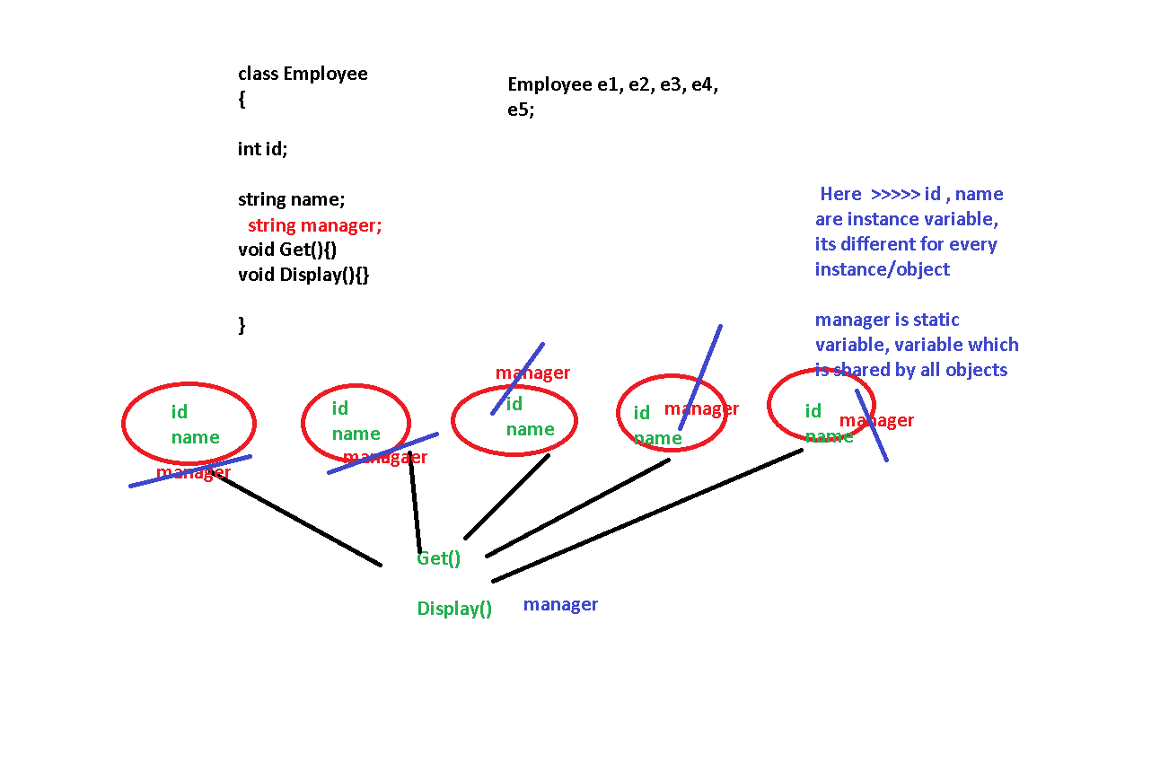

There is a single copy of static variable

using System;

using System.Collections;

using System.Collections.Generic;

using System.Linq;

using System.Text;

using System.Threading.Tasks;

namespace project1

{

class Employee

{

int Empid;

string name;

// Static varibales

static string dept;

static String Manager;

double BasicSalary;

int Exp;

double DA, HRA, PF, NetSalary;

public void GetEmployeeDetails()

{

Console.WriteLine("Enter Employee ID");

Empid = Convert.ToByte(Console.ReadLine());

Console.WriteLine("Enter Name of the employee");

name = Console.ReadLine();

Console.WriteLine("Enter Department name");

dept = Console.ReadLine();

Console.WriteLine("Enter Manager name");

Manager = Console.ReadLine();

Console.WriteLine("Enter Basic Salary");

BasicSalary = Convert.ToDouble(Console.ReadLine());

Console.WriteLine("Enter Experience of the employee");

Exp = Convert.ToByte(Console.ReadLine());

}

public void CalculateNetsalary()

{

if (Exp <= 5)

{

DA = (1.9 \* BasicSalary) / 100;

HRA = (2.0 \* BasicSalary) / 100;

PF = 1200;

}

else if (Exp > 5 && Exp <= 7)

{

DA = (4.1 \* BasicSalary) / 100;

HRA = (3.8 \* BasicSalary) / 100;

PF = 1800;

}

else if (Exp > 7 && Exp <= 10)

{

DA = (7 \* BasicSalary) / 100;

HRA = (6.5 \* BasicSalary) / 100;

PF = 4100;

}

else if (Exp > 10)

{

DA = (10 \* BasicSalary) / 100;

HRA = (8.5 \* BasicSalary) / 100;

PF = 6200;

}

NetSalary = (BasicSalary + DA + HRA) - PF;

}

public void DisplayEmployeeDetails()

{

Console.WriteLine("Employee ID : " + Empid);

Console.WriteLine("Employee Name : " + name);

Console.WriteLine("Basic Salary is" + BasicSalary);

Console.WriteLine("DA is" + DA);

Console.WriteLine("HRA is" + HRA);

Console.WriteLine("PF is" + PF);

Console.WriteLine("Net salary is" + NetSalary);

}

}

class assclasses

{

static void Main()

{

List<Employee> list = new List<Employee>();

Employee employee1 = new Employee();

list.Add(employee1);

Employee employee2 = new Employee();

list.Add(employee2);

Employee employee3 = new Employee();

list.Add(employee3);

Employee employee4 = new Employee();

list.Add(employee4);

Employee employee5 = new Employee();

list.Add(employee5);

foreach(Employee emp in list)

{

employee1.GetEmployeeDetails();

emp.CalculateNetsalary();

emp.DisplayEmployeeDetails();

}

//list.Add(1);

}

}

}