**Objectives**

* Explain the need and benefits of CSS
  + Cascading Style Sheets, describes how HTML elements are to be displayed on screen, saves a lot of work. It can control the layout of multiple web pages all at once, With an external stylesheet file, you can change the look of an entire website by changing just one file!
* Recall correct syntax for defining a style
  + A CSS rule-set consists of a selector and a declaration block, declaration block contains one or more declarations separated by semicolons, declaration includes a CSS property name and a value, separated by a colon
* Demonstrate various ways of application of styles
  + Inline style, Internal style sheet, External style sheet
* Demonstrate usage of various selectors
  + Element Selector, ID Selector and Class Selector
* Demonstrate formatting of HTML elements
  + Background Color, Color, Font, Font Style, Height, Width
* Demonstrate Box Model in CSS
  + Consists of margins, borders, padding, and the actual content

**Hands on 1**

**Ways to apply styles, fonts and colors**

Modify “favorite.html” to apply your personalized style by modifying the below elements:

1. Change font and color for Heading as per your interest.
2. Change font, color for website links. Apply this style uniformly for all website links.

Apply styles based on all the three options one by one in the below specified order:

1. Inline
2. Internal
3. External CSS [NOTE: The style of website link needs to be repeated. Reuse the style using class.]

**NOTE:**Code submission not required. To be implemented using Notepad++ and manually verified by the SME.   
  
  
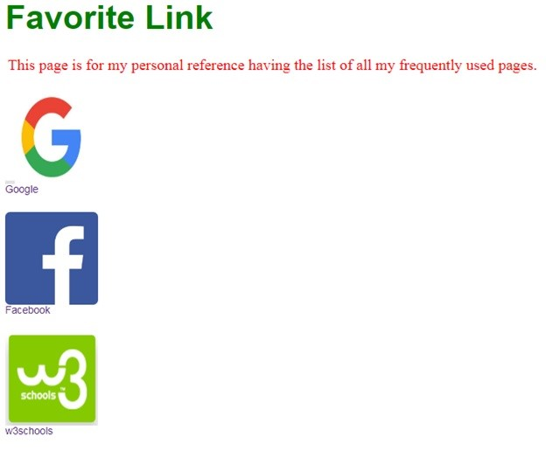

**Hands on 2**

# Selectors

We have changed the page heading color. Now let us make the paragraph color to red and center it. Let us accomplish it by using the below specified options one by one:

1. Element Selector
2. ID Selector
3. Class selector

**NOTE:**Code submission not required. To be implemented using Notepad++ and manually verified by the SME.   
  


**Hands on 3**

# Box model – margin, borders, padding

We have changed the heading color, font and changed the paragraph color and position centered. Now using the box model change the margin, border, and padding around the image as shown below.  
  
**NOTE:**Code submission not required. To be implemented using Notepad++ and manually verified by the SME.  
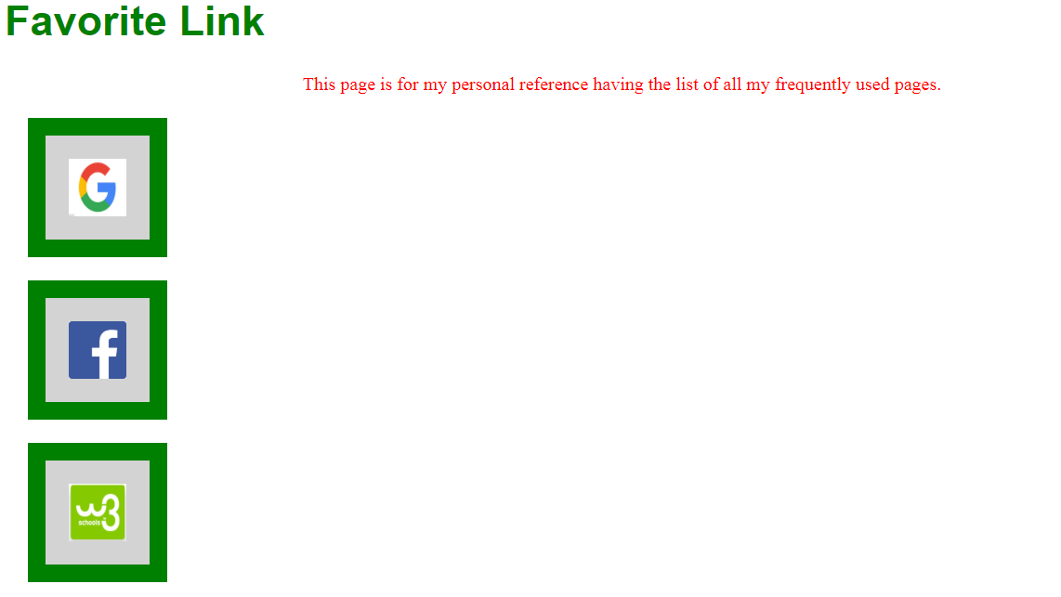

**Hands on 4**

**Application Layout Wireframe**   
  
Create a web page similar to the layout defined below **without using** table. This should be achieved using DIV, box model and color stylesheets. 

**NOTE:**Code submission not required. To be implemented using Notepad++ and manually verified by the SME. 

