**Objectives**

* Demonstrate usage of Form to group input elements and submit form data
  + <form>, action, <input> type submit
* Demonstrate usage of Input and text area
  + Text Boxes, Text Area, Check Boxes, Radio Buttons and Buttons
* Demonstrate usage of Select and Option tag to define list of items
  + <select>, <option>
* Demonstrate linking of form field with Label
  + <label>
* List the options available in HTML5 form fields
  + Data List, Date, Date Time, Email, Range, Search, Telephone Number

Hands on 1

**Signup Form**

Create a web page signup.html with the following elements:

* Title of the page “Welcome to Cognizant”
* Create a form with heading “Personal Details”
* Create the following elements in the page:
  + Name (Input Text)
  + Gender (Radio button with label)
  + Home Town (Drop down with values: New Delhi, Mumbai, Kolkata, Chennai, Hyderabad)
  + Address (Text Area)
  + Skills (Separate checkboxes with label for Java, HTML,  Oracle)
  + Password (Password field)
  + Submit button

**NOTE:**Code submission not required. To be implemented using Notepad++ and manually verified by the SME.   
  
  
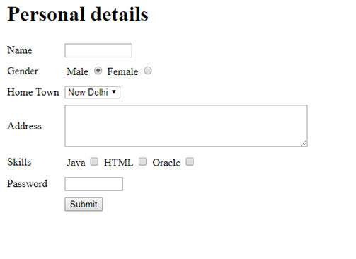

Hands on 2

# Applying Labels

In the signup form demonstrate usage of label tag by making below changes:

1. Clicking on Name label should place the cursor in the Name textbox
2. Clicking on Male or Female should make the respective option selected
3. Clicking on Java, HTML or Oracle should make the respective checkbox checked or unchecked

**NOTE: C**ode submission not required. To be implemented using Notepad++ and manually verified by the SME.   
  
