-- Views

-- Indexes

-- faster searching of records

create table stu1(id int primary key,

name varchar(20))

insert into stu1 values(1,'Ajay')

select * from stu1 where id=1

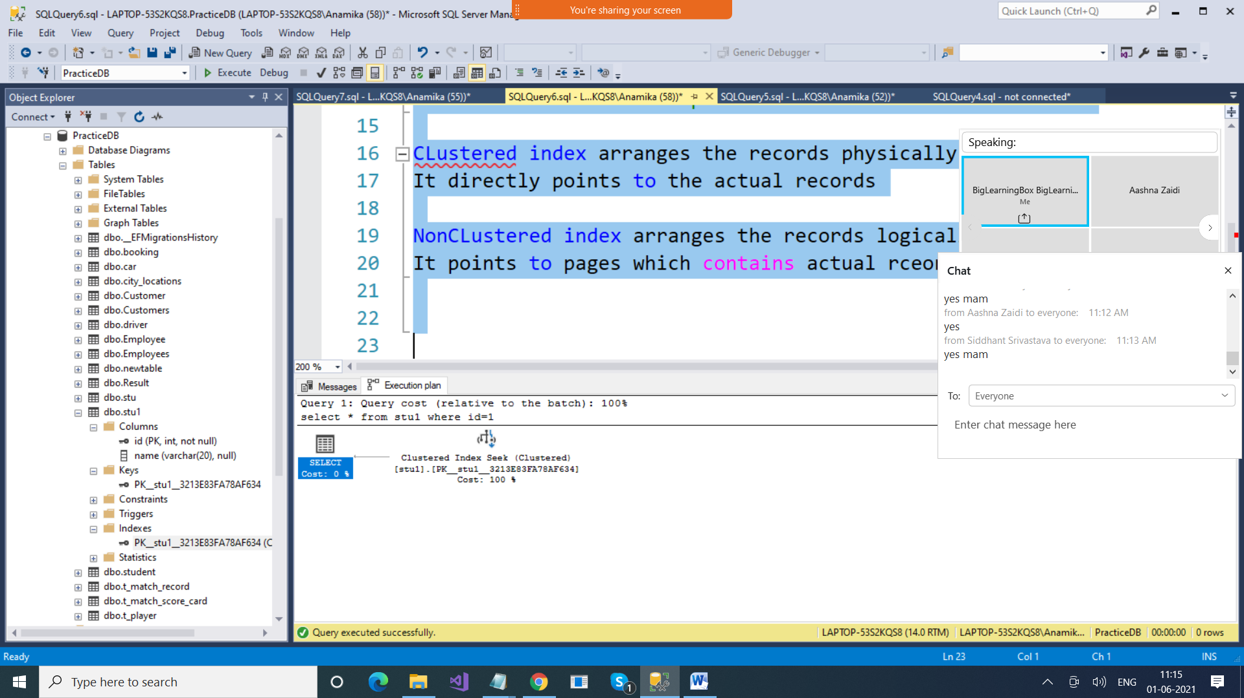

--- There can be only 1 clustered index in a table

--- There could be multiple non-clustered index in a table

CLustered index arranges the records physically

It directly points to the actual records

NonCLustered index arranges the records logically

It points to pages which contains actual rceords

create table empl(id int, name varchar(20))

insert into empl values(1,'Ajay'),

(2,'Ajay'),

(3,'Ajay')

select * from empl where id=2

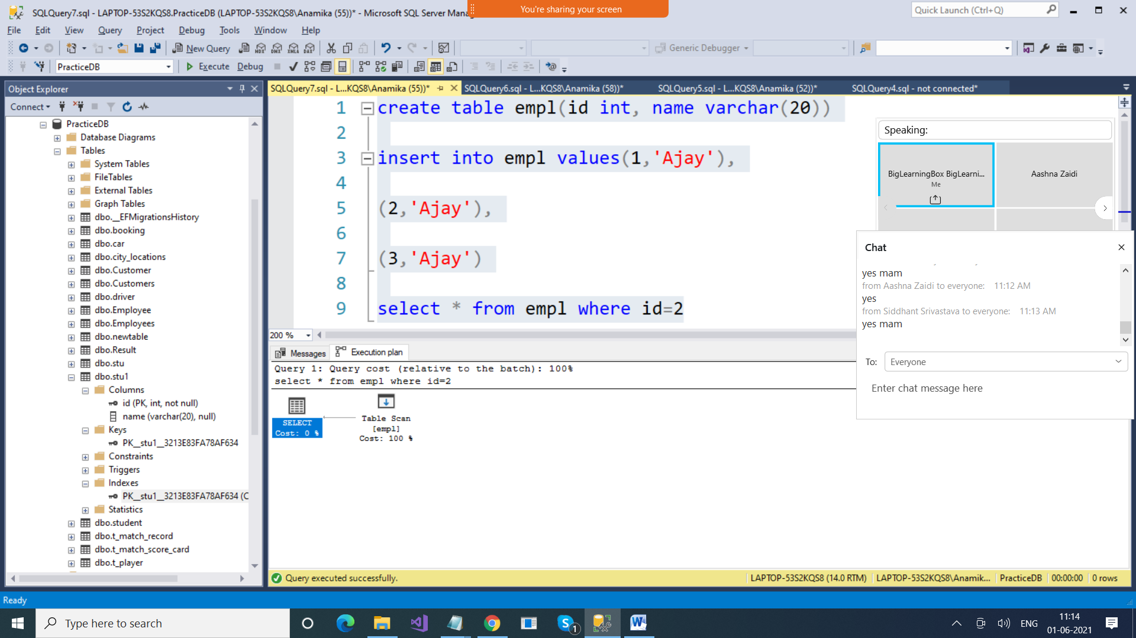

Clustered Index : 1

Non clustered index >More than 1

create index idxName on empl(name)

|  |  |  |  |  |
| --- | --- | --- | --- | --- |
| Id | Name | Address | Department | Manager |
| 1 | Deepti | Delhi | HR |  |
| 2 | Deepak |  | Accts |  |
| 3 | Sagar |  |  |  |
| 4 | Ajay |  |  |  |
| 90 | Jay |  |  |  |
| 23 | Vijay |  |  |  |
| 120 | Karan |  |  |  |

5 Chandan

|  |  |  |  |  |
| --- | --- | --- | --- | --- |
| Id | Name | Address | Department | Manager |
| 1 | Deepti | Delhi | HR |  |
| 2 | Deepak |  | Accts |  |
| 3 | Sagar |  |  |  |
| 4 | Ajay |  |  |  |
| 23 | Jay |  |  |  |
| 90 | Vijay |  |  |  |
| 120 | Karan |  |  |  |

Select * from empl where name=’Deepak’

Index is always stored as Key,Value

idxName

Select * from empl where name=’Deepak’

|  |  |
| --- | --- |
| Name | Address |
| Ajay | 9008 |
| Deepak | 2323 |
| Deepti | 3433 |
| Karan | 3434 |
| Sagar | 5666 |
| Jay | 6767 |

create index idxAddress on empl(address)

select * from empl where address=’Delhi’

|  |  |
| --- | --- |
| Address | Address |
| Delhi | 9008 |
| Mumbai | 2323 |
| Deepti | 3433 |
| Karan | 3434 |
| Sagar | 5666 |
| Jay | 6767 |

Indexes saves your time in searching

But increases time when you perform Insert Delete Update

Why? Because now in the table records are not arranged, but it will be added or deleted from indexes

Create clustered index idxID on empl(id)

Create index idxID on empl(id)

Create unique index idxCode on empl(code)

<https://www.sqlservertutorial.net/sql-server-indexes/>

--sort

select * from Employees

select * from Employees order by id desc

, name

-- Group By

-- Summarise records