Why do we need functions: Reusability Notes : Reusability

If we want to share functions across the projects, then

we create library Share your notes with your friends

Assembly : Unit of deployment , cud be either exe or dll

Exe means executable

Dll dynamic link library

Console App / windows App > exe

Class Library : dll

Class Library does not have Main() method

To access functions of Class Library in a project

Right Click on Console application >

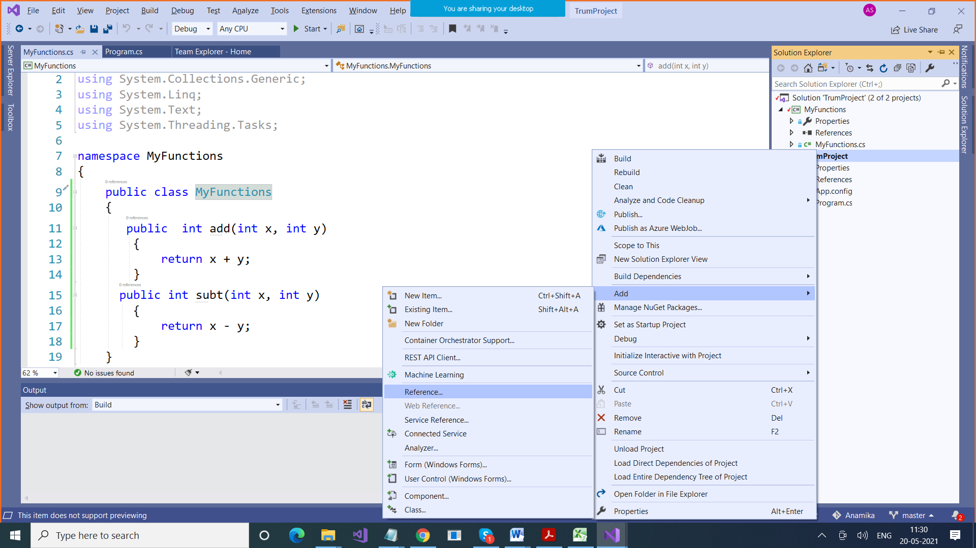

C:\Users\Anamika\source\repos\TrumProject\**MyFunctions\bin\Debug**

Class Library Project

using System;

using System.Collections.Generic;

using System.Linq;

using System.Text;

using System.Threading.Tasks;

namespace MyFunctions

{

public class MyFunctions

{

public int add(int x, int y)

{

return x + y;

}

public int subt(int x, int y)

{

return x - y;

}

}

}

Console Application

using System;

using System.Collections.Generic;

using System.Linq;

using System.Text;

using System.Threading.Tasks;

namespace TrumProject

{

class Program

{

static void Main(string[] args)

{

Console.WriteLine("Hello");

MyFunctions.MyFunctions x = new MyFunctions.MyFunctions();

Console.WriteLine(x.add(10,02));

Console.WriteLine(x.subt(10,5));

}

}

}

String is immutable

String name=”Deepak”;

Name+= “Kumar”;

Whenever we add something in a string variable, it removes the prev string variable, and creates a new one. Which means it will take more time

StringBuilder is mutable

StringBuilder str = new StringBuilder();

Str.Append(“Deepak”);

Str.Append(“Kumar””);