Authorization

Web.config file

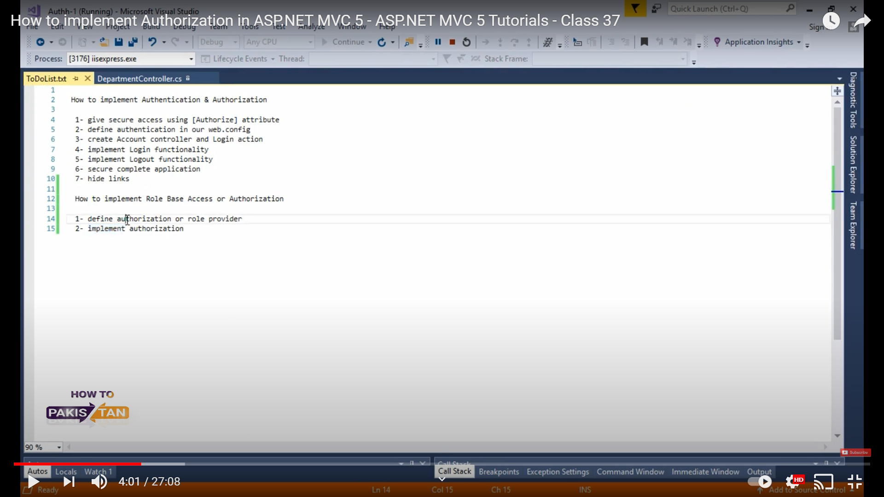

<authentication mode="Forms">

<forms loginUrl="Account/Login">

</forms>

</authentication>

**<roleManager enabled="true" defaultProvider="MyRoleProvider">**

**<providers>**

**<clear/>**

**<add name="MyRoleProvider" type="SalesSystem.MyRoleProvider"></add>**

**</providers>**

**</roleManager>**

Create a class inherits from RoleProvider

public class **MyRoleProvider : RoleProvider**

{

public override string ApplicationName { get => throw new NotImplementedException(); set => throw new NotImplementedException(); }

public override void AddUsersToRoles(string[] usernames, string[] roleNames)

{

throw new NotImplementedException();

}

public override void CreateRole(string roleName)

{

throw new NotImplementedException();

}

public override bool DeleteRole(string roleName, bool throwOnPopulatedRole)

{

throw new NotImplementedException();

}

public override string[] FindUsersInRole(string roleName, string usernameToMatch)

{

throw new NotImplementedException();

}

public override string[] GetAllRoles()

{

throw new NotImplementedException();

}

public override string[] GetRolesForUser(string username)

{

throw new NotImplementedException();

}

public override string[] GetUsersInRole(string roleName)

{

throw new NotImplementedException();

}

public override bool IsUserInRole(string username, string roleName)

{

throw new NotImplementedException();

}

public override void RemoveUsersFromRoles(string[] usernames, string[] roleNames)

{

throw new NotImplementedException();

}

public override bool RoleExists(string roleName)

{

throw new NotImplementedException();

}

}

Go to Index Action Method

[Authorize(Roles ="Admin"]

public ActionResult Index()

{

return View(db.Suppliers.ToList());

}

public override string[] GetRolesForUser(string username)

{

SalesDbContext db = new SalesDbContext();

string[] roles = { db.Users.Where(x => x.UserName == username).FirstOrDefault().Role };

return roles;

}

@if (User.IsInRole("admin"))

{

<li>@Html.ActionLink("List Suppliers", "Index", "Suppliers")</li>

}