C#

Language : Mode of communication between 2 parties

Programming Language : it’s a mode of communication between 2 parties

Machine > Programmer

Language : Eng Hindi Tamil French

The common thing is

Character Set

Syntax / Grammer

English >

Character Set

A-Z

Grammer : Noun pronoun verb

Hindi >

Logic will same no whatever lang we user

Programming Language C C++ Java C# Python

Character set , Syntax

Logic

Hindi Translator Tamil

Programming Lang

Machine (Machine Language) Translator (C, C++ ,Java) Programmer

Compiler / Interpreter

DotNet Framework

Operating System

MS DOS

Windows

C , C++ , Basic COBOL Foxpro

Visual C++ , Visual Basic, Visual Foxpro

DotNet Framework

Added multiple langauges under same framework

Framework : Collection of classes

Compilation : in other languages, compilation happens in one step

Source Code -------------1 Step ------------------------------🡪 Binary Code

in DotNet, compilation happens in one step

Source Code

C# --------------1 Step---------------- MSIL FORM ------2nd Step ------------------------🡪 Binary Code

Visual Basic -----1 Step --------MSIL FORM -------------2nd Step-----------------🡪 Binary Code

In the 1st step, Compilers of respective languages will compile code to MSIL(Microsoft

Intermediate Language)

In the 2nd step, CLR will convert code from MSIL from to binary form by using JIT

Compilation

JIT > Just In Time (The entire code is not converted to binary form, but what is needed at that time is only converted to binary form)

DOtNet Framework , we have some components

CLR : Common Language Runtime

Functions that it performs are

Memory Allocation

Garbage Collection

Code Compilation

CTS : Common Type System

C++ int char

Visual Basic number

CLS : Common Language Specification : guidelines & rules how to do conversions

Managed Code : Code which is managed by Dotnet runtime (CLR)

UnManaged Code : Code which is not managed by Dotnet runtime (CLR)

Interface : How user interacts with application

Character User Based Graphical User Interaction

Console Applications Windows , Web Application

SOlaution : 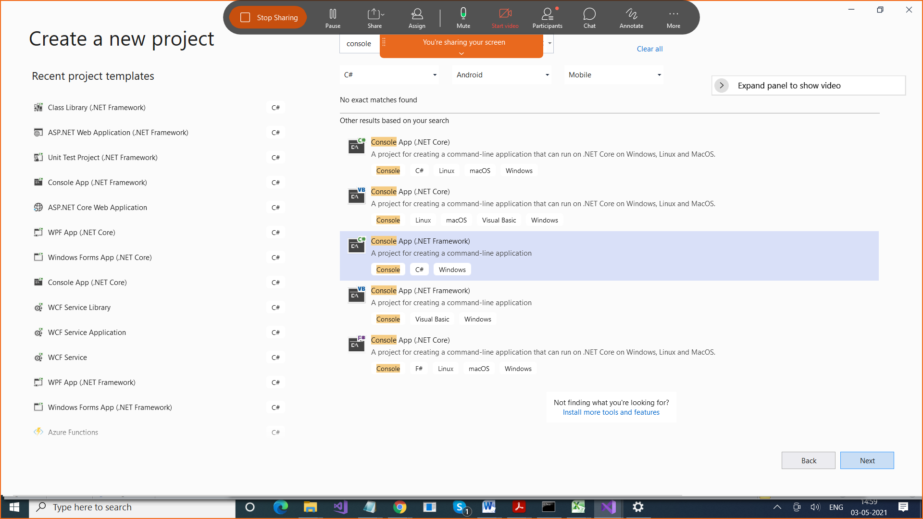

Solution > Container for more than 1 projects

using System;

using System.Collections.Generic;

using System.Linq;

using System.Text;

using System.Threading.Tasks;

namespace FirstProject

{

class Program

{

static void Main(string[] args)

{

}

}

}

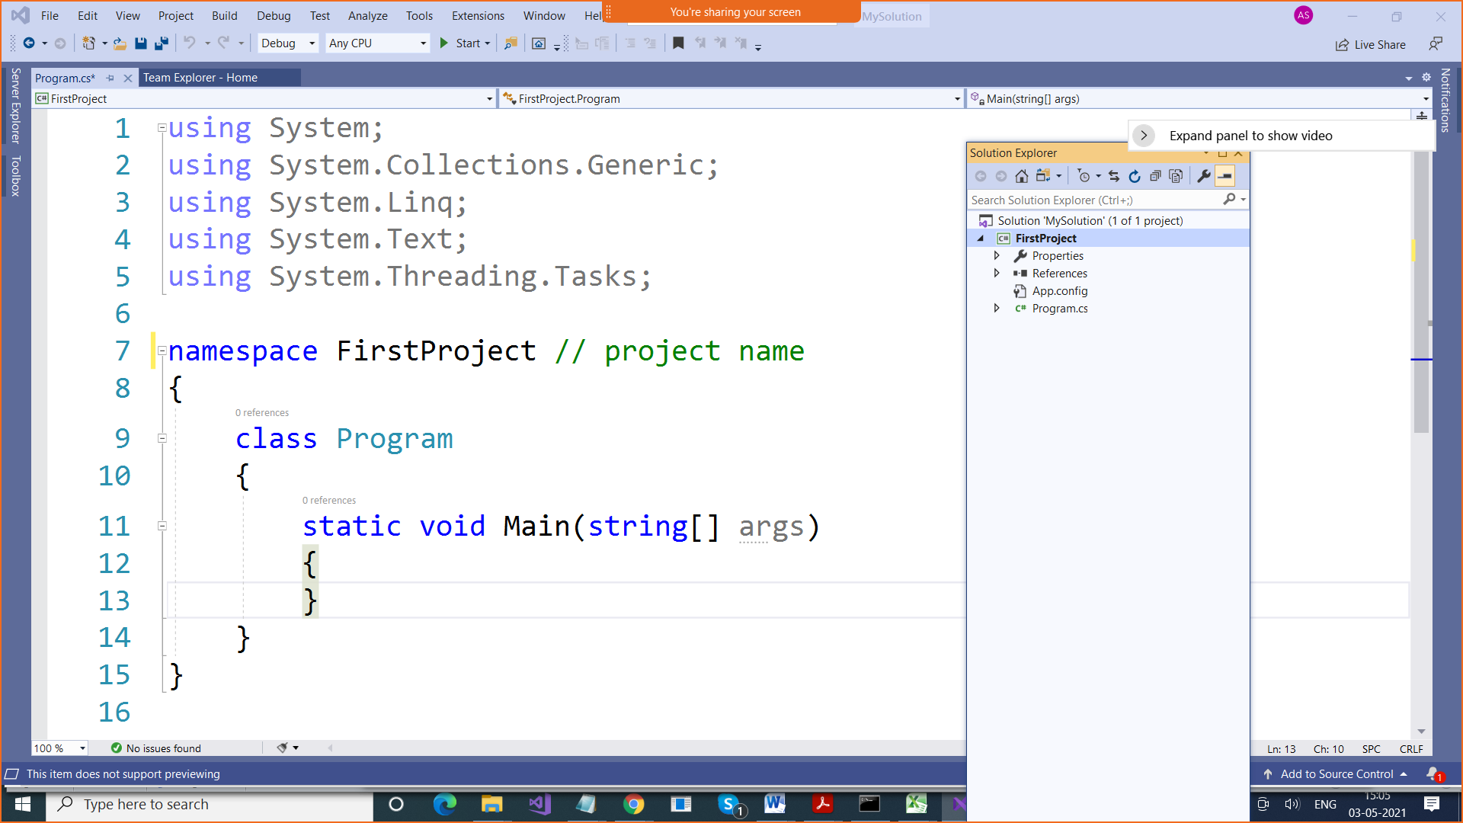

using System;

using System.Collections.Generic;

using System.Linq;

using System.Text;

using System.Threading.Tasks;

namespace FirstProject // project name

{

class Program

{

static void Main(string[] args)

{

// Print , WriteLine or Write

// But these methods are in Console Class

// And this Console class in System Library

Console.Write("Hello\n");

Console.Write("Hello\n");

Console.Write("Hello\n");

Console.WriteLine("Second Line");

Console.WriteLine("Second Line");

Console.WriteLine("Second Line");

// Console is class

// Write is Method

}

}

}

using System;

using System.Collections.Generic;

using System.Linq;

using System.Text;

using System.Threading.Tasks;

namespace FirstProject // project name

{

class Program

{

static void Main(string[] args)

{

// Add 2 numbers

int num1 = 10;

int num2 = 20;

Console.WriteLine("Sum of num1 & num2 is "

+ (num1+num2));

// Console.WriteLine("Sum of %d & %d is %d "

// ,num1, num2 , (num1 + num2));

Console.WriteLine("Sum of {0} and {1} is {2}"

, num1 , num2 , (num1+num2));

Console.WriteLine("Difference of {0} and {1} is {2}"

, num1, num2, (num1 - num2));

Console.WriteLine("Product of {0} and {1} is {2}"

, num1, num2, (num1 \* num2));

Console.WriteLine("Remainder of {0} and {1} is {2}"

, num1, num2, (num1 % num2));

Console.WriteLine("Quotient of {0} and {1} is {2}"

, num1, num2, (num1 / num2));

}

}

}

In any language , statements are of types

1. Sequential Statements
2. Conditional Statements
3. Repetitive Statements

Conditional Statements

If

If – else

If elseif elseif

Switch

Repetitive Statements

(Loops)

Do while

While

For

Foreach

1. If

If(condition)

{

statements

}

1. If else

If(condition)

{

statements

}

Else

{

Statements

}

1. If elseif

If(condition1)

{

statements

}

Else If(condition2)

{

statements

}

Else If(condition3)

{

statements

}

Else

{

Statements

}

Switch (to replace elseif statements)

Switch(expression)

{

Case

Case

default

}

How do we take input from user in C

Console.ReadLine(); : It takes input in string form which means we need to convert it to integer from if you want to take some number

Console.Read(); : It takes only one character and that too in int (ASCII Value)

DO addition , subatractio based on user choice

using System;

using System.Collections.Generic;

using System.Linq;

using System.Text;

using System.Threading.Tasks;

namespace FirstProject // project name

{

class Program

{

static void Main(string[] args)

{

// Add 2 numbers

int num1;

int num2;

int ch;

Console.WriteLine("Enter Value of num1");

num1 = Convert.ToInt16(Console.ReadLine());

Console.WriteLine("Enter Value of num2");

num2 = Convert.ToInt16(Console.ReadLine());

Console.WriteLine("Enter Choice");

ch = Convert.ToInt16(Console.ReadLine());

//Console.WriteLine("Sum of num1 & num2 is "

// + (num1+num2));

//// Console.WriteLine("Sum of %d & %d is %d "

// ,num1, num2 , (num1 + num2));

if (ch == 1)

Console.WriteLine("Sum of {0} and {1} is {2}"

, num1 , num2 , (num1+num2));

else if(ch==2)

Console.WriteLine("Difference of {0} and {1} is {2}"

, num1, num2, (num1 - num2));

else if (ch == 3)

Console.WriteLine("Product of {0} and {1} is {2}"

, num1, num2, (num1 \* num2));

else if (ch == 4)

Console.WriteLine("Remainder of {0} and {1} is {2}"

, num1, num2, (num1 % num2));

else if (ch == 5)

Console.WriteLine("Quotient of {0} and {1} is {2}"

, num1, num2, (num1 / num2));

else

Console.WriteLine("Invalid choice");

}

}

}

C

Int 2 bytes

Int x : 2 bytes 16 bits

Short int Bytes 1

Char 1 byte

C#

Int > 4 bytes

Char > 2 bytes

Convert.ToIn32

Byte > - 0 to 255

UByte()

16 bits > - 32000 to + 32000

32 bits

using System;

using System.Collections.Generic;

using System.Linq;

using System.Text;

using System.Threading.Tasks;

namespace FirstProject // project name

{

class Program

{

static void Main(string[] args)

{

// Add 2 numbers

int num1;

int num2;

int ch;

Console.WriteLine("Enter Value of num1");

num1 = Convert.ToByte(Console.ReadLine());

Console.WriteLine("Enter Value of num2");

num2 = Convert.ToByte(Console.Read());

Console.WriteLine("Enter Choice");

ch = Convert.ToByte(Console.ReadLine());

//Console.WriteLine("Sum of num1 & num2 is "

// + (num1+num2));

//// Console.WriteLine("Sum of %d & %d is %d "

// ,num1, num2 , (num1 + num2));

if (ch == 1)

Console.WriteLine("Sum of {0} and {1} is {2}"

, num1 , num2 , (num1+num2));

else if(ch==2)

Console.WriteLine("Difference of {0} and {1} is {2}"

, num1, num2, (num1 - num2));

else if (ch == 3)

Console.WriteLine("Product of {0} and {1} is {2}"

, num1, num2, (num1 \* num2));

else if (ch == 4)

Console.WriteLine("Remainder of {0} and {1} is {2}"

, num1, num2, (num1 % num2));

else if (ch == 5)

Console.WriteLine("Quotient of {0} and {1} is {2}"

, num1, num2, (num1 / num2));

else

Console.WriteLine("Invalid choice");

}

}

}