**Objectives**

* Demonstrate usage of anchor tag to navigate between pages
  + <a>, href, target
* Demonstrate usage of image tag to display image
  + <img>, src, alt
* Demonstrate usage of table tag to display a list of items
  + <table>, <tr>, <td>, <th>
* Demonstrate usage of Blocks and Inline to align content within the document
  + <div>, <span>

Hands on 1

**List and Anchor tag**

We have already created the favorite using list. Now let us convert the favorite list of websites into links and unordered list as shown in the screen below. When we click on the favorite link the respective page should open in a new tab. Refer screen shot below for layout.  
  
**NOTE:**Code submission not required. To be implemented using Notepad++ and manually verified by the SME.   
  
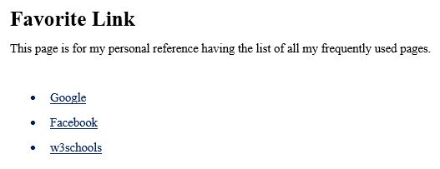

Hands on 2

**Adding Images**

We have already created a page with favorite links. To give a better look to the page for the end user we may have images, and text links as shown in the screen shot. The links should open the page in a different tab by clicking on the image or the text links.   
  
**NOTE:**Code submission not required. To be implemented using Notepad++ and manually verified by the SME.   
  
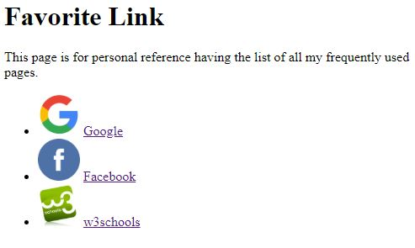

Hands on 3

# DIV and SPAN tag

We have included the images and text link in the favorite link page. Implement the page in below two different ways:

* Show the links one line after the other using DIV
* Show the links adjacent to each other using SPAN as specified in the screen shot below

**NOTE: Code submission not required. To be implemented using Notepad++ and manually verified by the SME.**   
   
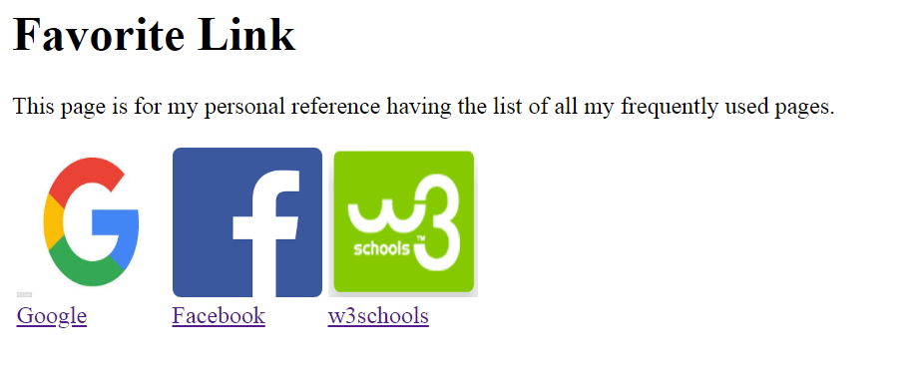

Hands on 4

**Table, Table header, Table data**

Create a page employees.html showing the first name, last name and department as shown in the screen shot below.   
  
**NOTE:**Code submission not required. To be implemented using Notepad++ and manually verified by the SME.   
  
  
