Let’s understand it with the following steps –

Since we want to make search-bar component as a shared component, we will keep related files in a new folder i.e. shared/searchbar.

**Step 1.** **Add the search bar component TypeScript file**

Add a new folder named “Shared” inside app folder and create another folder “SearchBar” inside this “Shared” folder to add the component files. And now, create a TypeScript file “searchbar.component.ts” under this “SearchBar” folder.  
  
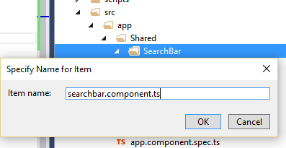  
  
Add the below code into the “searchbar.component.ts” file.

**searchbar.component.ts**

**import** { Component, Output, EventEmitter } from '@angular/core'

@Component({

    selector: 'search-bar',

    templateUrl: 'searchbar.component.html',

    moduleId: module.id

})

**export** **class** SearchBarComponent {

    @Output()

    Search = **new** EventEmitter<string>();

    OnStudentSearch(searchTerm:string): **void** {

**this**.Search.emit(searchTerm);

    }

}

In the above code, we imported two components, Output and EventEmitter, from Angular core module. With the help of these two, we will inform the parent component when OnStudentSearch method will be called. We created a custom event “Search” which will emit when OnStudentSearch method will be called, so parent component will know about the event. The emit function has been used to fire this custom event.

We have mentioned the search bar template URL in templateUrl property, which we will create in a little bit.

**Step 2.** **Add the search bar template file**

Add an html searchbar.component.html file inside the same app -> Shared -> “SearchBar” folder and add the below code into this file,

<div **class**="form-group">

    <div **class**="md-col-4">

        <label>Enter Student Name:</label>

    </div>

    <div **class**="md-col-4">

        <input **class**="form-control" #searchInput type="text" />

    </div>

</div>

<button type="submit" **class**="btn btn-default" (click)="OnStudentSearch(searchInput.value)">

    Search

</button>

Now our searchbar component is complete to nest inside the existing StudentList component.

**Step 3.** **Nest the SearchBar component inside the StudentList component**

Open the existing student.component.html file from app -> student folder and added the below code as highlighted,

<search-bar (Search)="OnStudentSearch($event)"></search-bar>

<table **class**="table table-responsive table-bordered table-striped">

    <thead>

        <tr>

            <th>Student ID</th>

            <th>Name</th>

            <th>Gender</th>

            <th>Age</th>

            <th>Course</th>

            <th>DOB</th>

            <th>Grade</th>

            <th>Rating</th>

        </tr>

    </thead>

    <tbody>

        <tr *ngFor="let s of students;">

            <td>{{s.studentID}}</td>

            <td>{{s.studentName | uppercase}}</td>

            <td>{{s.gender | lowercase}}</td>

            <td>{{s.age}}</td>

            <td>{{s.course | courseCategory}}</td>

            <td>{{s.DOB | date:'yMMMMd' | uppercase }}</td>

            <td>{{s.grade | percent:'.2'}}</td>

            <td>{{s.rating | number:'2.1-2'}}</td>

        </tr>

    </tbody>

</table>

In the above code, you can see how it has been nested with the StudentList component. This is how we can create nested component in Angular 2.

**Step 4.** **Update StudentList component for search functionality**

To filter the student list, we will update the LoadStudents method which will provide us the result after filtering the students with the help of search term passed from child component i.e. SearchBar component. Take a look at the code highlighted below.

**import** { Component, OnInit} from '@angular/core'

@Component({

    selector: 'list-student',

    templateUrl: 'app/student/student.component.html'

})

**export** **class** StudentListComponent **implements** OnInit {

    students: any[];

**public** LoadStudents(filterText: string): **void** {

**this**.students = [

            { studentID: 1, studentName: 'Steve', gender: 'Male', age: 35, course: 'MCA', DOB: '10/12/1982', grade:0.7500,rating:7.5123 },

            { studentID: 2, studentName: 'Bobby', gender: 'Male', age: 32, course: 'MBA', DOB: '12/1/1985', grade: 0.7850, rating: 7.8223 },

            { studentID: 3, studentName: 'Rina', gender: 'Female', age: 45, course: 'B.Tech', DOB: '9/11/1972', grade: 0.8525, rating: 8.5263 },

            { studentID: 4, studentName: 'Alex', gender: 'Female', age: 24, course: 'M.Tech', DOB: '1/1/1993', grade: 0.5540, rating: 5.5123 },

            { studentID: 5, studentName: 'Rahul', gender: 'Male', age: 26, course: 'MCA', DOB: '1/21/1991', grade: 0.9550, rating: 9.5534 },

        ];

**if** (filterText != "") {

**var** filterStudentList: any[] = [];

**this**.students.forEach(stu => {

**if** (stu.studentName.toLowerCase().includes(filterText)) {

                    filterStudentList.push(stu);

                }

            })

**this**.students = filterStudentList;

        }

    }

    Ng

OnInit() {

**this**.LoadStudents("");

    }

    OnStudentSearch(searchTerm: string): **void** {

**this**.LoadStudents(searchTerm);

    }

}

**Step 5.** **Register the SearchBar component in Angular app module**

Now, we will include our SearchBar component in the Angular app module. Add the code as highlighted below.

**import** { NgModule }      from '@angular/core';

**import** { BrowserModule } from '@angular/platform-browser';

**import** { AppComponent } from './app.component';

**import** { StudentListComponent } from './student/student.component'

**import** { courseCategoryPipe } from './student/student.coursepipe'

**import** { SearchBarComponent } from './Shared/SearchBar/searchbar.component'

@NgModule({

    imports: [BrowserModule],

    declarations: [AppComponent, StudentListComponent, courseCategoryPipe, SearchBarComponent],

  bootstrap:    [ AppComponent ]

})

**export** **class** AppModule { }

**Step 6. Now, run the application to get the expected result**

Run the application using F5 or Ctrl + F5 and see the search bar as expected in the browser.

**Output  
  
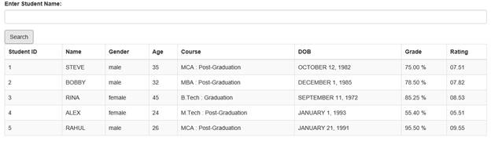**Let’s take a look at search functionality. Let’s enter the term “Rahul” in the search box and hit the "Search" button to get the student list.

**Output on filter  
  
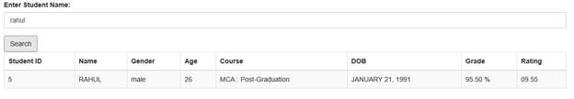**

<https://www.c-sharpcorner.com/article/what-are-components-in-angular-and-nested-components/>