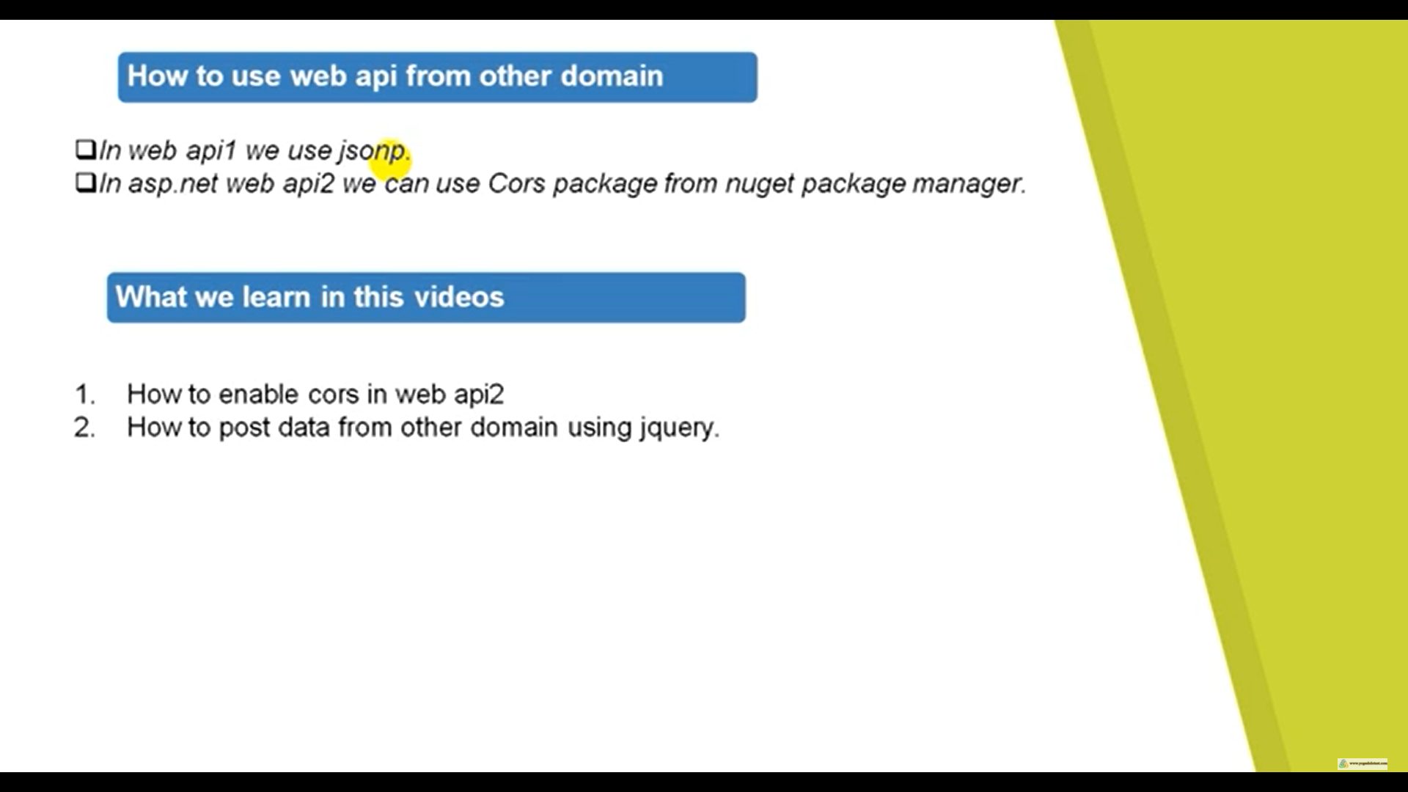

Make a MVC Application

Install JQuery Package if its not there

Enable CORS in web Api > Install Microsoft.AspNet.WebApi.Cors

services. AddCors(c =>

{

c. AddPolicy("AllowOrigin", options => options. AllowAnyOrigin());

});

// Add Cors

services.AddCors(o => o.AddPolicy("MyPolicy", builder =>

{

builder.AllowAnyOrigin()

.AllowAnyMethod()

.AllowAnyHeader();

}));

app.UseCors("MyPolicy");

If you haven't already, install the CORS nuget package.

Install-Package Microsoft.AspNetCore.Cors

In the ConfigureServices method of your startup.cs, add the CORS services.

public void ConfigureServices(IServiceCollection services)

{

services.AddCors(); // Make sure you call this previous to AddMvc

services.AddMvc().SetCompatibilityVersion(CompatibilityVersion.Version_2_1);

}

Then in your Configure method of your startup.cs, add the following :

public void Configure(IApplicationBuilder app, IHostingEnvironment env, ILoggerFactory loggerFactory)

{

// Make sure you call this before calling app.UseMvc()

app.UseCors(

options => options.WithOrigins("http://example.com").AllowAnyMethod()

);

app.UseMvc();

}

services.AddCors(options => options.AddPolicy("ApiCorsPolicy", builder =>

{

builder.WithOrigins("http://localhost:4200").AllowAnyMethod().AllowAnyHeader();

}));

services.AddMvc();

}

In the configure method tell CORS to use the policy you just created:

app.UseCors("ApiCorsPolicy");

app.UseMvc();