The StringReader and StringWriter classes, also derived from TextReader and TextWriter, are mainly used to manipulate strings rather than files. The StringReader class is built from a string and provides methods Read and ReadLine to read parts of that string. The StringWriter class is used to write to a StringBuilder class (from the System.Text namespace). Since strings in C# are immutable, the StringBuilder class is used to build a string efficiently. StringWriter provides methods like Write and WriteLine to write to the StringBuilder object. Use these streams if you are dealing with many string manipulations (e.g., a text-to-HTML parser). The StringRW class in Listing 6.11 is similar to the StreamRW class shown in Listing 6.10, except that it uses the StringReader and StringWriter classes.  
  
**Listing 6.11: StringReader and StringWriter Example**  
  
using System;  
using System.IO;  
using System.Text;  
  
public class StringRW  
{  
    StringBuilder sb = new StringBuilder();  
    public StringRW()  
    {  
        //Call the Writer Method  
        Writer();  
  
        //Call the Reader Method  
        Reader();  
    }  
  
    public static void Main()  
    {  
        StringRW srw = new StringRW();  
    }  
  
    //Writer Method  
    private void Writer()  
    {  
        StringWriter sw = new StringWriter(sb);  
        Console.WriteLine("Welcome to the Profile Program");  
        Console.Write("Name :");  
  
        //Get the name from the console  
        string name = Console.ReadLine();  
  
        //Write to StringBuilder  
        sw.WriteLine("Name :" + name);  
        Console.Write("Country :");  
        string country = Console.ReadLine();  
  
        //Write to StringBuilder  
        sw.WriteLine("Country :" + country);  
        Console.Write("Age :");  
        string age = Console.ReadLine();  
  
        //Write to StringBuilder  
        sw.WriteLine("Age :" + age);  
        Console.WriteLine("Thank You");  
        Console.WriteLine("Information Saved!");  
        Console.WriteLine();  
  
        //Close the stream  
        sw.Flush();  
        sw.Close();  
        Console.ReadLine();  
    }  
  
    private void Reader()  
    {  
        StringReader sr = new StringReader(sb.ToString());  
        Console.WriteLine("Reading Profile");  
  
        //Peek to see if the next character exists  
        while (sr.Peek() > -1)  
        {  
            //Read a line from the string and display it on the  
            //console  
            Console.WriteLine(sr.ReadLine());  
        }  
  
        Console.WriteLine("Data Read Complete!");  
        //Close the string  
        sr.Close();  
           }  
}  
  
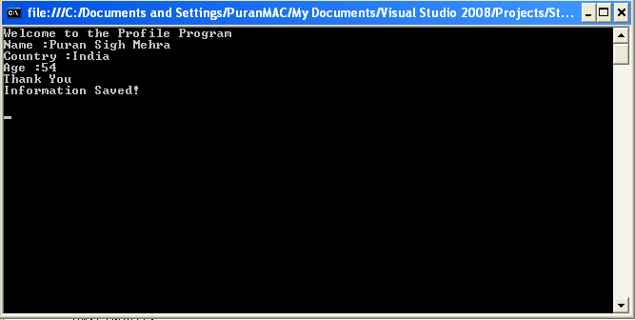  
  
**Output of listing 6.11**  
Instead of using a file as a data source (as in the StreamRW class in Listing 6.10), this example uses a StringBuilder object to store the input from the user in the Writer method using the StringWriter class. Later, in the Reader method, the example uses the StringReader class to read from the string, which was built in the Writer method.