1 ajay btech(elc) 78

2 deepak be (cs) 87

3 manoj

Data > Raw facts or figures meaningless

Information > Analysed & Processed data (meaningful)

To store data , we need database

Database > collection of data

Dbms > database management system software

Functions of dbms

1. Insert record
2. Delete record
3. Update record
4. Search data
5. List data

DBMS

RDBMS > Relational dbms

NDBMS > network dbms

HDBMS > hierarchial dbms

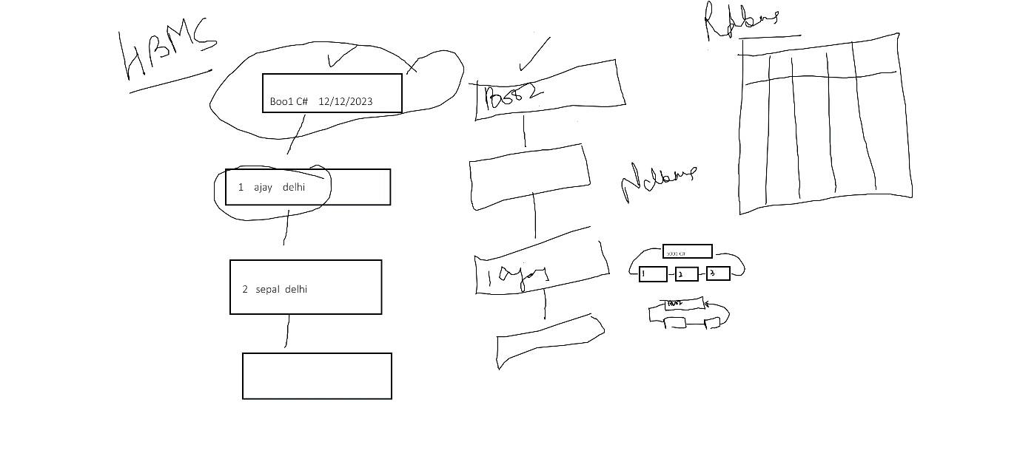

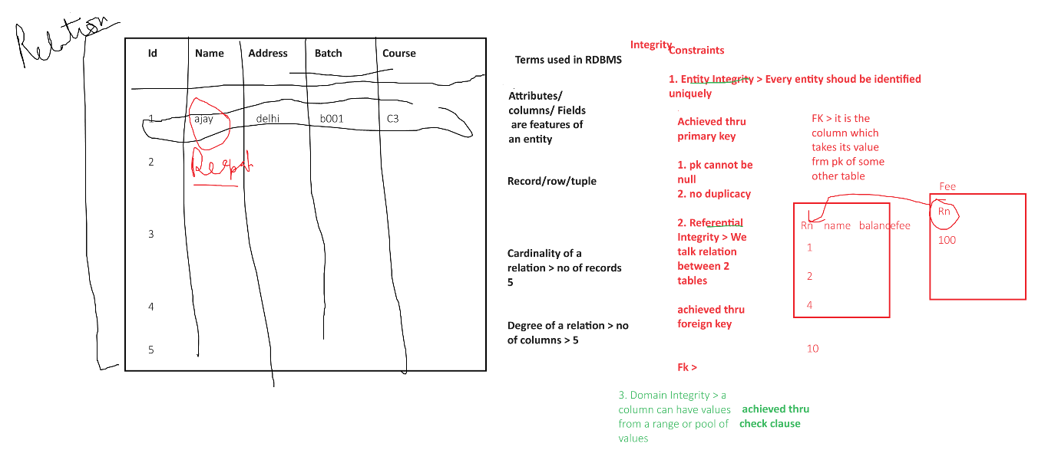

RDBMS

MsSql

MySql

Access

Oracle

Sql > Structured Query Language

Features of Sql

1. It is query language to work with RDBMS
2. Case insensitive
3. Uses simple English like words
4. It has different type of statements
5. DDL > Data definition language > it is used to describe table/ object structurre

Create alter drop truncate table

1. DML > Data manipulation language > used to work with records

Insert delete update

1. Dql > data Query language > used to query data , select
2. TCL > Transaction control lang > commit rollback savepoint
3. DCL > Data Control lang > grant revoke

create database DemoDb

use DemoDB

create table Employee (id int,

name varchar(20),

dept varchar(20),

salary int)

select * From employee

insert into employee values(1,'Ajay','Accts',19000)

insert into employee values(2,'Deepak','Accts',29000)

insert into employee values(3,'Manoj','IT',45000)

select * from employee

select id,name from employee

insert into employee values

(5,'Ajay','Accts',19000),

(6,'Gargi','Sales',23000),

(7,'Shobha','IT',56000),

(8,'Meena','Accts',19000)

-- filter records using where clause

select * from Employee where id =2

select * from employee where name LIKE 'Ajay'

select * From employee where salary > 12000 AND salary <30000

select * from Employee where salary BETWEEN 10000 AND 30000

select * From Employee where dept = 'HR' OR dept ='Accts'

select * From Employee where dept IN('HR','Accts')

select id 'Employee ID' from Employee

select id 'Employee ID', name 'Employee Name' from Employee

select id As 'Employee ID', name As 'Employee Name' from Employee

select id as 'Employee ID', salary + 12000 from employee

select id as 'Employee ID', salary + 12000 As 'Incremented Salary' from employee

select * from employee

-- edit

update Employee set salary = salary + 1200 where id In(3,6)

-- delete

delete from Employee where id < 2

-- add new column

alter table employee add manager varchar(20)

select * from employee

-- remove column

alter table employee drop column manager

alter table employee add manager varchar(20) default 'Meena' with values

-- rename a column

sp_rename 'employee.manager', 'managername', 'column'

-- rename a table

sp_rename 'employee' , 'emp'