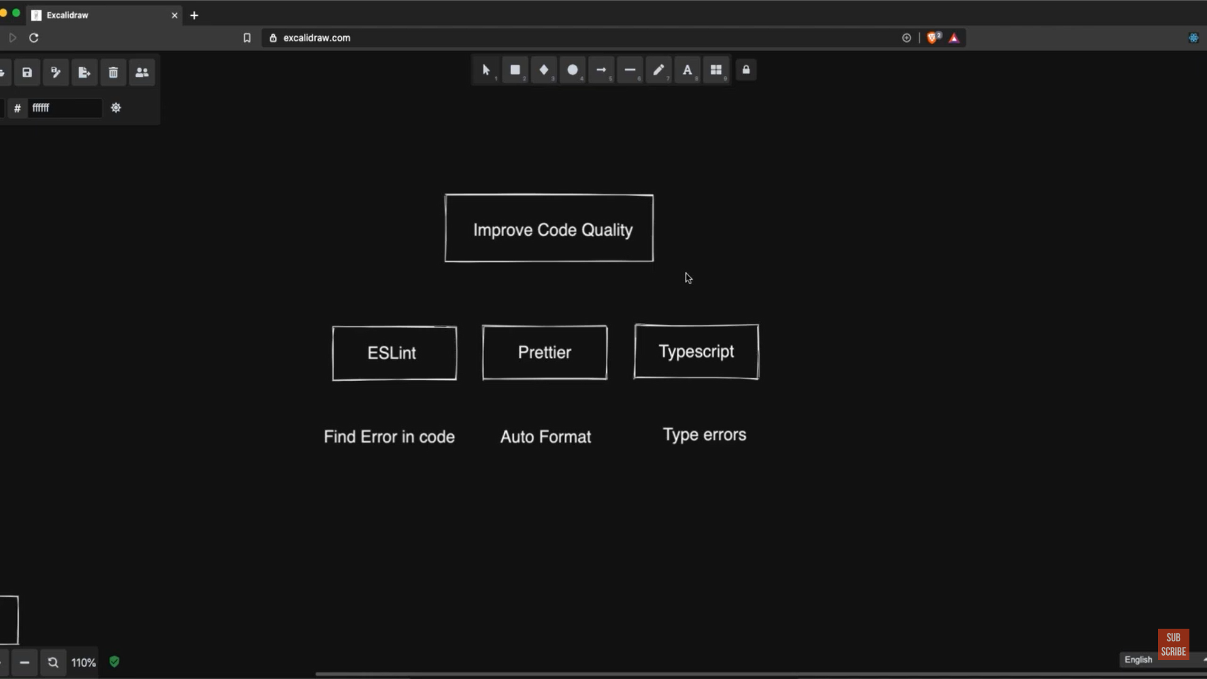

C:\Users\Anamika\data>npm run lint

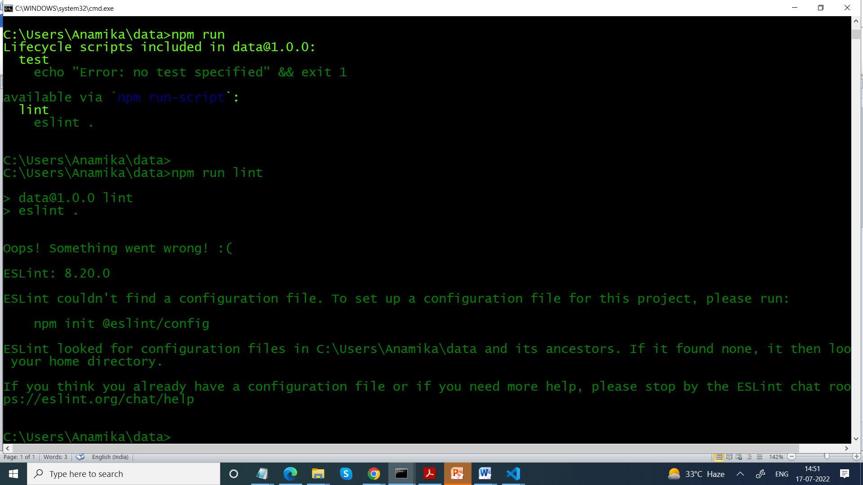

You need to add configuration file

.eslintrc.js file

module.exports = {

  "rules" :

  {

  "semi":

  [

 "error",

 "always"

  ]

  }

}

Add .eslintignore

.eslintrc.js

module.exports ={

"extends":

[

  "eslint:recommended"

]

}

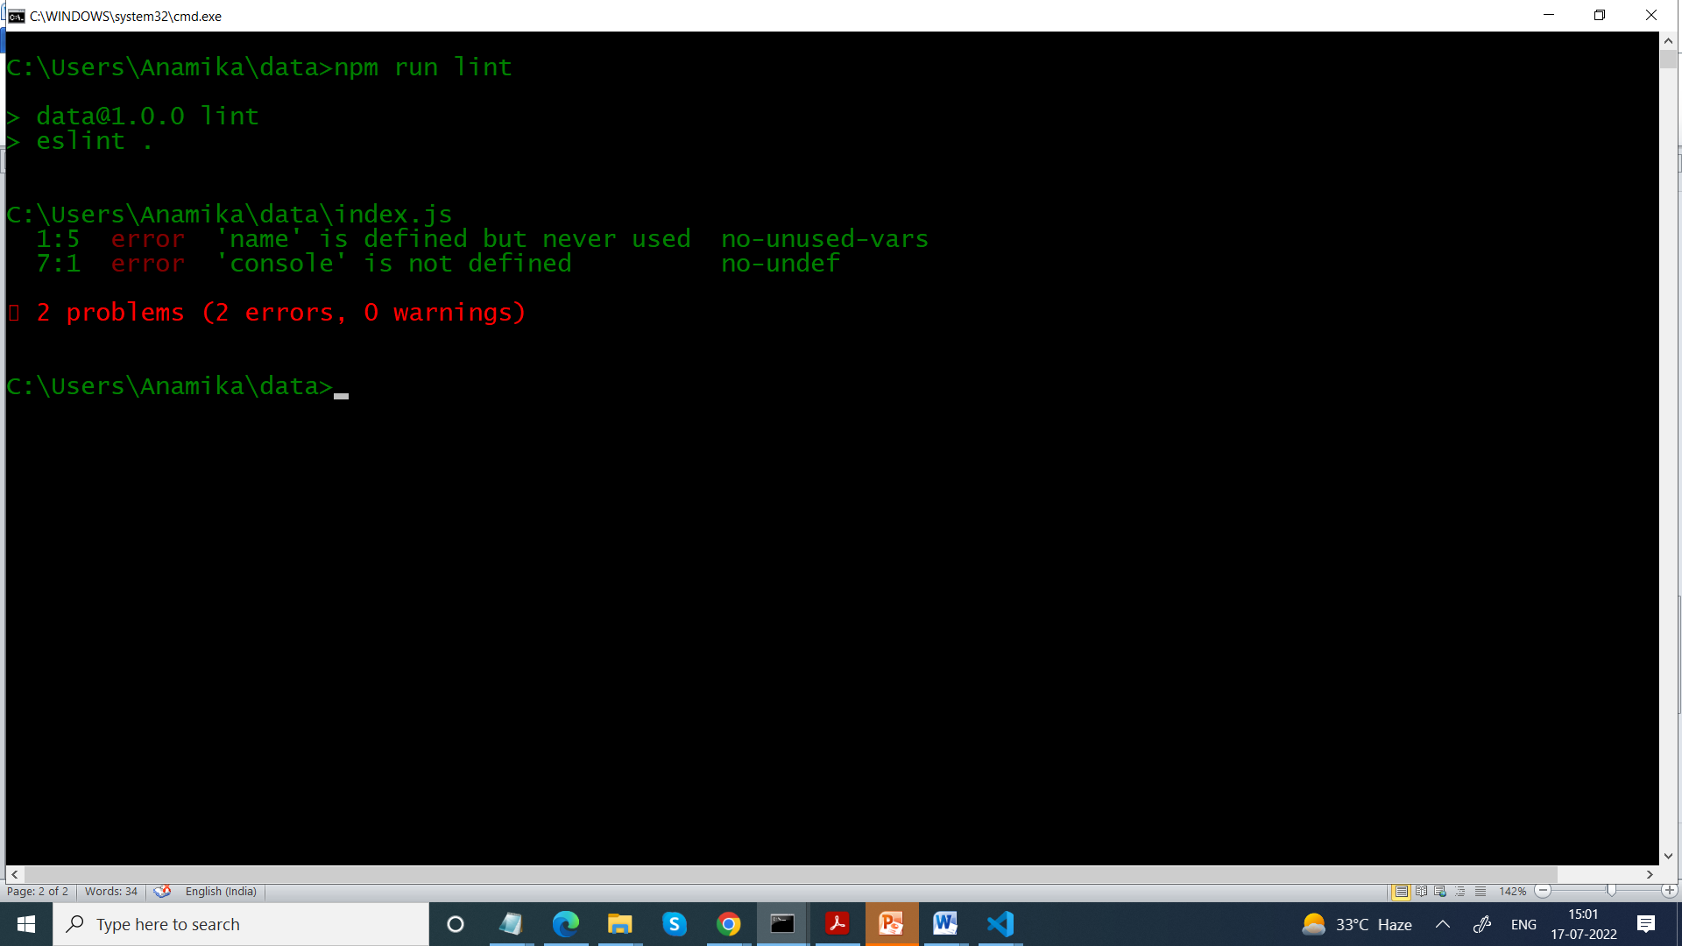

Test.js

export const foo="bar"

import {foo} from './Test'

var name

function hello()

{

return "hello"

}

console.log(hello())

Will give error

module.exports ={

parserOptions:

{

ecmaVersion:6,

sourceType:"module"

}

,

"extends":

[

  "eslint:recommended"

]

}

import {foo} from './Test'

function hello()

{

return foo

}

console.log(hello())

The no-undef rule looks out for undefined variable, without any initial assumption on the environment and the global variables (console for instance).

You can specify that you are in an environment where console indeed exists, by adding browser and/or node envs in your .eslintrc:

env: {

browser: true,

node: true,

},

Search in google

react eslint plugin

<https://www.npmjs.com/package/eslint-plugin-react>

npm install eslint eslint-plugin-react --save-dev

// module.exports = {

//   "rules" :

//   {

//   "semi":

//   [

//  "error",

//  "always"

//   ]

//   }

// }

module.exports ={

parserOptions:

{

ecmaVersion:6,

sourceType:"module",

ecmaFeatures:{

jsx:true

}

}

,

"plugins": ["react"],

"extends":

[

  "eslint:recommended",

  "plugin:react/recommended"

],

env: {

    browser: true,

    node: true,

  }

}

class Hello1 extends React.Component

{

  render()

  {

    return <div> Hello World </div>

  }

}

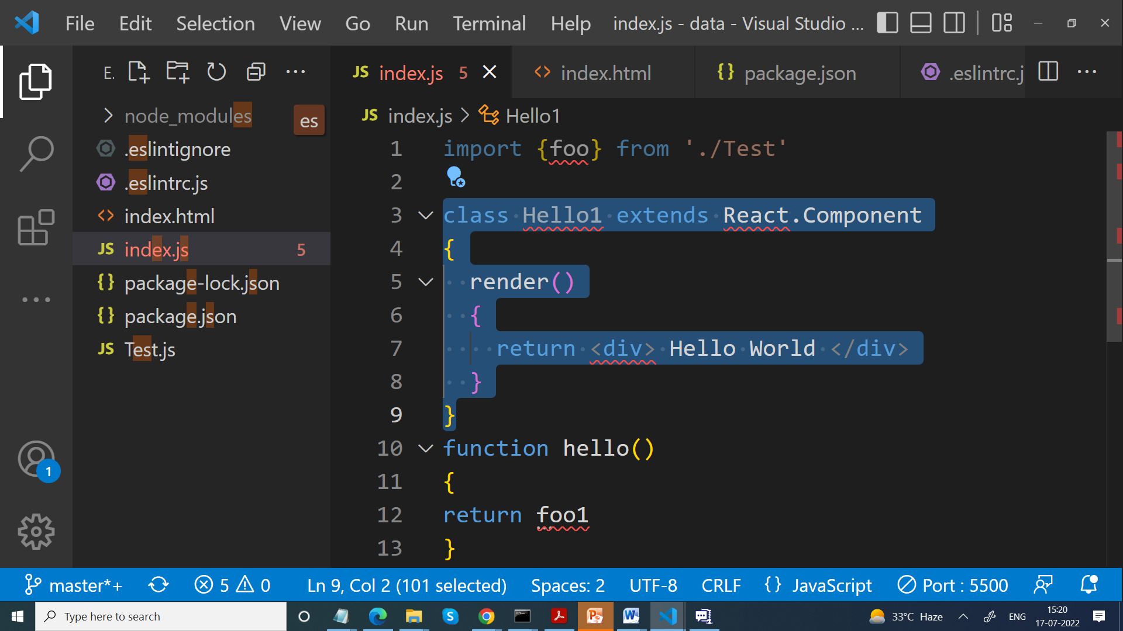

npm i react

import React from ' react'

<https://prettier.io/playground/>