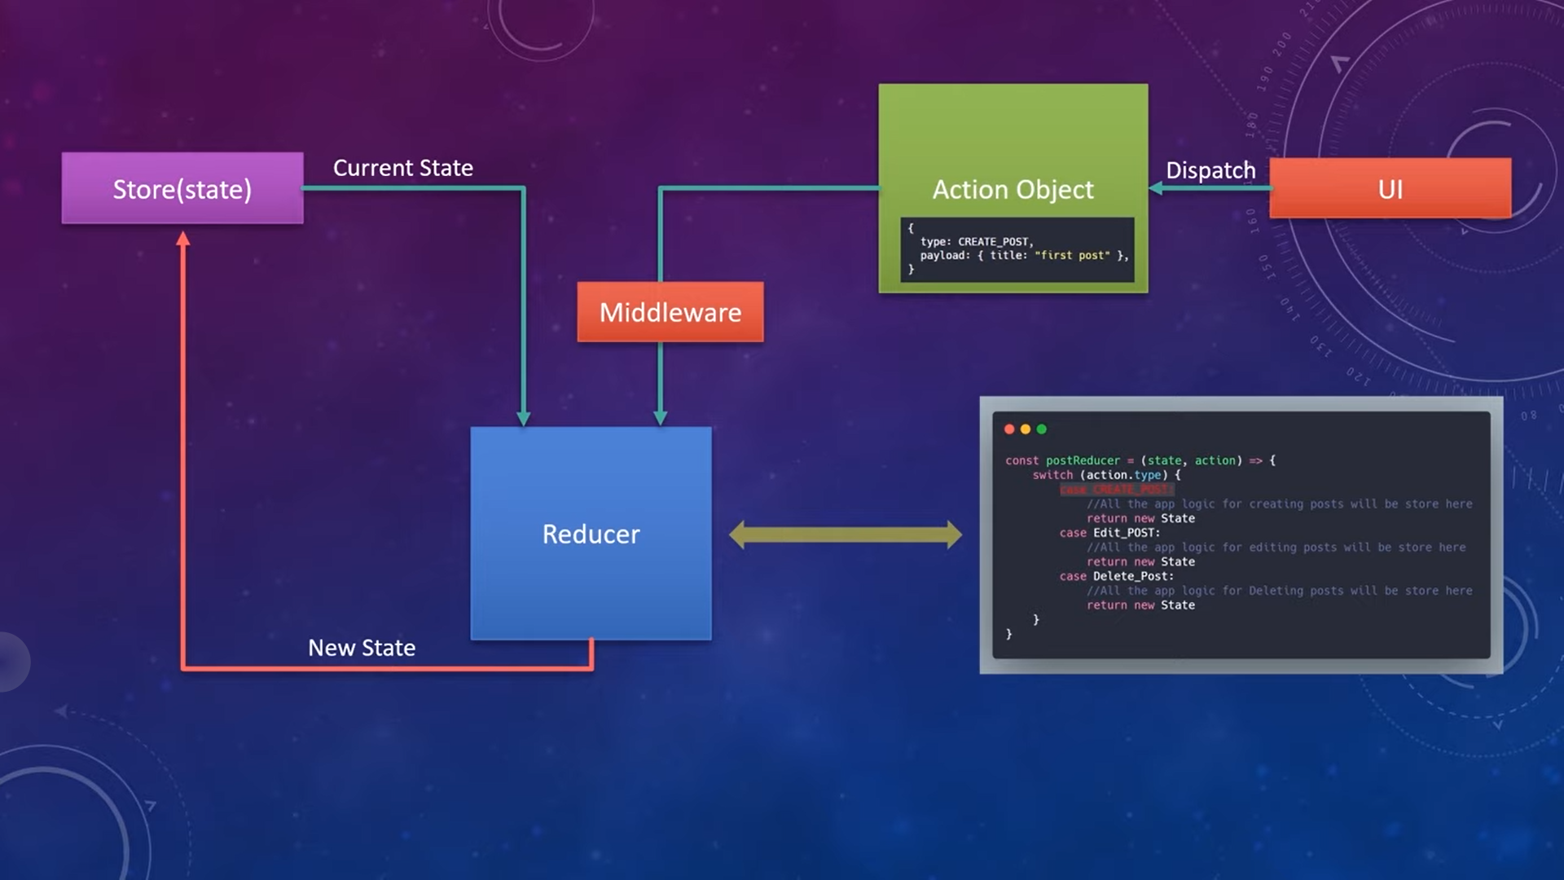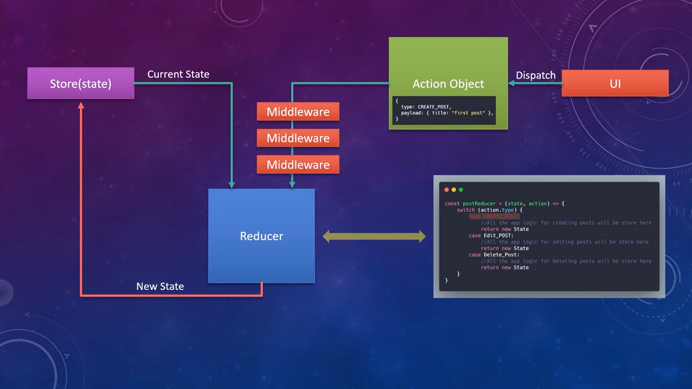

Action creators can only return plain javascript objects with a type propertry

The action will get sent to reducer before the data is fetched from API