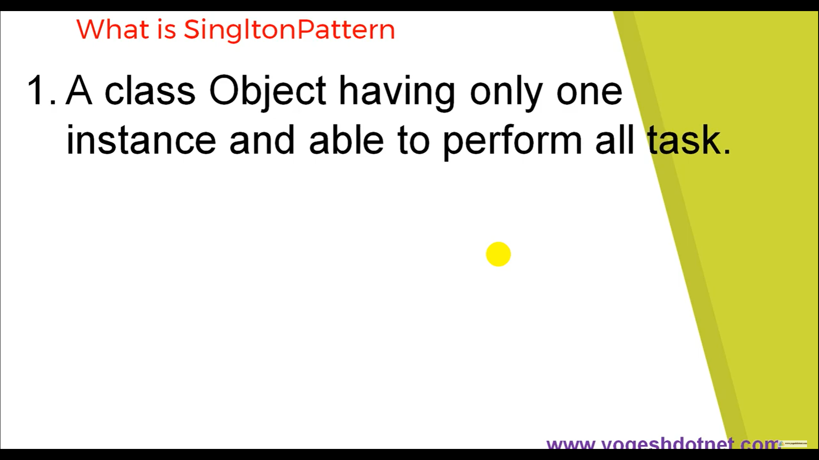

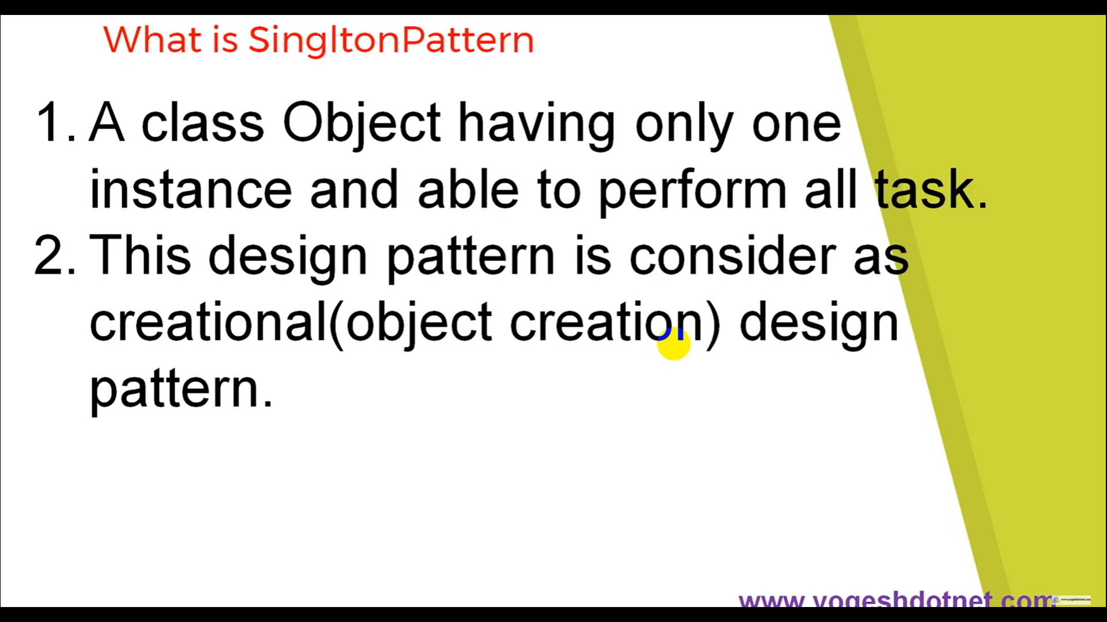

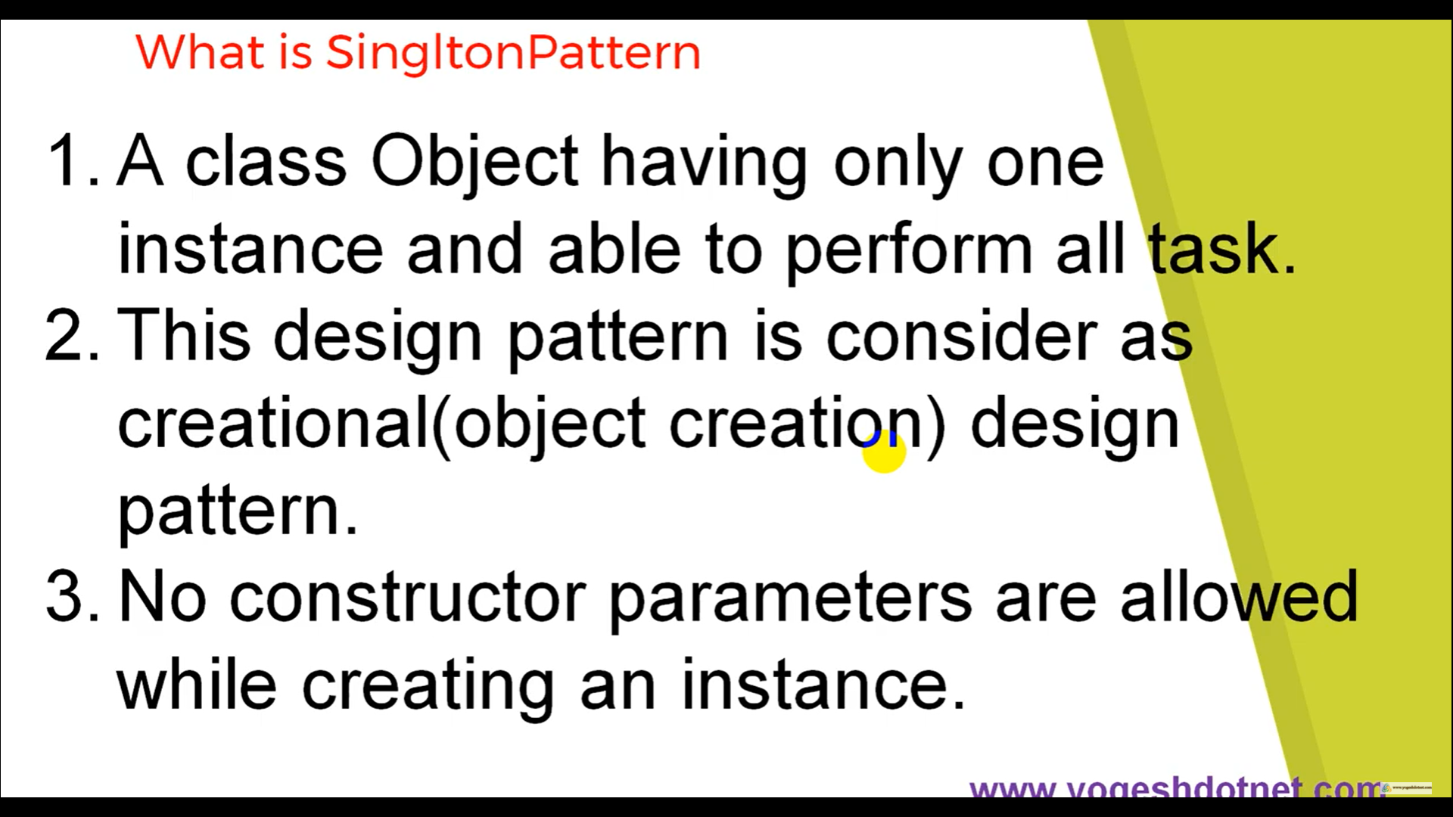

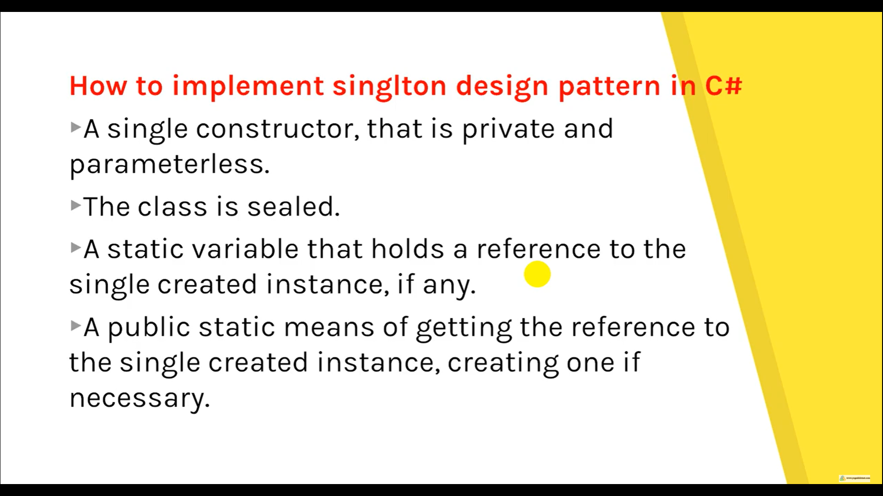

Thread Safe

// Thread Safe

public sealed class Singleton2

{

Singleton2() { }

private static readonly object Lock = new object();

private static Singleton2 instance = null;

public static Singleton2 Instance

{

get

{

lock (Lock)

{

if (instance == null)

{

instance = new Singleton2();

}

return instance;

}

}

}

}

<https://www.c-sharpcorner.com/UploadFile/8911c4/singleton-design-pattern-in-C-Sharp/>