Steps to Create Windows Service

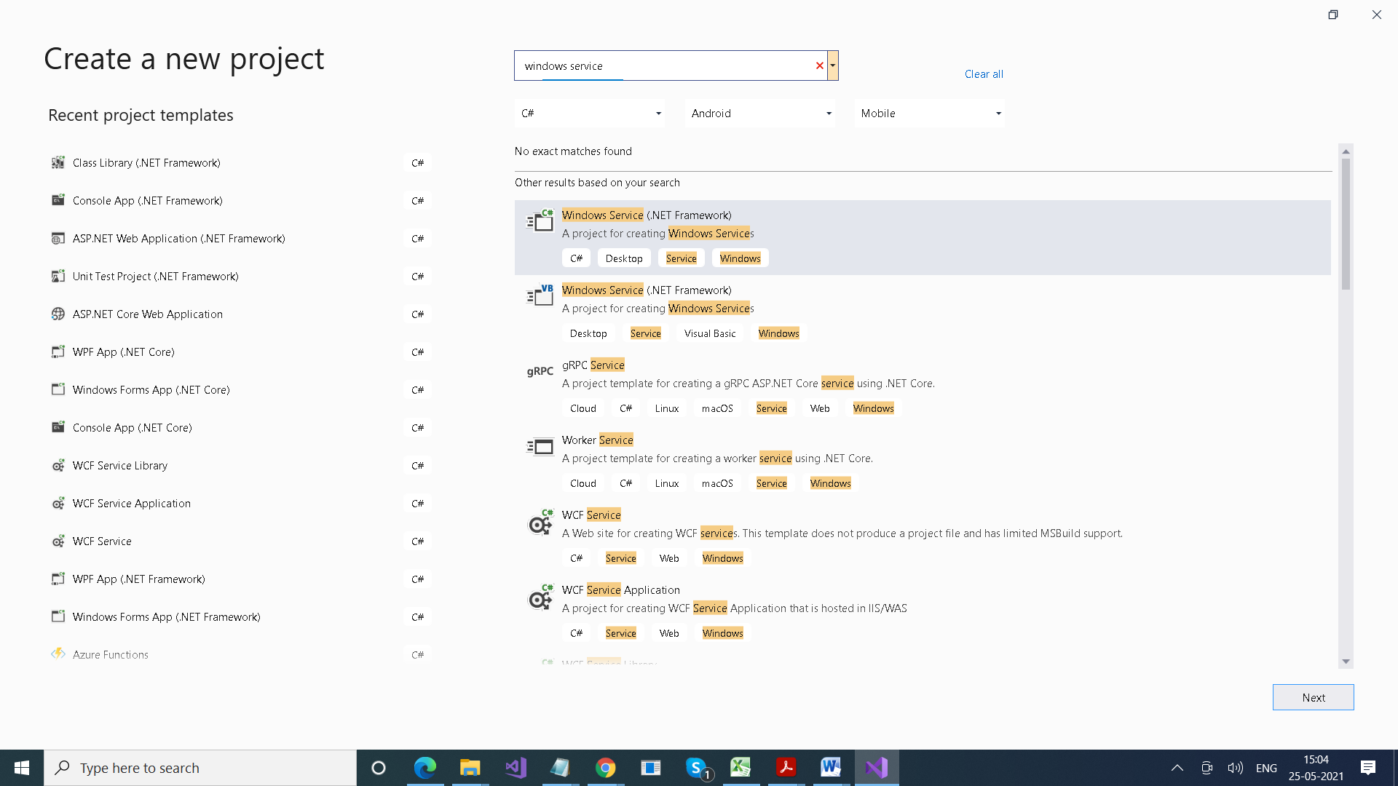

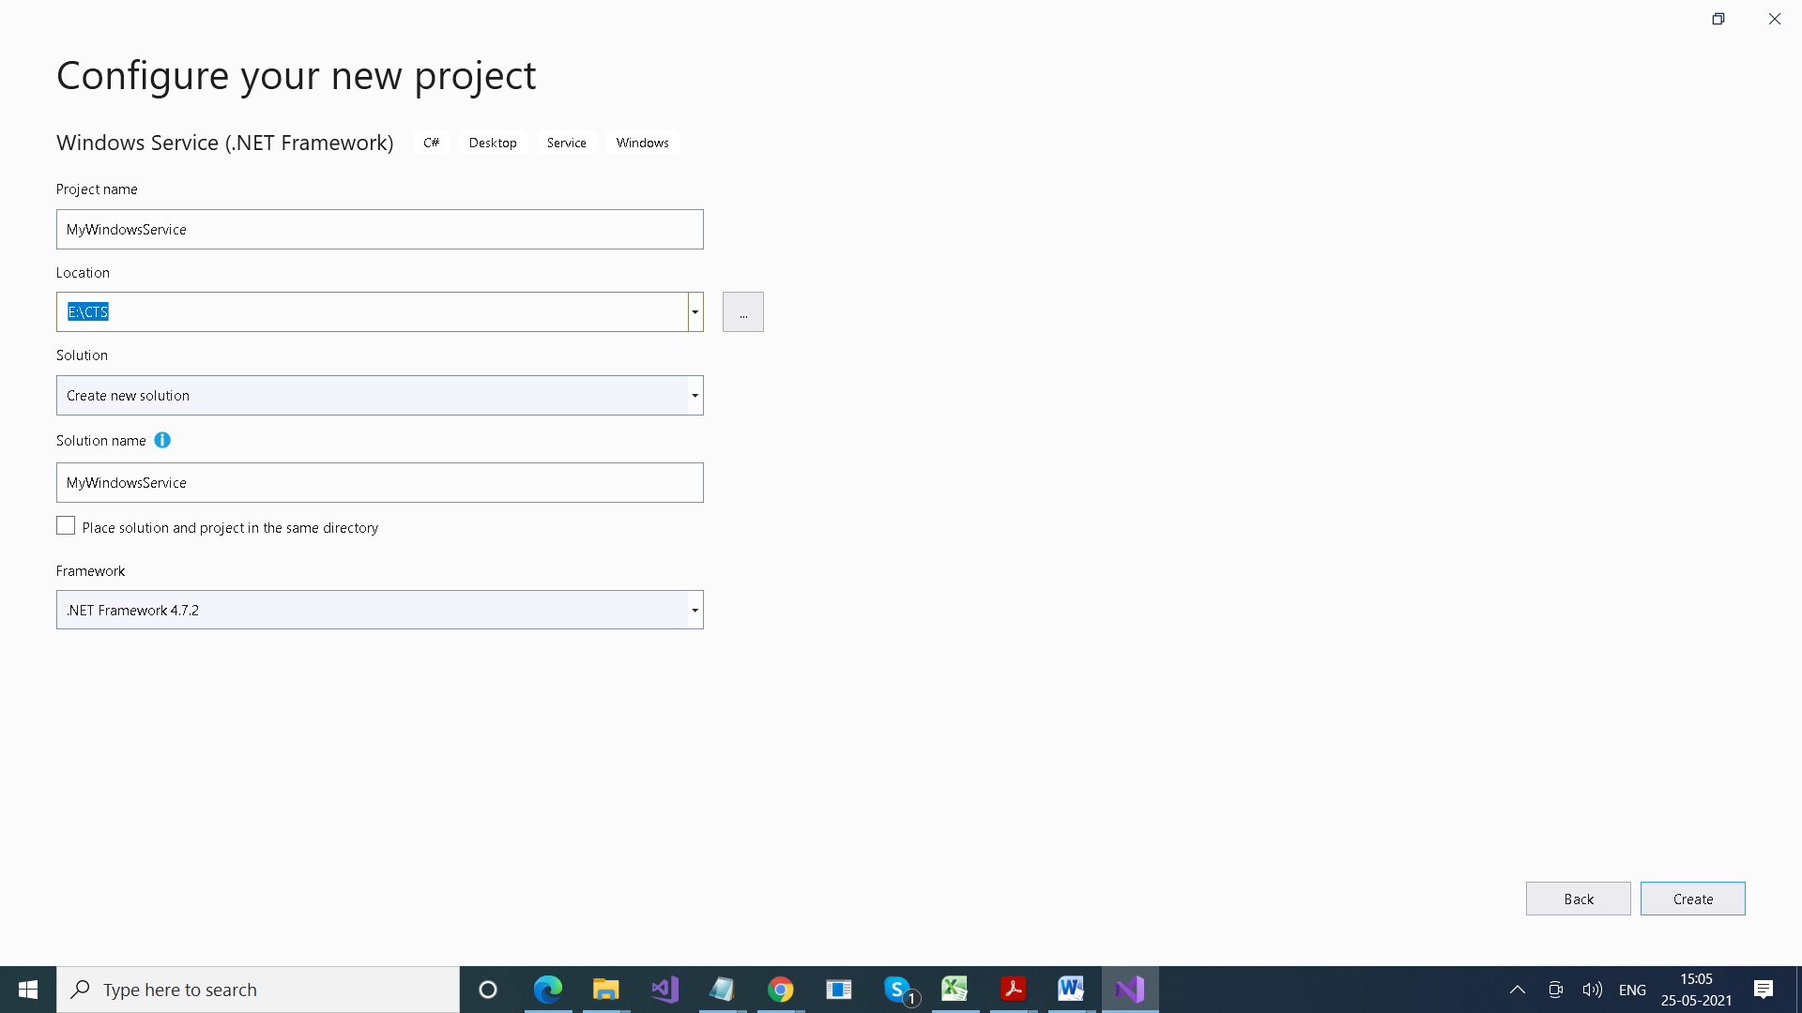

Add Installer

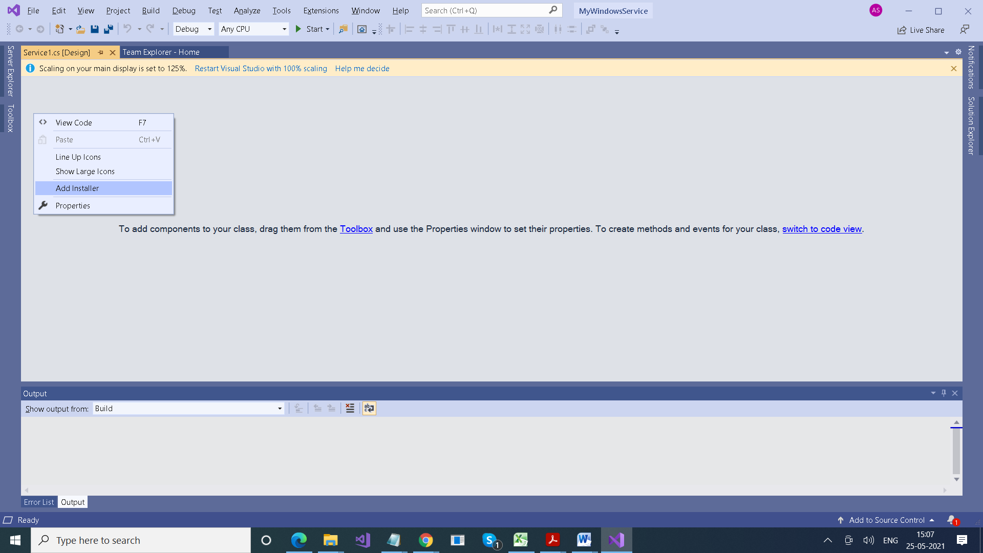

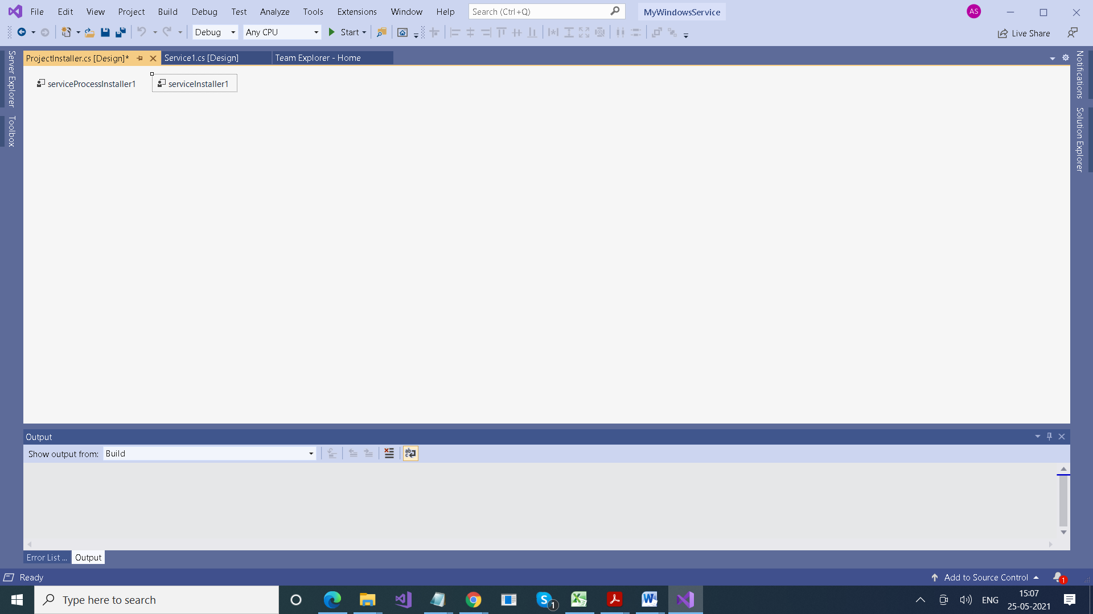

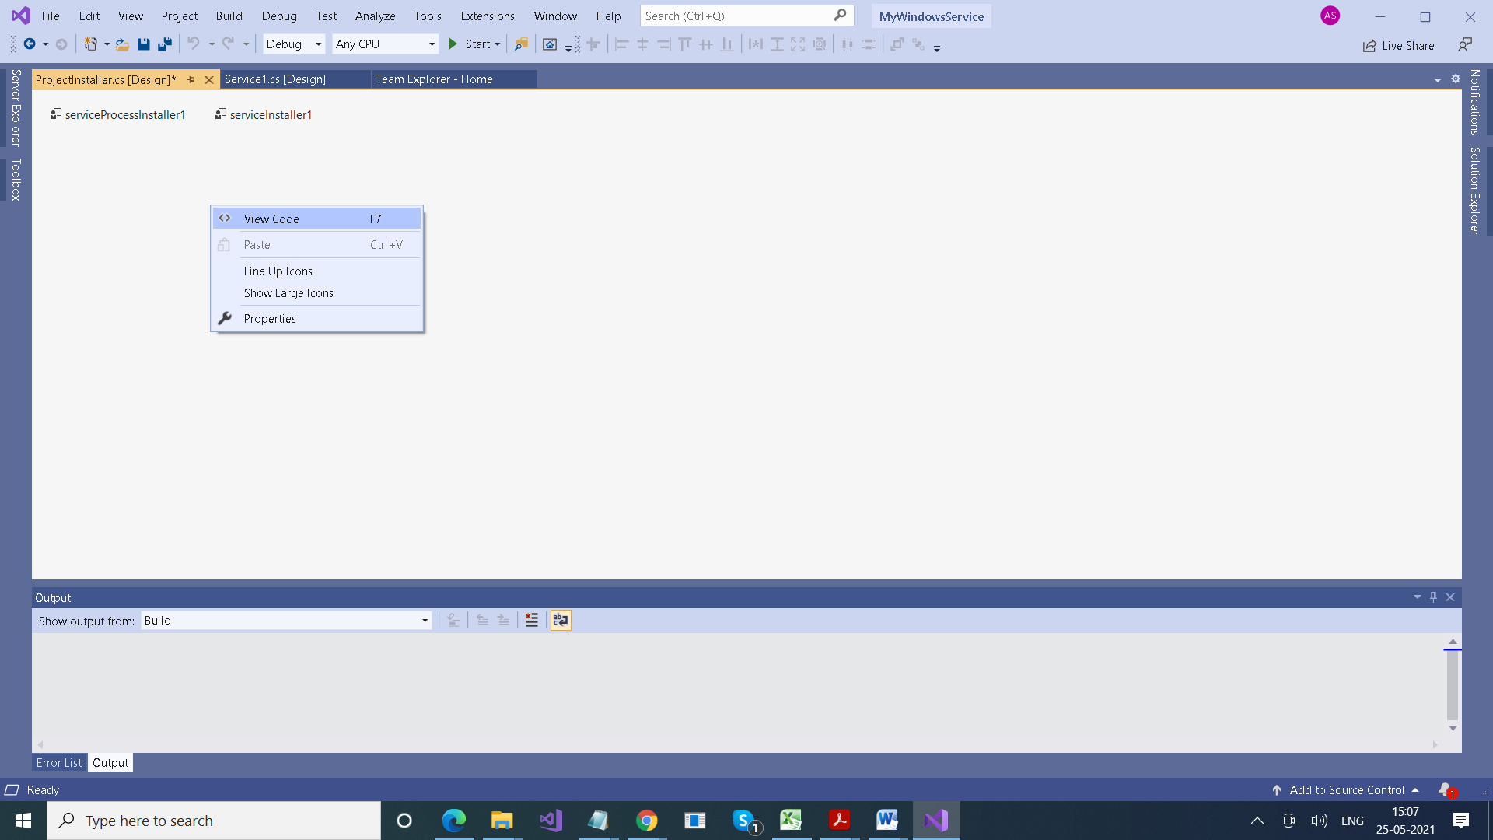

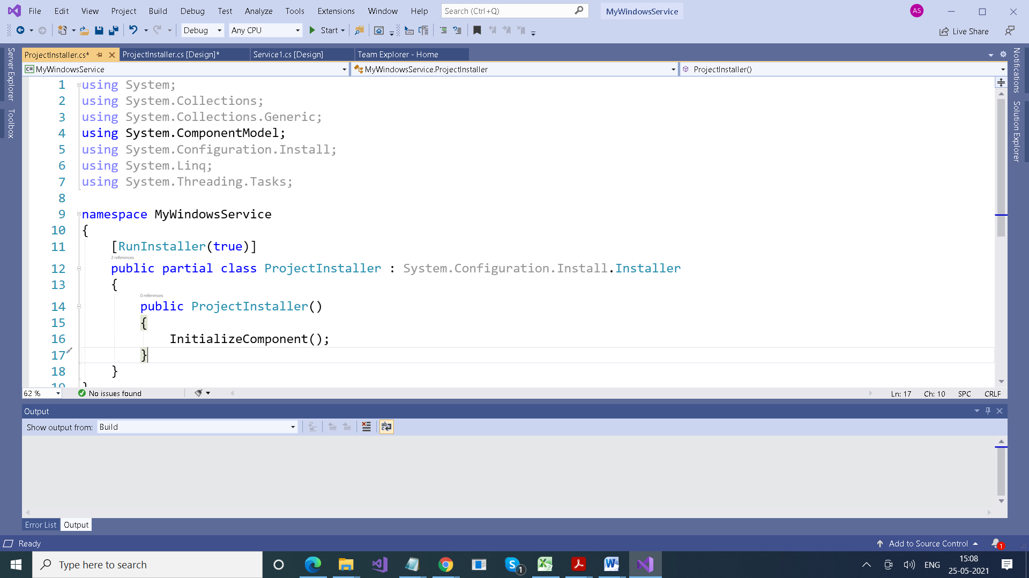

Its has Constructor which contains InitializeComponent method:

The InitializeComponent method contains the logic which creates and initializes the user interface objects

* LocalService account (preferred) A limited **service** account that is very similar to **Network Service** and meant to run standard least-privileged **services**. ...
* **NetworkService** account. Limited **service** account that is meant to run standard privileged **services**. ...
* **LocalSystem** account (admin rights)

private void InitializeComponent()

{

this.serviceInstaller1.DisplayName = "MyWindowsService.Demo";

this.serviceInstaller1.Description = "My First Service";

………………….

}

namespace MyWindowsService

{

partial class ProjectInstaller

{

/// <summary>

/// Required designer variable.

/// </summary>

private System.ComponentModel.IContainer components = null;

/// <summary>

/// Clean up any resources being used.

/// </summary>

/// <param name="disposing">true if managed resources should be disposed; otherwise, false.</param>

protected override void Dispose(bool disposing)

{

if (disposing && (components != null))

{

components.Dispose();

}

base.Dispose(disposing);

}

#region Component Designer generated code

/// <summary>

/// Required method for Designer support - do not modify

/// the contents of this method with the code editor.

/// </summary>

private void InitializeComponent()

{

this.serviceProcessInstaller1 = new System.ServiceProcess.ServiceProcessInstaller();

this.serviceInstaller1 = new System.ServiceProcess.ServiceInstaller();

**this.serviceProcessInstaller1.Account = System.ServiceProcess.ServiceAccount.LocalSystem;**

//

// serviceProcessInstaller1

//

this.serviceProcessInstaller1.Password = null;

this.serviceProcessInstaller1.Username = null;

//

// serviceInstaller1

//

this.serviceInstaller1.ServiceName = "Service1";

**this.serviceInstaller1.DisplayName = "MyWindowsService.Demo";**

**this.serviceInstaller1.Description = "My First Service";**

//

// ProjectInstaller

//

this.Installers.AddRange(new System.Configuration.Install.Installer[] {

this.serviceProcessInstaller1,

this.serviceInstaller1});

}

#endregion

private System.ServiceProcess.ServiceProcessInstaller serviceProcessInstaller1;

private System.ServiceProcess.ServiceInstaller serviceInstaller1;

}

}

**Service1.cs file**

using System;

using System.Collections.Generic;

using System.ComponentModel;

using System.Data;

using System.Diagnostics;

using System.IO;

using System.Linq;

using System.ServiceProcess;

using System.Text;

using System.Threading.Tasks;

**using System.Timers;**

namespace MyWindowsService

{

public partial class Service1 : ServiceBase

{

**Timer timer = new Timer();**

public Service1()

{

InitializeComponent();

}

protected override void OnStart(string[] args)

{

**WriteToFile("Service is started at " + DateTime.Now);**

**timer.Elapsed += new ElapsedEventHandler(OnElapsedTime);**

**timer.Interval = 5000; //number in milisecinds**

**timer.Enabled = true;**

}

**protected override void OnStop()**

**{**

**WriteToFile("Service is stopped at " + DateTime.Now);**

**}**

**private void OnElapsedTime(object source, ElapsedEventArgs e)**

**{**

**WriteToFile("Service is recall at " + DateTime.Now);**

**}**

**public void WriteToFile(string Message)**

**{**

**string path = AppDomain.CurrentDomain.BaseDirectory + "\\Logs";**

**if (!Directory.Exists(path))**

**{**

**Directory.CreateDirectory(path);**

**}**

**string filepath = AppDomain.CurrentDomain.BaseDirectory + "\\Logs\\ServiceLog_" + DateTime.Now.Date.ToShortDateString().Replace('/', '_') + ".txt";**

**if (!File.Exists(filepath))**

**{**

**// Create a file to write to.**

**using (StreamWriter sw = File.CreateText(filepath))**

**{**

**sw.WriteLine(Message);**

**}**

**}**

**else**

**{**

**using (StreamWriter sw = File.AppendText(filepath))**

**{**

**sw.WriteLine(Message);**

**}**

**}**

**}**

}

}

After Writing this code, build your project

Go to command prompt

**cd C:\Windows\Microsoft.NET\Framework\v4.0.30319**

InstallUtil.exe ***+*** Your copied path + \your service name + .exe

Service Created

How to run this

Write services.msc

Select your service Name > Start