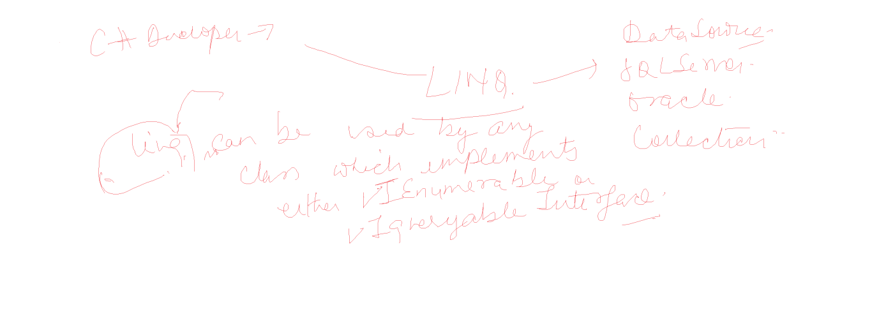

using System;

using System.Collections.Generic;

using System.Linq;

using System.Text;

using System.Threading.Tasks;

namespace ADODemos

{

class LinqDemo

{

static void Main()

{

int[] num = new int[] { 1, 2, 3, 4, 5, 6 };

// LINQ

var list = (from x in num

select x);

foreach(var temp in list)

Console.WriteLine(temp);

var sum = (from x in num

select x).Sum();

Console.WriteLine("Sum is " + sum);

var avg = (from x in num

select x).Average();

Console.WriteLine("Avg is " + avg);

var evenlist = (from x in num

where x % 2 == 0

select x);

Console.WriteLine("Even Nums");

foreach(var temp in evenlist)

Console.WriteLine(temp);

List<string> names = new List<string>()

{

"Ajay Kumar", "Deepak Sahni", "Arun Kumar" };

var nameslist = (from x in names

select x);

foreach(string temp in nameslist)

Console.WriteLine(temp);

var kumarlist = (from x in names

where x.Contains("Kumar")

select x);

Console.WriteLine("List of kumars");

foreach (string temp in kumarlist)

Console.WriteLine(temp);

}

}

}