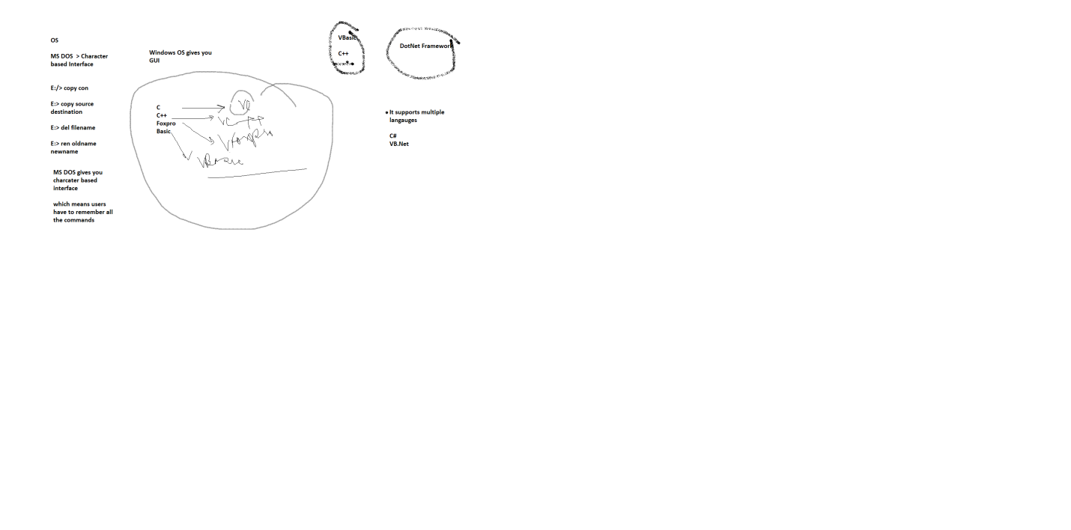

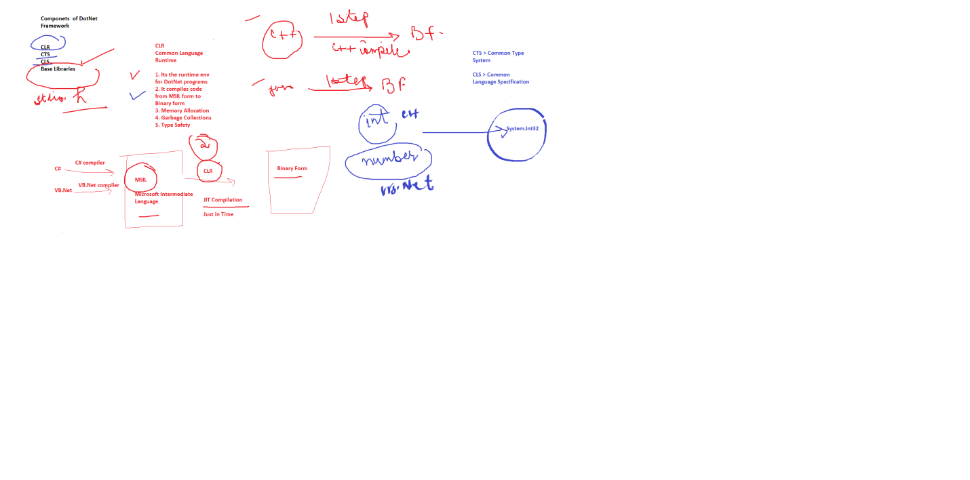

Language > Means / Mode of communication

Eng Hindi Tamil German

Common thing > Syntax/Grammar , Keywords

A-Z

Logic will remain same

Programming Lang

Syntax > Keywords

Logic will remain same

How do we write program

We need an editor

Structure of C program

#include <stdio.h>

Main()

{

}

Structure of C# program

using System;

class Program

{static void Main()

{

}

}

using System; // System , library , namespace

namespace FirstProject // whatever project name we gave,

// we get namespace with that name by default// optional

{

class Program // Min we need one class which will contain Main method

{

static void Main(string[] args) // Main method is entry & exit point

// of program

{

Console.Write("Hello1\n");

Console.Write("Hello2\n");

Console.Write("Hello3\n");

}

}

}

// Console > its a class in System namespace

// WriteLine > Its a method which belongs to Console Classs