Vehicles Released in Certain Years - Linq

**Grade settings**: Maximum grade: 100  
**Disable external file upload, paste and drop external content**: Yes  
**Run**: Yes **Evaluate**: Yes  
**Automatic grade**: Yes **Maximum execution time**: 16 s

Write a program to find the vehicles released between certain year.

1. **class Vehicle** is already given for your reference.

2.**class Program**contains a hard-coded **list**with vehicle information in the **'VehicleList'** attribute.

a) Implement method **'GetVehicleName'**.

*public static void GetVehicleName(int fromYear, int toYear)*          //method signature

This method must display the vehicle names (from the given list) released between the **fromYear**and **toYear** (including these years).  **USING LINQ CONCEPT**

b) Implement method 'Main'.

Get the "fromYear" and "toYear" from the user. Pass it to 'GetVehicleName' method.

**NOTE :**NEED NOT call 'GetMyExpression' method in Main.

c) method **'GetMyExpression'**

public static Expression GetMyExpression(int fromYear, int toYear)

This method snippet is already given for you. **THIS METHOD IS FOR TESTING YOUR LINQ QUERY EXPRESSION**.  So fill your query expression in the space holder provided. **ONLY THE QUERY EXPRESSION.**Nothing more need to be implemented in this method.

Sample Input/Output 1:

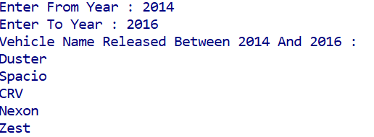

Sample Input/Output 2:

