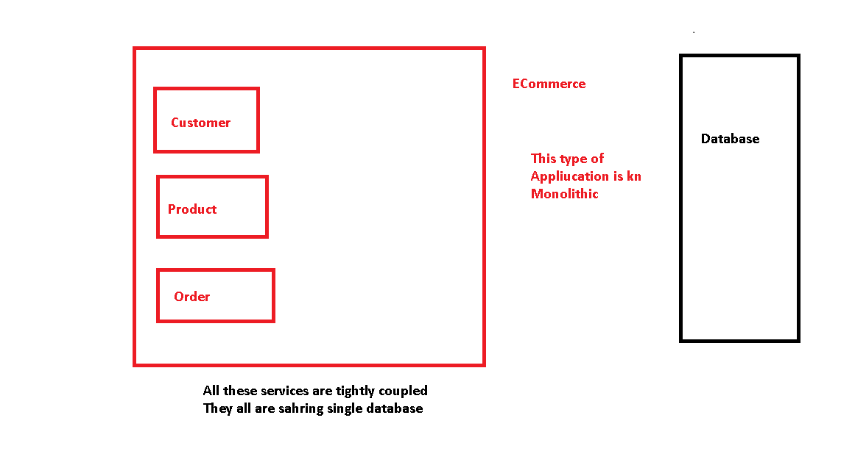

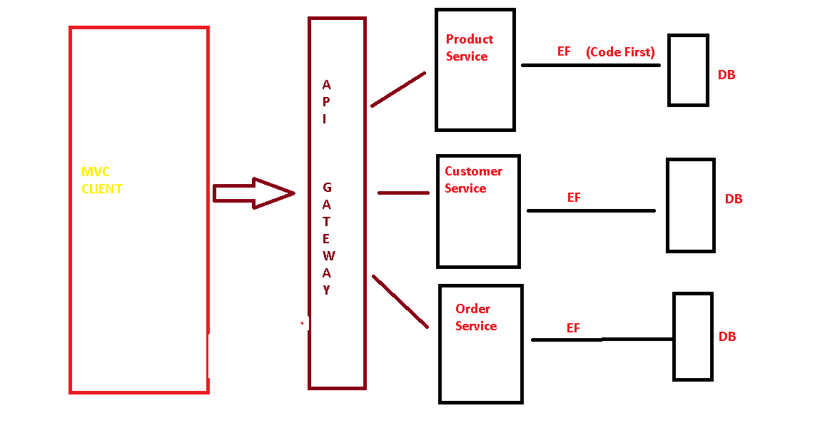

Microservices are small independent services running separately . All of them are stored in separate project. All of them have their separate database

Microservies are loosely coupled . If one service does not work, it will not affect other services

Application is Ecommerce:

3 Components

Front End MiddleWare BackEnd

MVC Client Service ADO.Net

EF Database