FE (from where user interacts)

Middleware

BE (database)

Restaurant :

Single Tier

Two tier :

3 tier

Restaurant : controller view model

Controller > is a component which wil take request from user, depending upon user request , request will be redirected to action method, and you will get response what that action method is returning

Model > Cook (Domain , Create your classes)

View (What uses sees , thru which user interacts)

There is a separation of concerns from very beginning

MVC follows some conventions

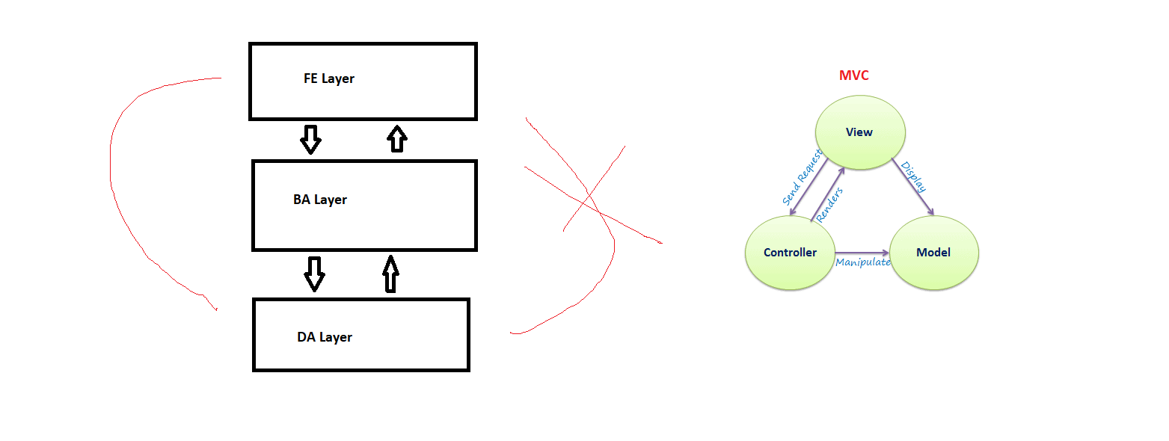

What is Controller ?

It is a class that inherits form Controller Class. It contains Action Methods

public ActionResult Index()

{

return View();

}

ActionResult is the return type

ActionResult is a abstract class

<https://www.tutorialspoint.com/asp.net_mvc/asp.net_mvc_life_cycle.htm>

<https://www.c-sharpcorner.com/UploadFile/00a8b7/Asp-Net-mvc-life-cycle/>

<https://www.dotnettricks.com/learn/mvc/aspnet-mvc-request-life-cycle>