What is Virtual Machine

Kernel shell in OS

Virtual Machine Container (Virtualization at OS level)

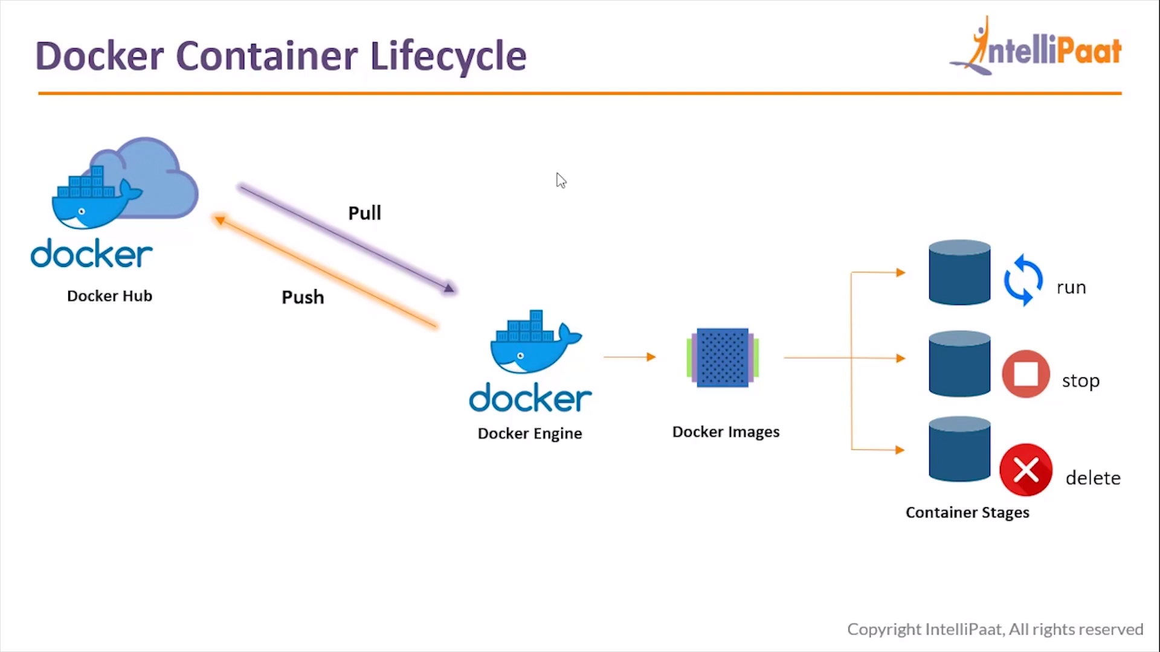

Life cycle of Container

You pull an image from docker hub. When you pull an image, we can create container/s from that image

Container is running

It is stopped

It is removed

**COMMON DOCKER COMMANDS**

**1:** This command helps you know the installed version of the docker software on your system

$ docker --version

docker -v

**2:** This command helps you pull images from the central docker repository.

$ docker pull <image-name>

3. This command helps you in listing all the docker images, downloaded on your system.

$ docker images

**4:** This command helps in running containers, from their image name.

$ docker run <image-name>

**5:** This command helps in listing all the containers which are running in the system

$ docker ps

**6:** If there are any stopped containers, they can be seen by adding the “-a” flag in this command

$ docker ps –a

**7:** For logging into/accessing the container, one can use the exec command

$ docker exec <container-id>

8. For stopping a running container, we use the “stop” command

$ docker stop <container-id>

**9:** This command kills the container by stopping its execution immediately. The difference

between ‘docker kill’ and ‘docker stop’. ‘docker stop’ gives the container time to shutdown

gracefully, in situations when it is taking too much time for getting the container to stop, one can opt to kill it

$ docker kill <container-id>

**10:** To remove a stopped container from the system, we use the “rm” command

$ docker rm <container-id>

**11:** To remove an image from the system we use the command “rmi”

$ docker rmi <image-id>

PUSHING THE CONTAINER ON DOCKERHUB

Step 1: The first step is to login, it can be done using the following command:

$ docker login

Step 2: Finally, for pushing your container on DockerHub, use the following command

$ docker push <username>/<container-id>

Step 3: You can verify the push on DockerHub

$ docker exec –it<container-id> bash

Now anyone, who wants to download this container. Can simply pass the following command:

docker pull containername/apache

-----------------------------

What is a Docker Hub?

[[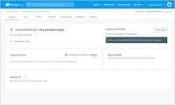](https://www.google.com/search?q=What+is+a+Docker+Hub?&rlz=1C1CHZL_enIN777IN777&sxsrf=AOaemvJvvbkkpoqLpAObgm7Ssk2j0k2VfA:1639371791594&tbm=isch&source=iu&ictx=1&fir=P1J8ai-Xlm_7wM%2C1U8m0TRe5rggeM%2C_&vet=1&usg=AI4_-kTWwhnSdaBLziEJmGkCcxwcoqCVqQ&sa=X&ved=2ahUKEwiyp6vq_9_0AhXRxDgGHS3DBqMQ9QF6BAgHEAE#imgrc=P1J8ai-Xlm_7wM)](https://www.google.com/search?q=What+is+a+Docker+Hub?&rlz=1C1CHZL_enIN777IN777&sxsrf=AOaemvJvvbkkpoqLpAObgm7Ssk2j0k2VfA:1639371791594&tbm=isch&source=iu&ictx=1&fir=P1J8ai-Xlm_7wM%252C1U8m0TRe5rggeM%252C_&vet=1&usg=AI4_-kTWwhnSdaBLziEJmGkCcxwcoqCVqQ&sa=X&ved=2ahUKEwiyp6vq_9_0AhXRxDgGHS3DBqMQ9QF6BAgHEAE" \l "imgrc=P1J8ai-Xlm_7wM)

Docker Hub is **a service provided by Docker for finding and sharing container images with your team**. ... Docker Hub provides the following major features: Repositories: Push and pull container images. Teams & Organizations: Manage access to private repositories of container images.

SAVING CHANGES TO A DOCKER CONTAINER

Step 1: Pull the docker image using the command:

$ docker pull Ubuntu

Step 2: Run the container using the commands

$ docker run –it –d Ubuntu

Step 3: Access the container using the command:

$ docker exec –it<container-id> bash

Step 4: Install apache2 on this container, using the following commands

$ apt-get update

$ apt-get install apache2

Step 5: Exit the container, and save the container using this command. The saved container will be converted into an image with the name specified is

$ docker commit <container-id> <username>/<container-name>

The username must match with the username which you created on dockerhub. The container-name name can be anything.

CREATING A DOCKERFILE

Step 1: First, create a folder docker, in the home directory

$ mkdir docker

Step 2: Enter into this directory, and create a file called ‘Dockerfile’, with the same contents as the Sample Dockerfile. Add the following content in the Dockerfile.

$ cd docker

$ sudo nano Dockerfile

FROM ubuntu

RUN apt-get update

RUN apt-get -y install apache2

ADD . /var/www/html

ENTRYPOINT apachectl -D FOREGROUND

ENV name Devops Learning

OR

FROM ubuntu

ENV TZ=Europe/Kiev

RUN ln -snf /usr/share/zoneinfo/$TZ /etc/localtime && echo $TZ > /etc/timezone

RUN apt-get update

RUN apt-get -y install apache2

ADD . /var/www/html

ENTRYPOINT apachectl -D FOREGROUND

ENV name Devops

Step 3: Create one more file called, index.html with the following contents can verify the push on DockerHub.

$ sudo nano index.html

<html>

<body>

Hello World

</body>

</html>

Step 4: Now pass the following command

$ docker build <directory-of-dockerfile> -t <name of image>

Sudo docker build . –t newimage

Step 5: Finally, run this built image, using the following command:

$ docker run –it –p 81:80 –d <name of container>

sudo docker run –it –p 81:80 –d newimage

Step 6: Now navigate to the server IP address on port 81

Step 7: Finally, login into the container, and check the variable $name, it will have the same value, as given in the Dockerfile.

Sudo docker run

sudo docker images

sudo docker pull nginx

sudo docker run --name docker-nginx -p 80:80 nginx

Check in Browser : 80

sudo docker rm docker-nginx

sudo docker run --name docker-nginx -p 80:80 -d nginx

sudo docker stop docker-nginx