HTML > Create Static Web Pages

CSS > Style your web pages , BootStrap

Javascript > It is a scripting language , make ur static web page interactive

How do you make your web application dynamic

1. At client side (javascript vbscript)
2. At server side (Asp.Net code , MVC)

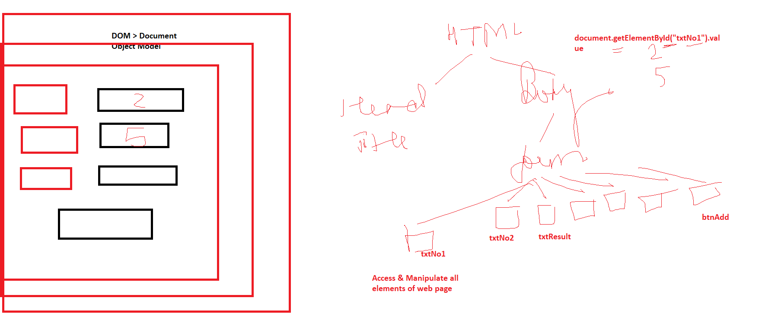

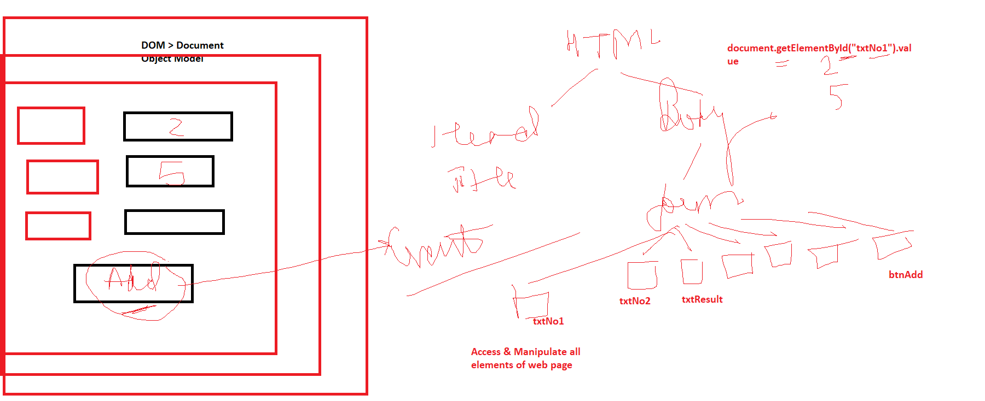

Statements

1. Sequential
2. Conditional (if else)
3. Repetitive (Loops)

Hoisting > Even if we use variables & declare them later, we are able to use them

Variable declaration part is moved or pushed to the top of the program