**Semantic HTML elements** are those that clearly describe their meaning in a human- and machine-readable way. **Elements** such as <header> , <footer> and <article> are all considered **semantic** because they accurately describe the purpose of the **element** and the type of content that is inside them.

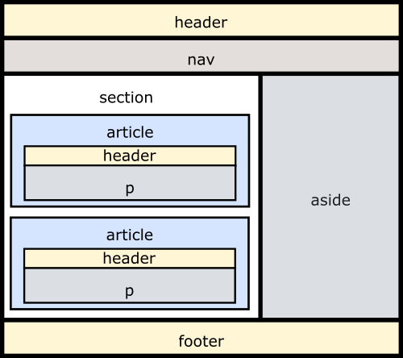

<!DOCTYPE html>

<html>

<head>

<!--<link href="style.css" rel="stylesheet" />-->

<meta charset="utf-8" />

<style>

* {

box-sizing: border-box;

}

div{

width : 300px;

height: 200px;

padding: 15px;

margin: 10px;

border : 5px solid red;

}

</style>

<title></title>

</head>

<body>

<div style="background-color:pink"> These are contents of Div 1 </div>

<div style="background-color:gray"> These are contents of Div 2 </div>

</body>

</html>

<DOCTYPE html>

<head>

<style>

input[type=text],[type=number] {

height:30px;

margin-left:200px;

}

input:required {

background-color: pink;

}

input:valid {

background-color: green;

}

input:invalid {

background-color: yellow;

}

input[type=submit] {

background-color: blue;

color: white;

width: 200px;

}

input {

background-color: red;

}

</style>

</head>

<body>

<form>

<fieldset>

<legend> Personal Info </legend>

<div>

<label for="name"> ENter Name </label>

<input type="text" id="name" maxlength="20" size="5" required/>

</div>

<div>

<label for="markseng"> Enter Marks of English </label>

<input type="number" id="markseng" min="0" max="100" />

</div>

<div>

<label for="markshindi"> Enter Marks of Hindi </label>

<input type="number" id="markshindi" min="0" max="100" />

</div>

</fieldset>

<br />

<fieldset>

<legend> Educational Info </legend>

<label for="name"> Enter Name </label>

<input type="text" id="name" name="name" required />

<br>

<label for="marks"> ENterMarksName </label>

<input type="number" id="marks" name="marks" min="0" max="100" />

<br>

<label for="marks"> ENterMarksName </label>

<input type="number" id="marks" name="marks" min="0" max="100" />

<br>

<br> <br> <br> <br>

Select Age : <input id="ageCategory" name="ageCategory" list="ageRanges" />

<datalist id="ageRanges">

<option value="Under Two's"></option>

<option value="2-7"> </option>

<option value="8-12"> </option>

<option value="13-17"> </option>

<option value="Adult"> </option>

</datalist>

<br>

<div id="carManufacturee">

<select id="carManufacturer">

<optgroup label="European">

<option value="volvo"> Volvo </option>

<option value="audi"> Audi </option>

</optgroup>

<optgroup label="American">

<option value="chrysler"> Chrysler </option>

<option value="ford"> Ford </option>

</optgroup>

</select>

</div>

<input id="orderRef" name="orderReference" type="text" pattern="[0-9]{2}[A-Z]{3}" title="2 digits and 3 uppercase letters" />

</fieldset>

<input type="submit" value="Submit" name="b1" id="b1"/>

</form>

</body>

<!DOCTYPE html>

<html>

<head>

<link href="main2.css" rel="stylesheet" />

<title></title>

</head>

<body>

<div>

<h1 class="header"> Welcome to LTI </h1>

</div>

<div class="topnav">

<ul>

<li> <a href="Htmlpage3.html"> Home </a></li>

<li> <a href="register1"> Register </a></li>

<li> <a href="login1"> Login </a></li>

<li> <img src="images/lti.jpg" style="float:right; height:80px; padding:20px; width:auto;" /> </li>

</ul>

</div>

<div class="main">

<div class="card">

<p>

Static Web Page : A page with no interaction

HTML : Hyper Text Markup Language

Which means it is made up of some tags

<h1> </h1>

Tags : Container Tags, Empty Tags

</p>

</div>

<div class="card">

<p>

Static Web Page : A page with no interaction

HTML : Hyper Text Markup Language

Which means it is made up of some tags

<h1> </h1>

Tags : Container Tags, Empty Tags

</p>

</div>

<div class="card">

<h1 style="text-align:center"> Our Bileifs </h1>

<div class="imagescr">

<img src="images/push-frontiers-of-innovation-237x300_robo.jpg" />

<p> Go to Extra Miles </p>

</div>

<div class="imagescr">

<img src="images/keep-learning-237x300.png" />

<p> Go to Extra Miles </p>

</div>

<div class="imagescr">

<img src="images/solve-for-society-237x300_new-237x300.png" />

<p> Go to Extra Miles </p>

</div>

<div class="imagescr">

<img src="images/extra-mile-237x300.png" />

<p> Go to Extra Miles </p>

</div>

<!--<div class="imagescr">

<img src="images/ceo.jpg" />

</div>-->

</div>

</div>

<div class="footer">

<p> 2020 LTI </p>

</div>

</body>

</html>