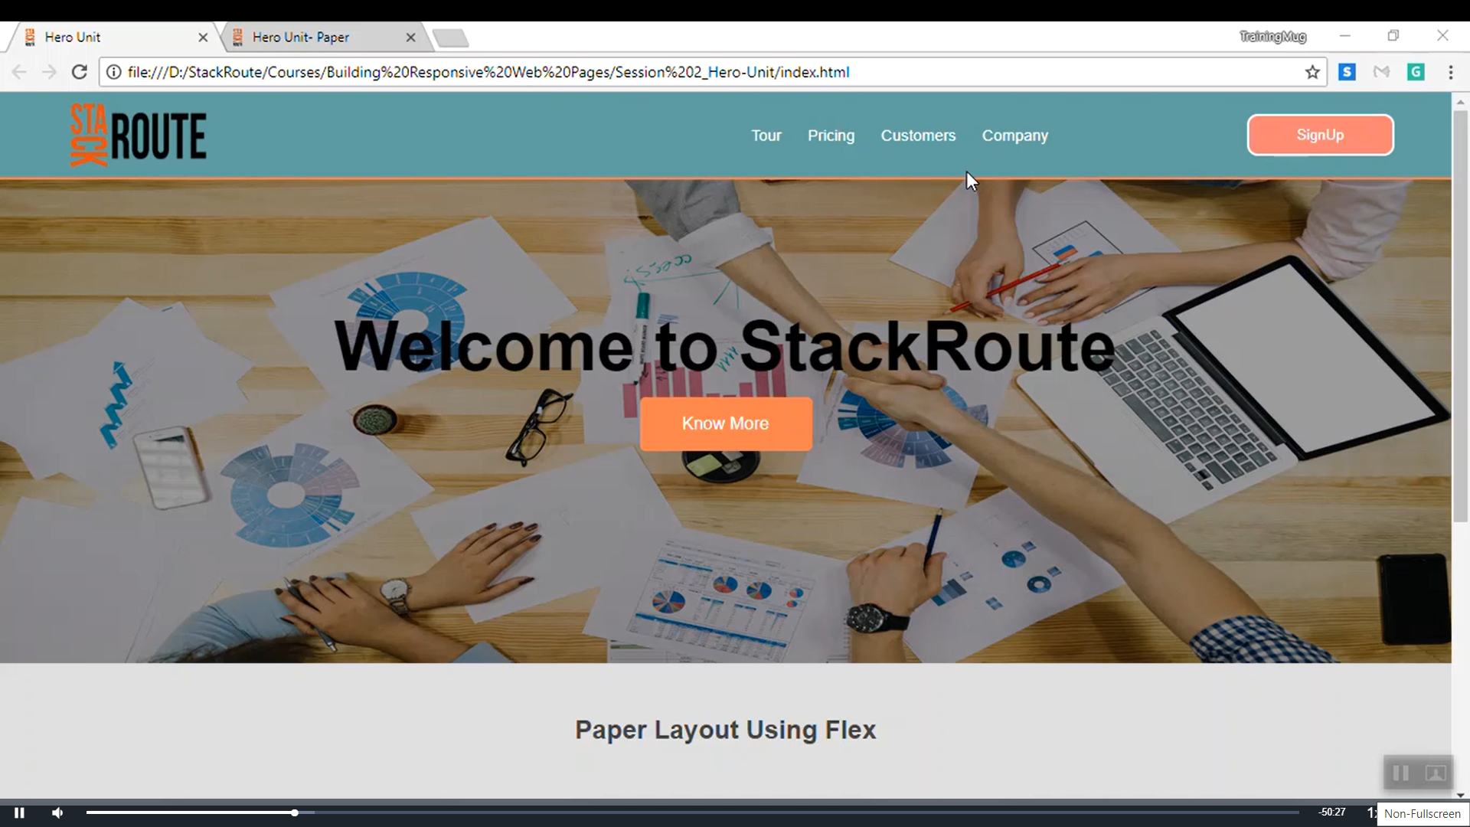

<!DOCTYPE html>

<html>

    <head>

        <title> Hero Unit Demo </title>

        <link href="style3.css" rel="stylesheet">

        </head>

<body>

    <header class="header-container">

        <div class="branding">

<img src="StackRoute.png"  style="align-self: center;">

        </div>

<nav class="nav-bar">

<ul>

    <li> <a href=""> Tour</a></li>

    <li> <a href=""> Pricing </a></li>

    <li> <a href=""> Customers </a></li>

    <li> <a href=""> Company</a></li>

</ul>

</nav>

<button class="signup"> Sign Up </button>

    </header>

</body>

</html>

<!DOCTYPE html>

<html>

    <head>

        <title> Hero Unit Demo </title>

        <link href="style3.css" rel="stylesheet">

        </head>

<body>

    <header class="header-container">

        <div class="branding">

<img src="StackRoute.png"  style="align-self: center;">

        </div>

<nav class="nav-bar">

<ul>

    <li> <a href=""> Tour</a></li>

    <li> <a href=""> Pricing </a></li>

    <li> <a href=""> Customers </a></li>

    <li> <a href=""> Company</a></li>

</ul>

</nav>

<button class="signup"> Sign Up </button>

    </header>

    <section class="hero-unit-section">

        <div class="hero-unit-mask">

            <h1> Welcome to StackRoute </h1>

            <a href="">Know More</a>

        </div>

    </section>

</body>

</html>