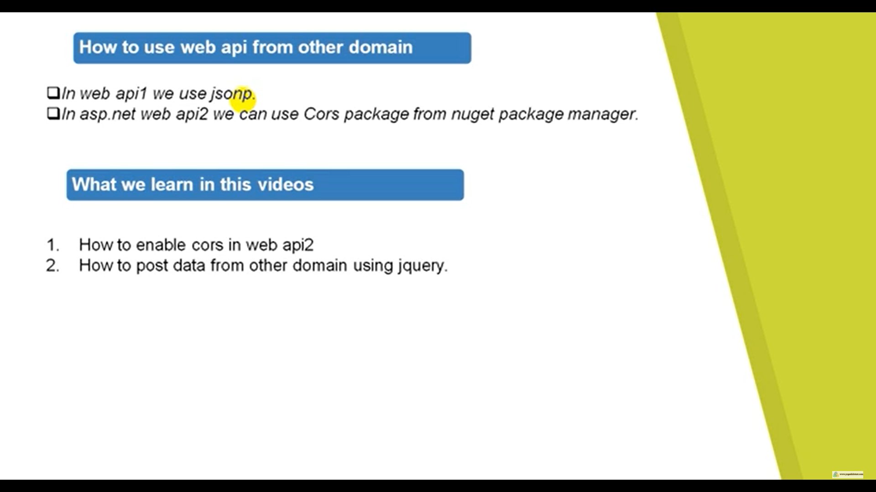

Make a MVC Application

Install JQuery Package if its not there

Enable CORS in web Api > Install Microsoft.AspNet.WebApi.Cors

services. AddCors(c =>

{

c. AddPolicy("AllowOrigin", options => options. AllowAnyOrigin());

});