When you provision a Vm in a Region , we select a region where to put a VM, then there is a option of AZ, AS

We are about to cover **Microsoft Azure’s** most important concepts **Region, Availability Zone, Availability Set, Fault Domain, and Update Domain,**and how it plays a key role in Virtual Machines. What is the SLA that Azure provide for ur VM deoendng upon the options that you select.

**Availability options menas how much uoptime I will get with ethat VM, No Infr means that if this achine fauils I have no other machine serving user request. We can select AZ, AS**

**Befire thatr w understand Architecture of Azure**

**On the top, weh have geographies geo are mage up of regions**

**Than we have vregions are mage up of AZones, AZ is nothing but collection of Data Csnters. Within a data centre, you have server rack. So lets assume you g=have a server rack, in which we have multiple servers, These server racks are called Fault domain. In the fault domains, we have update omains. When we keep outr machine in ASet, it keeps two machines in two A Set. Across two fault domains A Set means machine are in same datra centres.**

**These multiple data centers make A Zones. Within a regions we can have upto 3 A Zones. Every regions does not have multiple A Zones.**

The basic **Architecture** of the Azure can easily be understood by the following diagram

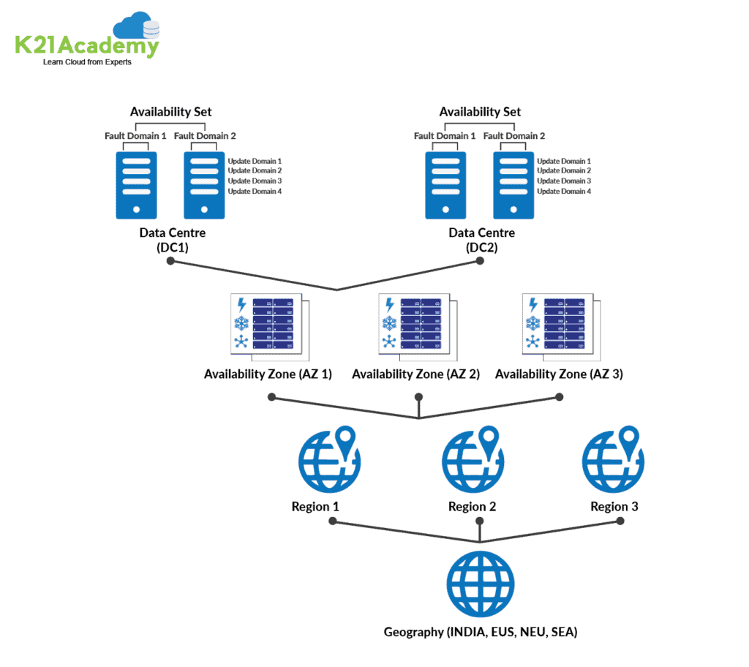

**Region**

A region is a set of data centers deployed within a latency-defined perimeter and connected through a dedicated regional low-latency network.

With more global regions than any other cloud provider, Azure gives customers the flexibility to deploy applications where they need to. Azure is generally available in 52 regions around the world, with plans announced for 6 additional regions.

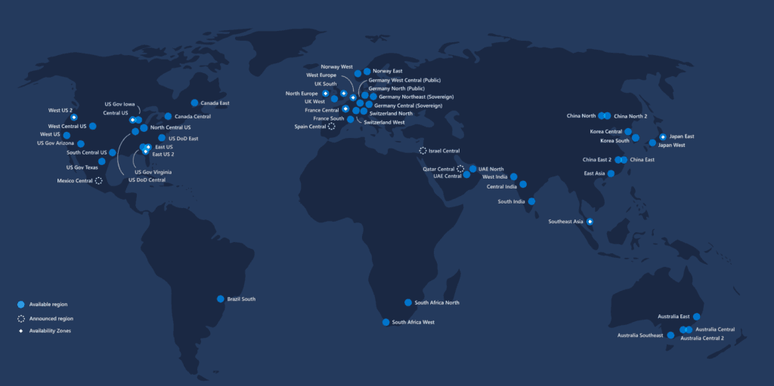

**Region Pairs**

* Each Azure region is paired with another region within the same geography, together making a regional pair.
* Azure serializes platform updates so only one region is updated at a time.
* Azure Regions in a Pair have direct connections that bring additional benefits to use them together.
* Each Azure Region in a pair is always located greater than 300 miles apart when possible.
* **Examples of region pairs** are West US paired with East US, South-East Asia paired with East Asia.

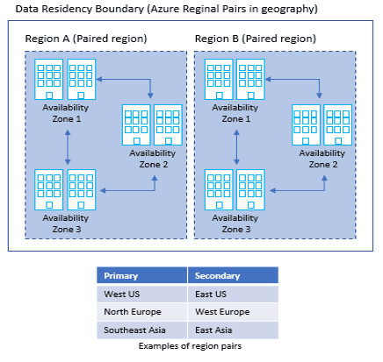

**Geographies**

Geography is a discrete market, typically containing two or more regions, that preserves data residency and compliance boundaries.

It allows customers with specific **data-residency** and compliance needs to keep their data and applications close. However, they are fault-tolerant to withstand complete region failure through their connection to our dedicated high-capacity networking infrastructure.

To know more about the Geography locations [refer here](https://azure.microsoft.com/en-in/global-infrastructure/geographies/)

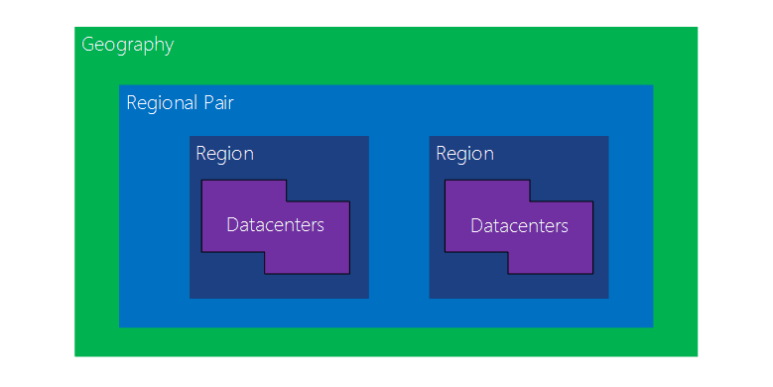

**Availability Zone**

* Availability Zones is a high-availability offering that protects your applications and data from datacenter failures.
* These are unique physical locations within an Azure region. Each zone is made up of one or more data centers equipped with independent **power**, **cooling**, and **networking**.
* The physical separation of Availability Zones within a region protects applications and data from datacenter failures.
* **Zone-redundant** services replicate your applications and data across Availability Zones to protect from single-points-of-failure.
* **Not every region has support for Availability Zones.** The **examples of Availability Zones** are Central US**,**East US 2, West US 2, West Europe, France Central, North Europe & Southeast Asia
* With **Availability Zones**, **Azure** offers industry best 99.99% VM uptime **SLA(Service Level Agreement)**

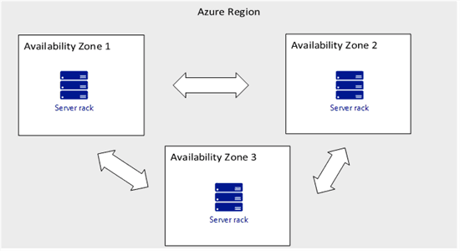

To achieve comprehensive business continuity on Azure, build your application architecture using the combination of Availability Zones with Azure region pairs.

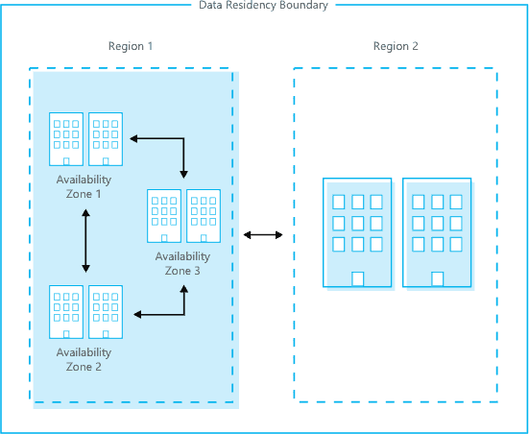

**Availability Set**

* An Availability Set is a logical grouping capability for isolating VM resources from each other when they’re deployed.
* By deploying your VMs across multiple hardware nodes Azure ensures that if hardware or software failure happens within Azure, only a sub-set of your virtual machines is impacted and your overall solution is safe and in working condition.
* It provides redundancy for your virtual machines.
* An Availability set spreads your virtual machines across multiple **fault domains** and**update domains.**
* If you want to leverage Microsoft’s 99.95% SLA from Microsoft you must place your VMs inside availability set except your VMs are having premium storage.

An **Update Domain** and **Fault Domain** is assigned to each VM in Availability Set by Azure platform.

**Fault Domain**

* Fault domains define the group of virtual machines that share a **common power source** and **network switch.**
* Each and every fault domain contains some racks and each rack contains a virtual machine.
* Each of these Fault domain shares a power supply and a network switch.
* All the resources in the fault domain become unavailable when there is a failure in the fault domain.
* You should place your VMs in such a way that each fault domain gets one web server, one database server, and like that.

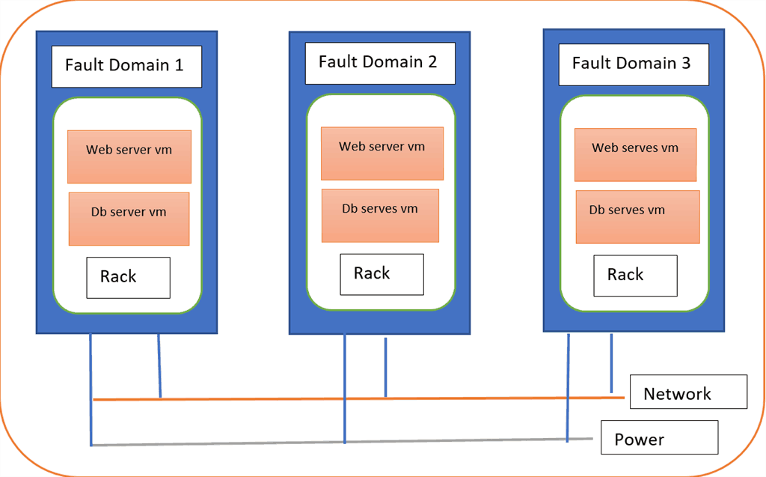

**Update Domain**

* Virtual machines get update domains automatically once they are put inside the availability set.
* All virtual machines within that update domain will reboot together.
* They are used for patching of the virtual machines.
* Only one update domain can be updated at the time.

**How many Fault Domains and How many Update Domains we can have?**

* In the Azure Service Management (ASM) portal, we have two Fault domains and 5 update domains.
* In the Azure Resource Manager(ARM) portal, we have three Fault domains and 5 update domains but we can upgrade our update domains from 5 to 20.
* VMs are assigned sequentially in the update domains and fault domains.

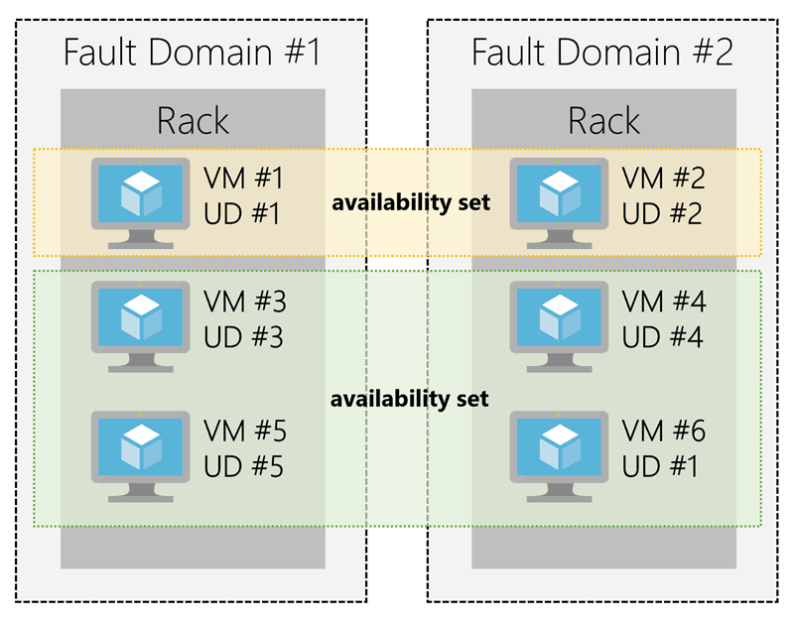

**Key Points To Remember**

* You need to create virtual machines in the same resource group as the availability set.
* Only one virtual machine can only be in one availability set.
* Virtual machines can be assigned availability set only during the creation of it.

**SLA(Service Level Agreement) for VM:**

* For all Virtual Machines that have two or more instances deployed in the same Availability Set, Azure guarantees you will have Virtual Machine Connectivity to at least one instance at least 99.95% of the time.
* For any Single Instance Virtual Machine using premium storage for all disks, Azure guarantees you will have Virtual Machine Connectivity of at least 99.9%.

