Any idea about DotNet Framework?

MS DOS > We were to remember the commands to perform basic functions

File Management

Copy source dest

Del filename

Rd dir

Then Win 3.1 came > GUI

Programming lang > C , C++, COBOL , PASCAL, BASIC , FOXPRO

They introduced Visual Effect into the Programming languages

Basic > Visual Basic

Foxpro > Visual Foxpro

C++ > Visual C++

They thought that why don’t we bring these dif languages under one platform > DotNet Platform

Main benefit of DotNet Framework > It supports multiple languages

 it supports more than 60 programming languages such as C#, F#, VB.NET, J#, VC++, JScript.NET, APL, COBOL, Perl, Oberon, ML, Pascal, Eiffel, Smalltalk, Python, Cobra, Ada, etc.

C# , Vb.Net



Framework > Collection of packages (namespaces) , classes



Components of DotNet Framework

1. CLR > Common Language Runtime (It’s a run time environment for DotNet Programs)
2. CTS > Common Type System
3. CLS > Common Language Specification
4. Base Libraries

Compilation > Converting a program from one lang to other lang

C++ , C , Java > Compilation happens on 1 step

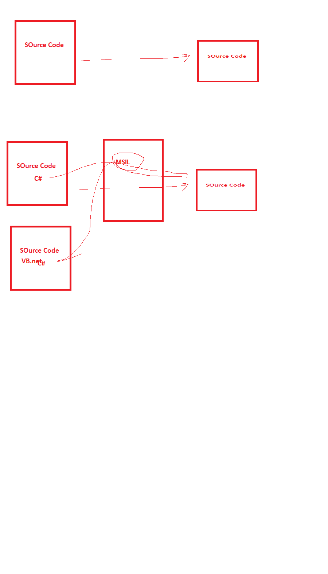

C# > Compilation happens on 2 steps

C# > C# compiler will convert program from C# to MSIL, this is a form which is understood by CLR

, after that CLR will compile that program to binary form using JIT compilation

JIT compilation > Complete program is not converted to binary form only, the statements needed at that time are converted to binary form

**Functions of CLR**

The heart of DotNet framework

1. Compiles your code from MSIL form to Binary Form
2. Garbage Collection
3. Memory Allocation
4. Type Safety
5. Code Security

CTS > Common Type System

CLS > Common Language Specification

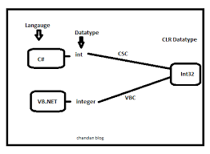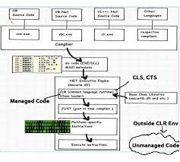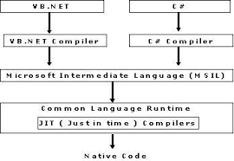

Managed Code > Code which is understood by CLR

UnManaged Code > Code which is not understood by CLR

Variables > Names given to memory locations where the values are stored

Int x

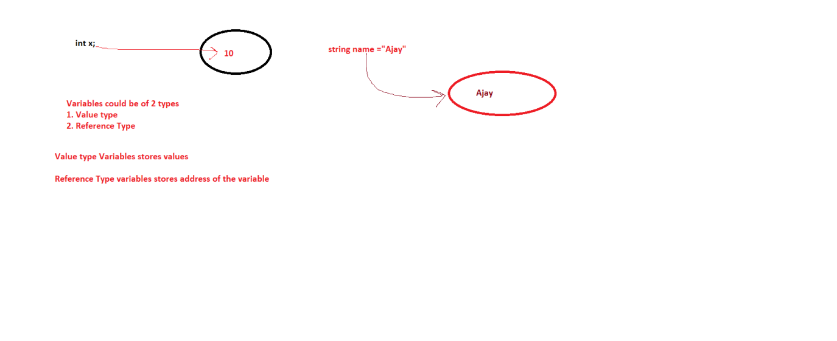

Compilation > Converts a lang from one form to other , compilation happens in 1 step

compilation

C > ----------------------- Binary Form

C++ > ----------------------- Binary Form

DotNet, compilation happens in 2 steps

C# compiler CLR (using JIT compilation)

C# > C# compiler > ----------------------- MSIL(Microsoft Intermediate Lang) -> -------------------------> Binary Form

VB Compiler CLR

VB.Net ---------------------------------------> MSIL-----------------------------------------------> Binary Form

CLR> Common Language Runtime (like JVM) CTS (Common Type System) CLS (Common Labuage Specification)

CLR > is the main component C# int System.Int32 Guidelines using which conversion happens

1. compilation of code from MSIL to binary form VB.Net number

2. It does memory allocation

3. Gargabe collection

4. It is the run time environment of Dotnet

