Visual Studio 2022 : Its an IDE > Integrated Development Environment

<https://visualstudio.microsoft.com/downloads/>

Language : Means of communication

Language has character set, grammer(syntax) , BUT LOGIC REMAINS SAME

Eng > A- Z , noun, pronoun, etc.

Programming language : Means of communication between system and human being

Language has character set, grammer(syntax), BUT LOGIC REMAINS SAME

C , C++ , Fortran , Pascal, COBOL, Visual Basic, Java, python, Javascript, C#

When you are communicating with system , you will write statements (program)

Different approaches are used whenever you are writing a program

1. Procedural Approach
2. Object Oriented Approach

**Using Procedural Approach (Step By Step)**

Students comes for enquiry

Counsellor handles enquiry

Students take admission

jjhgjhjkgjgjgjk

Trainer take classes

Trainer give tests

jgjghhghgh

Trainer check tests

Counsellor give certificate

**Using Object Oriented Approach**

**We start identifying the entities**

**How many entities will be there**

**What functions they will perform**

Student > Students comes for enquiry, Students take admission

Trainer > Trainer take classes,Trainer give tests,Trainer check tests, new task, new Task

Counsellor > Counsellor handles enquiry, Counsellor give certificate

The system that uses OOA has benefits

1. Are flexible
2. Easy to understand
3. Easy to maintain
4. Suitable for complex systems
5. Easy to test

**Concepts of OOP**

1. Class
2. Object
3. Polymorphism
4. Inheritance
5. Data Abstraction
6. Encapsulation
7. Data Hiding

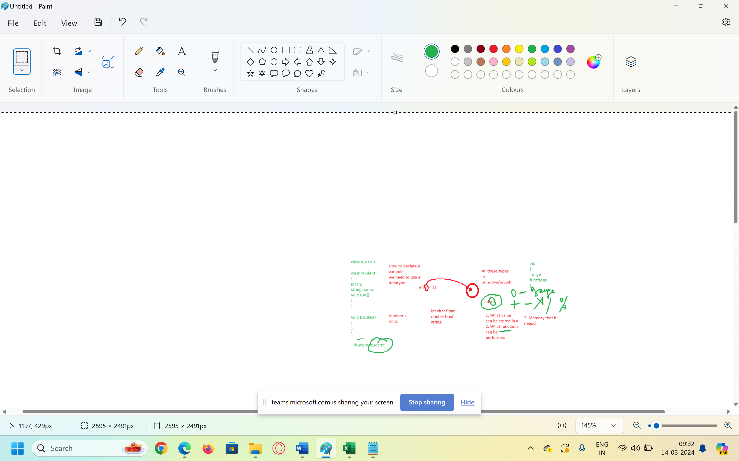

Variable > When we want to store some value in RAM, We need some location that will hold that value or some time

Int char float Boolean of some type

Inbuilt types

Int, Char, Float, double , bool

Class > Class is a user defined type OR it’s a blueprint based on which multiple objects of same type could be created

Data type : int , char , float

What does a type indicates(What data you can store, what functions we can perform on variable of that type)

Int > what data you can store (numbers)

+ , - * / % max()

Int x;

Int x;

Int x,y,z,a;

class student

{

Int rn;

String name;

Void get() {}

Void display() {}

}

2.Object > Variable of a class/ Instance of a class

Student student;

Int x;

1. Polymorphism > One name different forms
2. Inheritance > Deriving features of one class into other class
3. Encapsulation > Hiding details which are not needed by the user
4. Abstraction > Showing details which are needed by the user

How do we achieve them > By using Access Specifiers

Private, public, internal ,protected , Internal protected

Variables are stored as value OR as reference

Value Type Variables > int , char , float , bool, enum, struct

Reference Type variables > string, Array, class

