// Commaand Line Arguments are those arguments which are passed to the Main method

using System;

using System.Collections.Generic;

using System.Linq;

using System.Text;

using System.Threading.Tasks;

namespace SMSProject

{

class Program

{

static void Main(string[] args)

{

for(int i=0;i<args.Length;i++)

Console.WriteLine(args[i]);

Console.WriteLine("Hello");

}

}

}

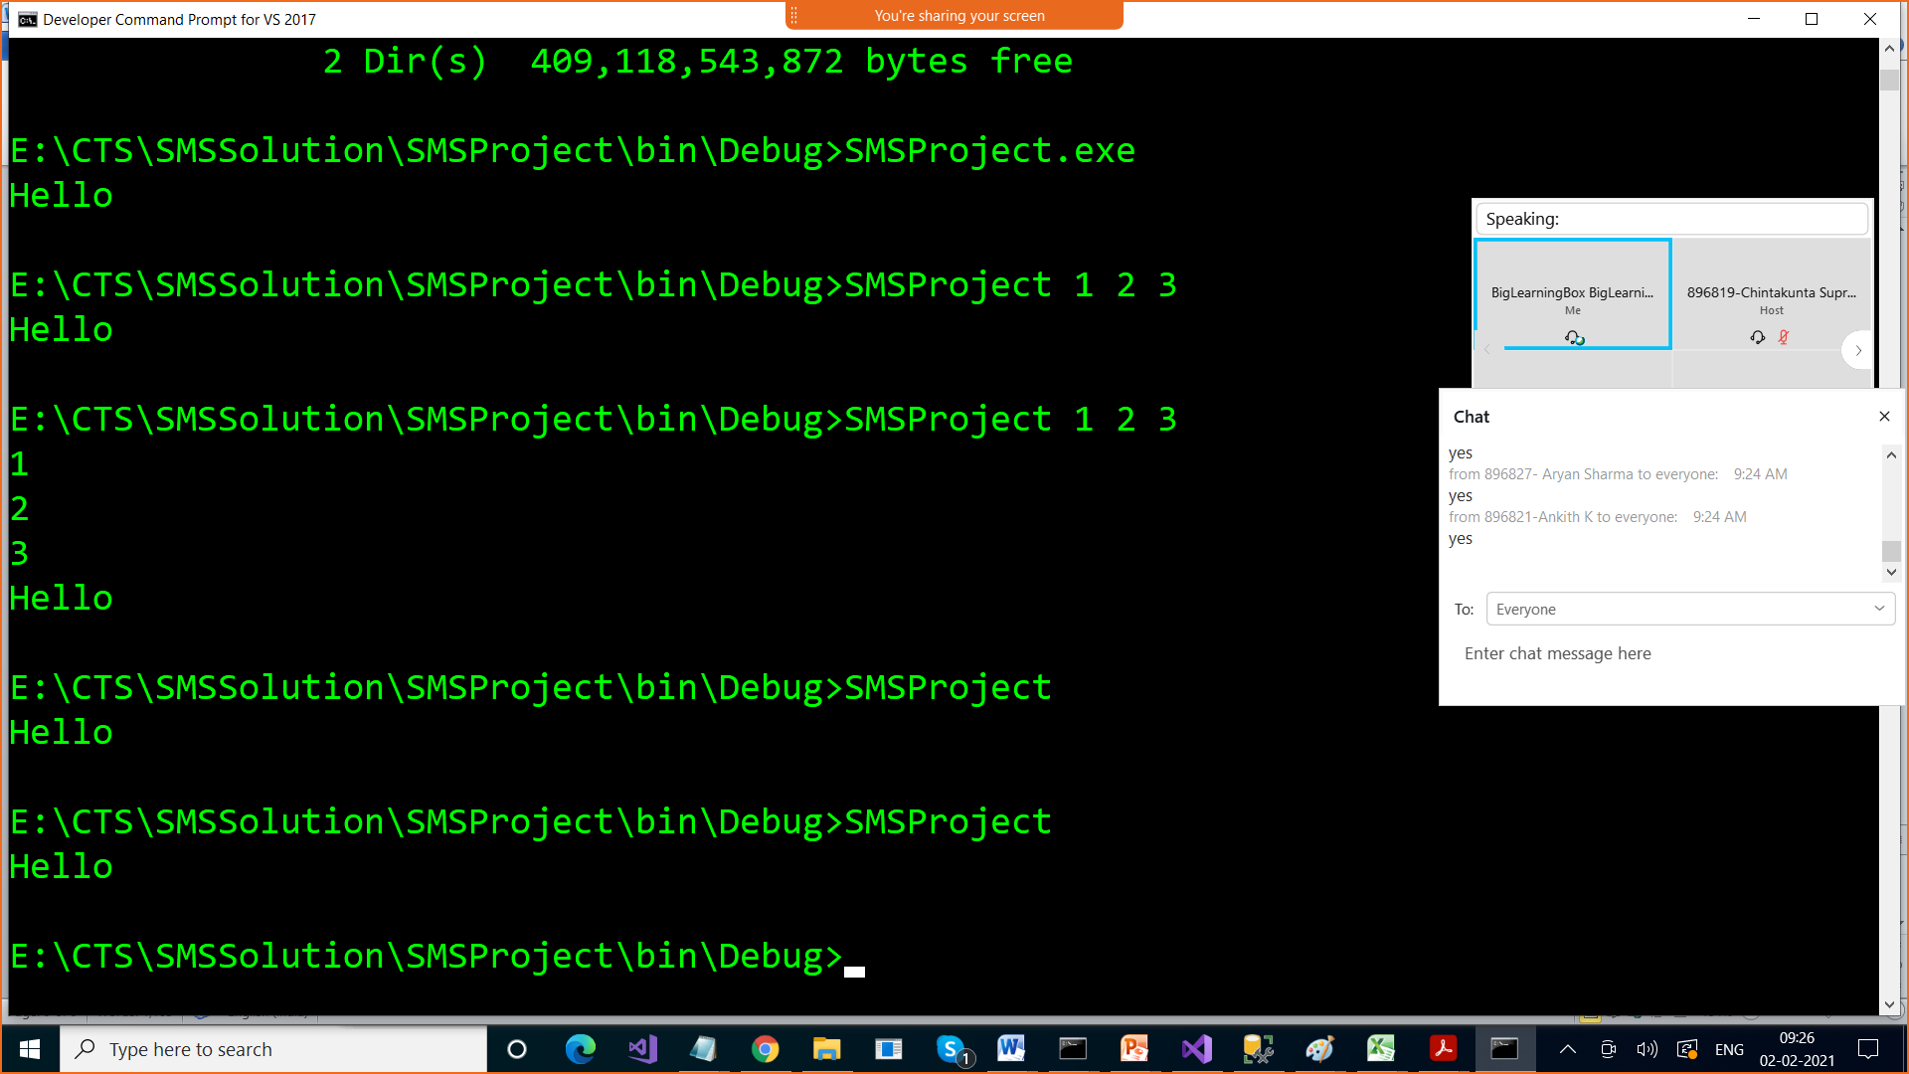

Inheritance : Deriving features of one class to other class

The class from which we derive features is k.a parent class / super class /base class

The class into which features are derived is k.a child class / sub class / derived class

Advantage :Code Reusability , reduces efforts, cost

Syntax for Inheritance :

class base {}

class child class : base class

Types of Inheritance

1. Single Inheritance

A

4. Multiple Inheritance / Hybrid Inheritance : More than 1 class into single class

This is not supported in C# through classes because of Ambiguity problem

Diamond problem

The "**diamond problem**" (sometimes referred to as the "Deadly **Diamond** of Death") is an ambiguity that arises when two classes B and C **inherit** from A, and class D **inherits** from both B and C. ... It is called the "**diamond problem**" because of the shape of the class **inheritance** diagram in this situation.

This problem is solved through Interface

B

1. Multilevel Inheritance

A

B

C

A

3. Hierarchial Inheritance

B

C

3.