Inheritance > It Is used to derive features of one class to other

Class from which features are derived is called Base Class / Parent Class / Super Class

Class from which features are derived is called Derived Class / Child Class / Sub Class

**What is the purpose of Inheritance > REUSABLITY**

Syntax :

Clas baseclass {}

Class childclass **:** baseclass{}

Type of Inheritance

1. Single Inheritance
2. Multilevel
3. Multiple ( Not supported with classes)
4. Hierarchial
5. Hybrid (Not supported with classes)

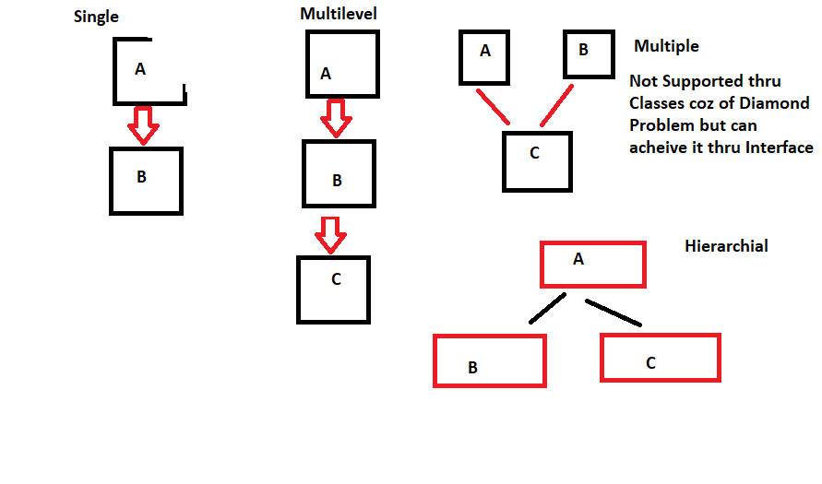

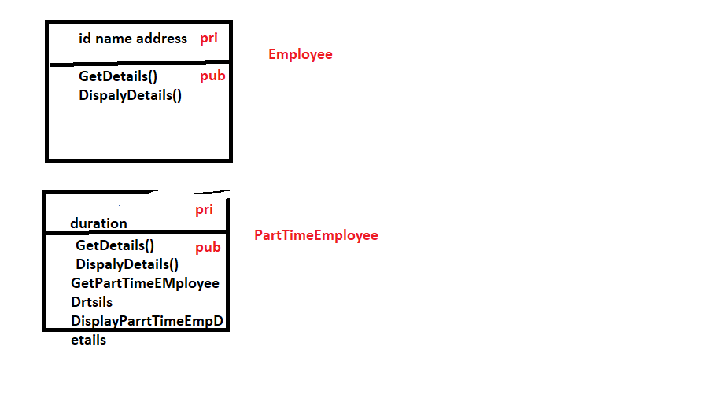

Method Overriding > Overriding / Overwriting methods of base or parent class in child class

Signature remains same