Contracts : Agreement between two parties / Service & client

Interface : It contains all the methods that we are exposing to the client

It contains method declaration

Svc Class : interface

We need to define all the methods

[ServiceContract]

When we are declaring interface

Methods , we will decorate with OperationContract

To expose service to the clients, what do we need > We need to define endpoints

Endpoints > ABC

A > Address , where service is available

B > Binding > Which protocol to be used , which binding to be used

C> Contract > which interface to be exposed to the client through this endpoint

Binding defines 2 things > Protocol (HTTP , HTTPS, TCP , MSMQ, NAMED PIPES)

Which Encoding scheme to be used , XML , Binary , UTF

& other features , security, reliability , communication way, transaction

<system.serviceModel>

<behaviors>

<serviceBehaviors>

<behavior>

<!-- To avoid disclosing metadata information, set the values below to false before deployment -->

<serviceMetadata httpGetEnabled="true" httpsGetEnabled="true"/>

<!-- To receive exception details in faults for debugging purposes, set the value below to true. Set to false before deployment to avoid disclosing exception information -->

<serviceDebug includeExceptionDetailInFaults="false"/>

</behavior>

</serviceBehaviors>

</behaviors>

<protocolMapping>

<add binding="basicHttpsBinding" scheme="https" />

</protocolMapping>

<serviceHostingEnvironment aspNetCompatibilityEnabled="true" multipleSiteBindingsEnabled="true" />

</system.serviceModel>

We have defined one endpoint for servive

<services>

<service name="WcfService5.MathsService">

<endpoint address="basic1" binding="basicHttpBinding"

contract="WcfService5.IMathsService">

</endpoint>

</service>

Service name > Namespace.ClassName

Contract > Namespace.InterfaceName

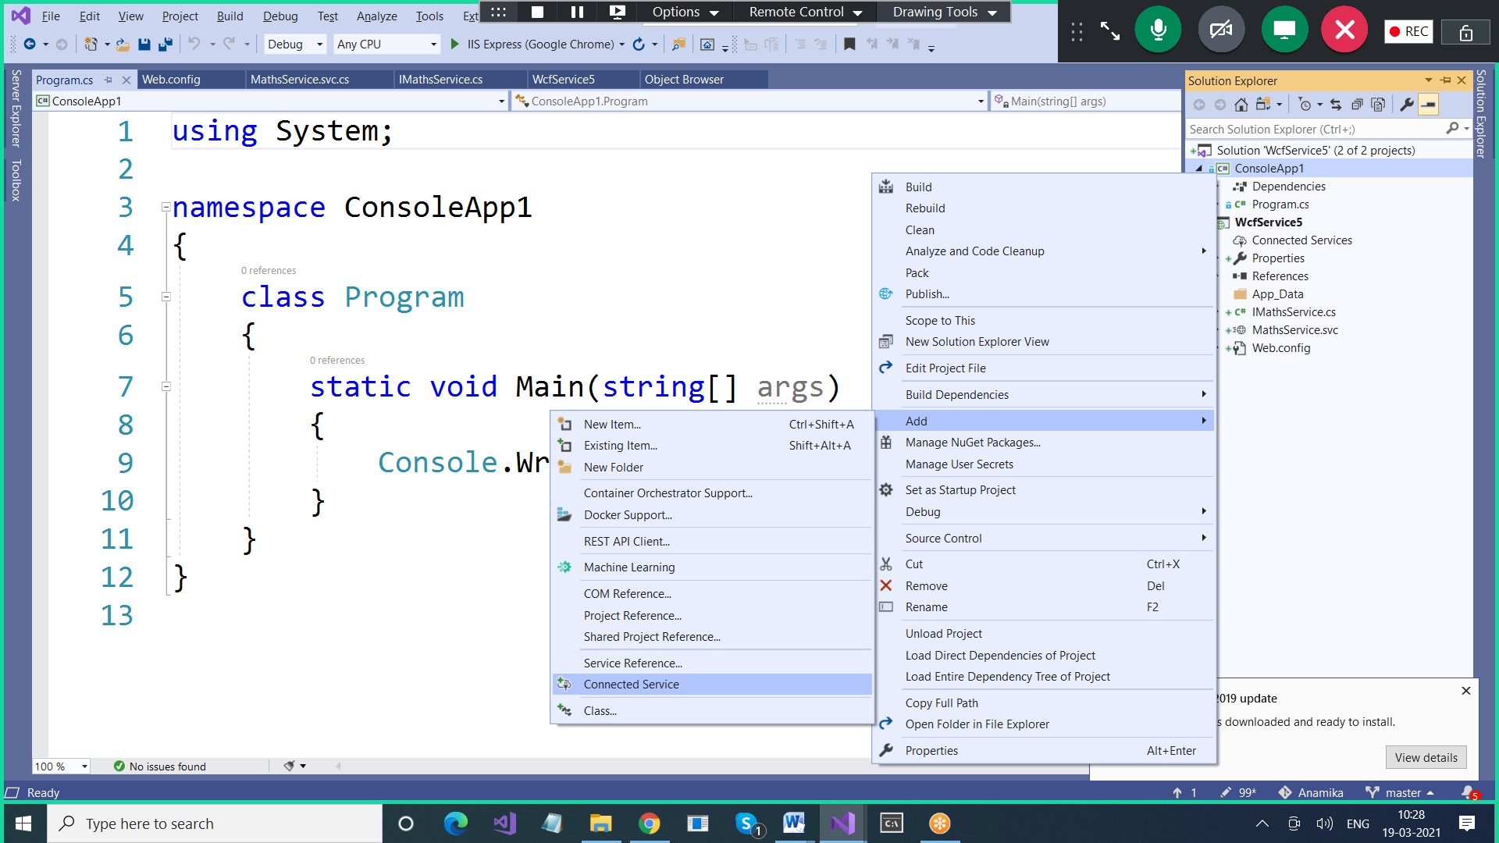

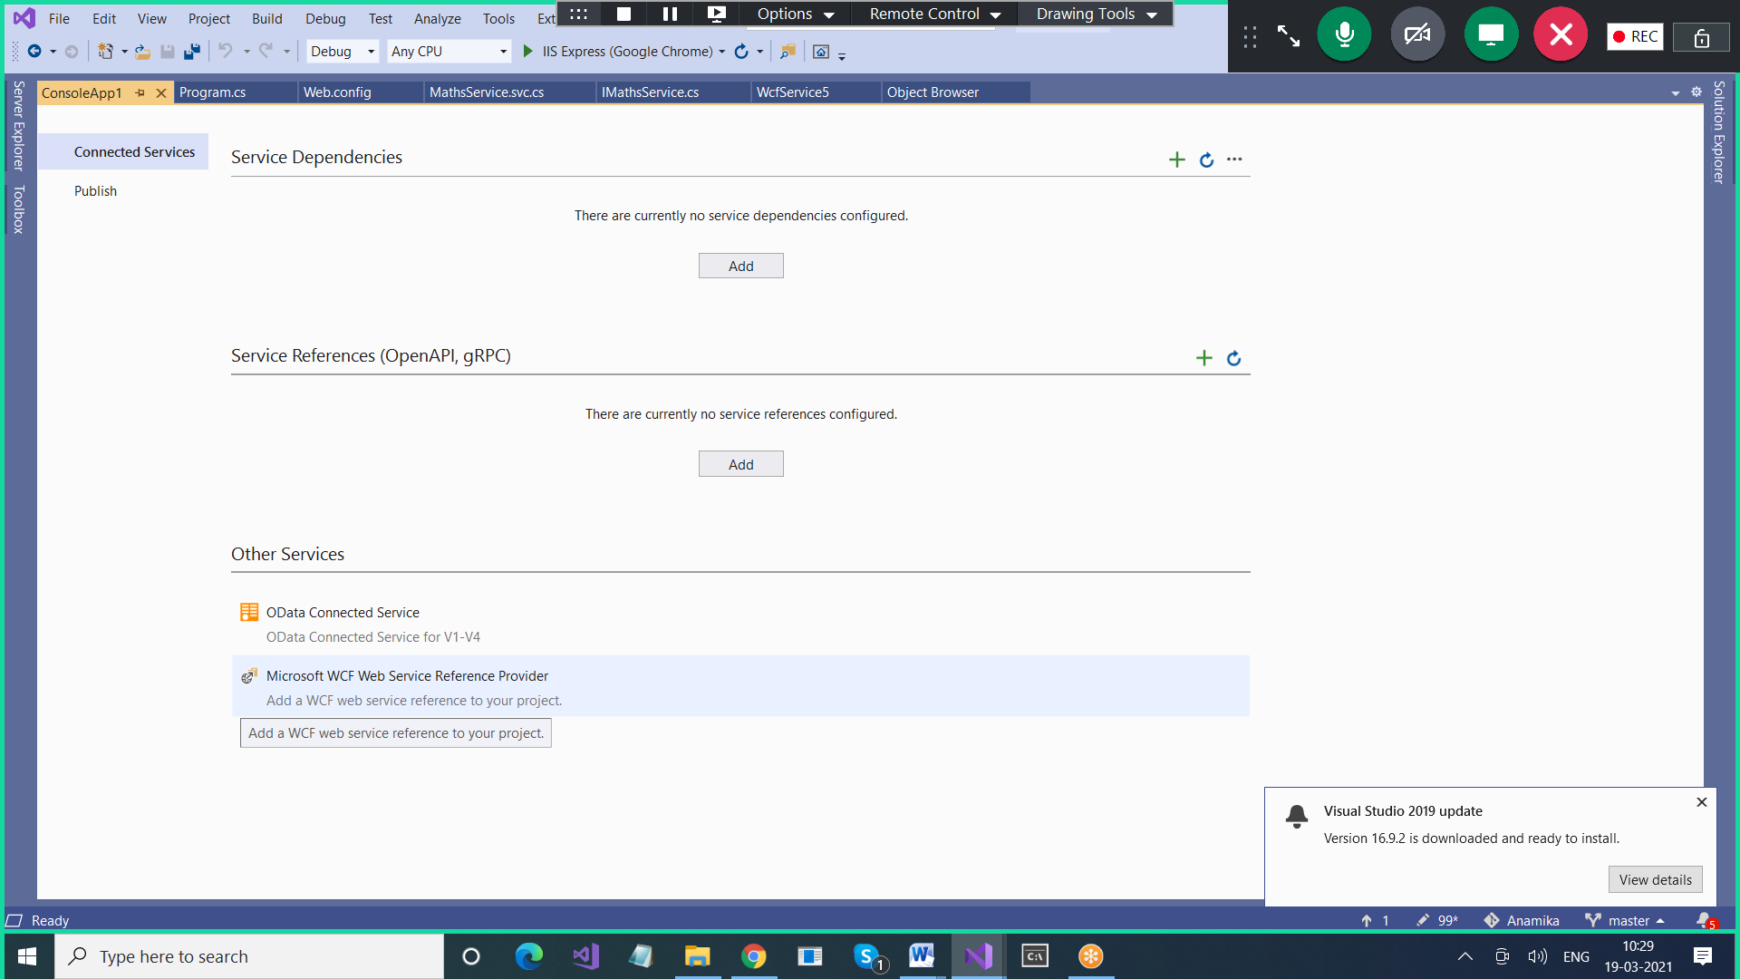

<?xml version="1.0"?>

<configuration>

<appSettings>

<add key="aspnet:UseTaskFriendlySynchronizationContext" value="true" />

</appSettings>

<system.web>

<compilation debug="true" targetFramework="4.7.2" />

<httpRuntime targetFramework="4.7.2"/>

</system.web>

<system.serviceModel>

<services>

<service name="WcfService5.MathsService">

<endpoint address="basic1" binding="basicHttpBinding"

contract="WcfService5.IMathsService">

</endpoint>

<endpoint address="basic1" binding="basicHttpBinding"

contract="WcfService5.IMathsService2"></endpoint>

</service>

</services>

<behaviors>

<serviceBehaviors>

<behavior>

<!--To avoid disclosing metadata information, set the values below to false before deployment-->

<serviceMetadata httpGetEnabled="true" httpsGetEnabled="true"/>

<!--To receive exception details in faults for debugging purposes, set the value below to true. Set to false before deployment to avoid disclosing exception information-->

<serviceDebug includeExceptionDetailInFaults="false"/>

</behavior>

</serviceBehaviors>

</behaviors>

<protocolMapping>

<add binding="basicHttpsBinding" scheme="https" />

</protocolMapping>

<serviceHostingEnvironment aspNetCompatibilityEnabled="true" multipleSiteBindingsEnabled="true" />

</system.serviceModel>

<system.webServer>

<modules runAllManagedModulesForAllRequests="true"/>

<!--

To browse web app root directory during debugging, set the value below to true.

Set to false before deployment to avoid disclosing web app folder information.

-->

<directoryBrowse enabled="true"/>

</system.webServer>

</configuration>