C:\Program Files (x86)\Microsoft Visual Studio\2019\Community\Common7\IDE

Bindings in WCF

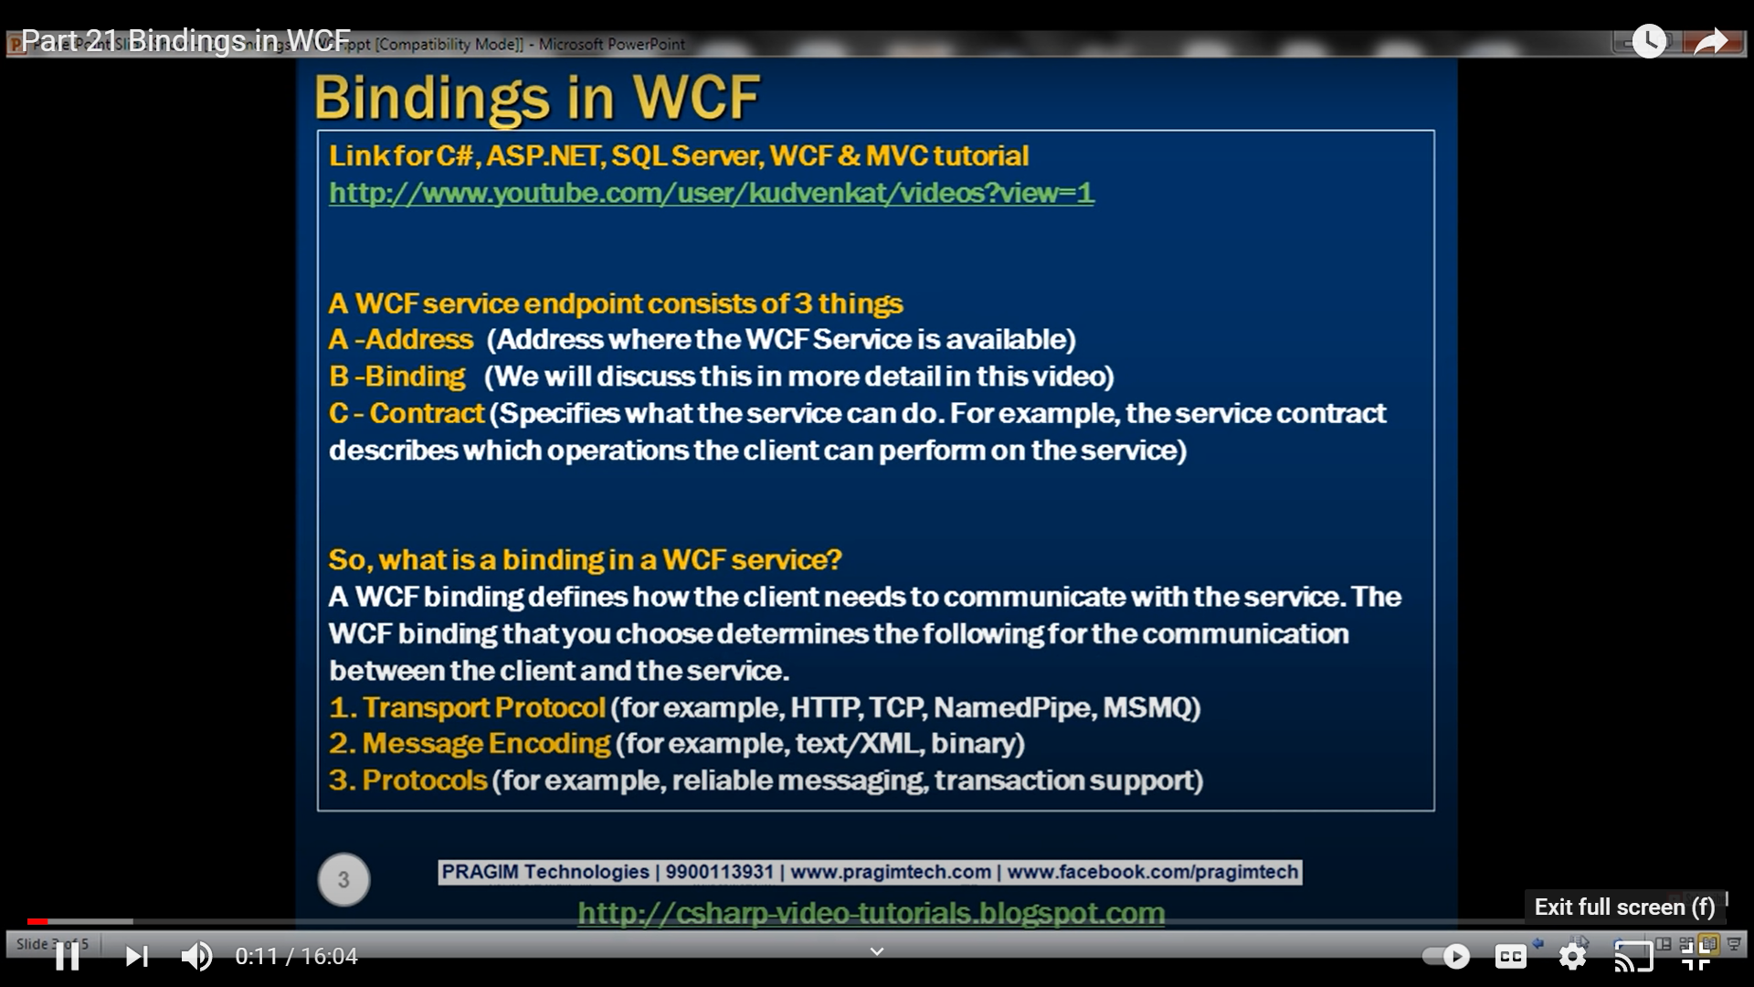

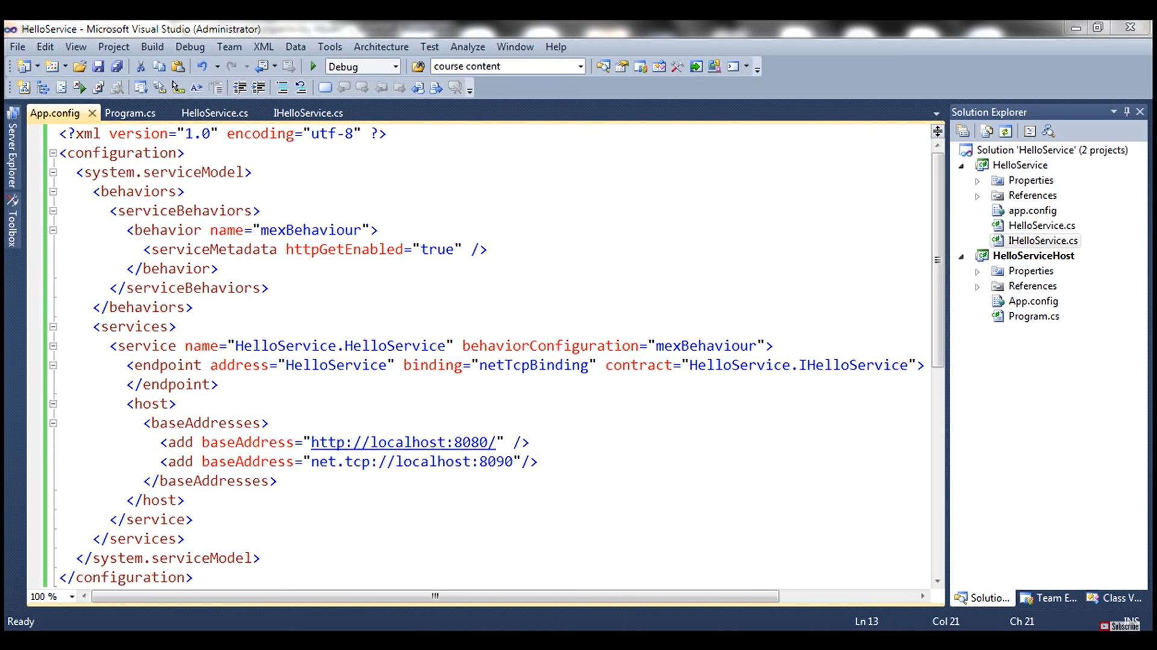

<?xml version="1.0"?>

<configuration>

<appSettings>

<add key="aspnet:UseTaskFriendlySynchronizationContext" value="true" />

</appSettings>

<system.web>

<compilation debug="true" targetFramework="4.7.2" />

<httpRuntime targetFramework="4.7.2"/>

</system.web>

<system.webServer>

<modules runAllManagedModulesForAllRequests="true"/>

<!--

To browse web app root directory during debugging, set the value below to true.

Set to false before deployment to avoid disclosing web app folder information.

-->

<directoryBrowse enabled="true"/>

</system.webServer>

<system.serviceModel>

<behaviors>

<serviceBehaviors>

<behavior name="">

**<serviceMetadata httpGetEnabled="true" httpsGetEnabled="true" />**

**<serviceDebug includeExceptionDetailInFaults="false" />**

</behavior>

</serviceBehaviors>

</behaviors>

<serviceHostingEnvironment aspNetCompatibilityEnabled="true"

multipleSiteBindingsEnabled="true" />

</system.serviceModel>

</configuration>

<system.serviceModel>

<behaviors>

<serviceBehaviors>

<behavior>

<!-- To avoid disclosing metadata information, set the values below to false before deployment -->

<serviceMetadata httpGetEnabled="true" httpsGetEnabled="true"/>

<!-- To receive exception details in faults for debugging purposes, set the value below to true. Set to false before deployment to avoid disclosing exception information -->

<serviceDebug includeExceptionDetailInFaults="false"/>

</behavior>

</serviceBehaviors>

</behaviors>

<protocolMapping>

<add binding="basicHttpsBinding" scheme="https" />

</protocolMapping>

<serviceHostingEnvironment aspNetCompatibilityEnabled="true" multipleSiteBindingsEnabled="true" />

</system.serviceModel>

<system.ServiceModel>

<services>

<!-- Define the service endpoints. This section is optional in the new

default configuration model in .NET Framework 4. -->

<service>

<endpoint/>

</service>

</services>

<bindings>

<!-- Specify one or more of the system-provided binding elements,

for example, <basicHttpBinding> -->

<!-- Alternatively, <customBinding> elements. -->

<binding>

<!-- For example, a <BasicHttpBinding> element. -->

</binding>

</bindings>

<behaviors>

<!-- One or more of the system-provided or custom behavior elements. -->

<behavior>

<!-- For example, a <throttling> element. -->

</behavior>

</behaviors>

</system.ServiceModel>

