Internet is a global communication system that links together thousands of individual networks. It allows exchange of information between two or more computers on a network. Thus internet helps in transfer of messages through mail, chat, video & audio conference, etc. It has become mandatory for day-to-day activities: bills payment, online shopping and surfing, tutoring, working, communicating with peers, etc.

Millions of people around the world use the Internet for communication, research, business, information, and recreation. One of the most popular and effective ways to tap into its resources is through the World Wide Web, a vast collection of information connected like a web.  
  
There is no beginning or end; the information is accessible in a nonlinear fashion through connections called hyperlinks. You view the resources on the Web by using a program called a Web browser. You navigate through the Web by pointing to hyperlinks (underlined or boldfaced words or phrases, icons, or images) and clicking. To use the Web and the Internet effectively, you need to know how to find and use the services, tools, and programs that give you access to their resources.  
It’s possible to link information in almost any digital form on the World Wide Web. Text files, programs, charts, images, graphics files, digitized video, and sound files are all available. Not only can you find things from a variety of media, but you also get a great deal of information in many categories or topics.  
  
When using the Web, you work in a hypertext or hypermedia environment. A Uniform Resource Locator, or URL, specifies items, services, and resources. Web browsers use these URLs to specify the type of Internet service or protocol needed and the location of the item. For example, the URL for the Web page General Collections Library of Congress is http://www.loc.gov/rr/coll-general.html. The protocol or service in this case is HTTP, or Hypertext Transfer Protocol, and a Web browser using that URL would contact the Internet site www.loc.gov and access the file coll-general.html in the directory or folder named rr. The documents on the Web are called Web pages.  
  
A number of different types of information sources are available on the World Wide Web. They include:

* Directories of selected collections of Internet and Web resources, arranged by subject
* Search engines, which are tools that provide keyword searching capability
* Meta-search tools, which allow you to access databases from one place
* Specialized databases, which contain comprehensive collections of hyperlinks in a particular subject area, or which are self-contained, searchable indexes made available on the Web
* Discussion groups, of which several thousand groups exist to share opinions and experiences, ask and answer questions, or post information about a specific topic
* Blogs, wikis, and tagged collections, enabling individuals to easily classify and put information on the Web.

Internet is called the network of networks. It is a global communication system that links together thousands of individual networks. In other words, internet is a collection of interlinked computer networks, connected by copper wires, fiber-optic cables, wireless connections, etc. As a result, a computer can virtually connect to other computers in any network. These connections allow users to interchange messages, to communicate in real time (getting instant messages and responses), to share data and programs and to access limitless information.

Basics of Internet Architecture

Internet architecture is a meta-network, which refers to a congregation of thousands of distinct networks interacting with a common protocol. In simple terms, it is referred as an internetwork that is connected using protocols. Protocol used is TCP/IP. This protocol connects any two networks that differ in hardware, software and design.

Process

TCP/IP provides end to end transmission, i.e., each and every node on one network has the ability to communicate with any other node on the network.

Layers of Internet Architecture

Internet architecture consists of three layers −

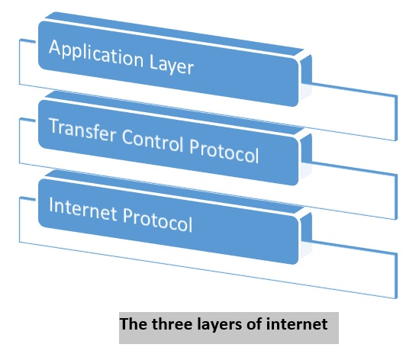

### IP

In order to communicate, we need our data to be encapsulated as Internet Protocol (IP) packets. These IP packets travel across number of hosts in a network through routing to reach the destination. However IP does not support error detection and error recovery, and is incapable of detecting loss of packets.

### TCP

TCP stands for "Transmission Control Protocol". It provides end to end transmission of data, i.e., from source to destination. It is a very complex protocol as it supports recovery of lost packets.

### Application Protocol

Third layer in internet architecture is the application layer which has different protocols on which the internet services are built. Some of the examples of internet services include email (SMTP facilitates email feature), file transfer (FTP facilitates file transfer feature), etc.

**Different Types of Networking Protocols**

* HTTP or HTTPs. This stands for Hypertext **Transfer** Protocol or Hypertext **Transfer** Protocol (secure). ...
* FTP (File **Transfer** Protocol) ...
* Email Protocols (POP3, IMAP, SMTP) ...
* TCP(Transmission Control Protocol) and UDP(User Datagram Protocol)

**TCP and IP** are two separate computer network protocols. **IP** is the part that obtains the address to which data is sent. **TCP** is responsible for data delivery once that **IP** address has been found.