Flexbox is a one-dimensional layout method for laying out items in rows or columns

It’s a better way to align items into a container

Flexbox = flexible + box

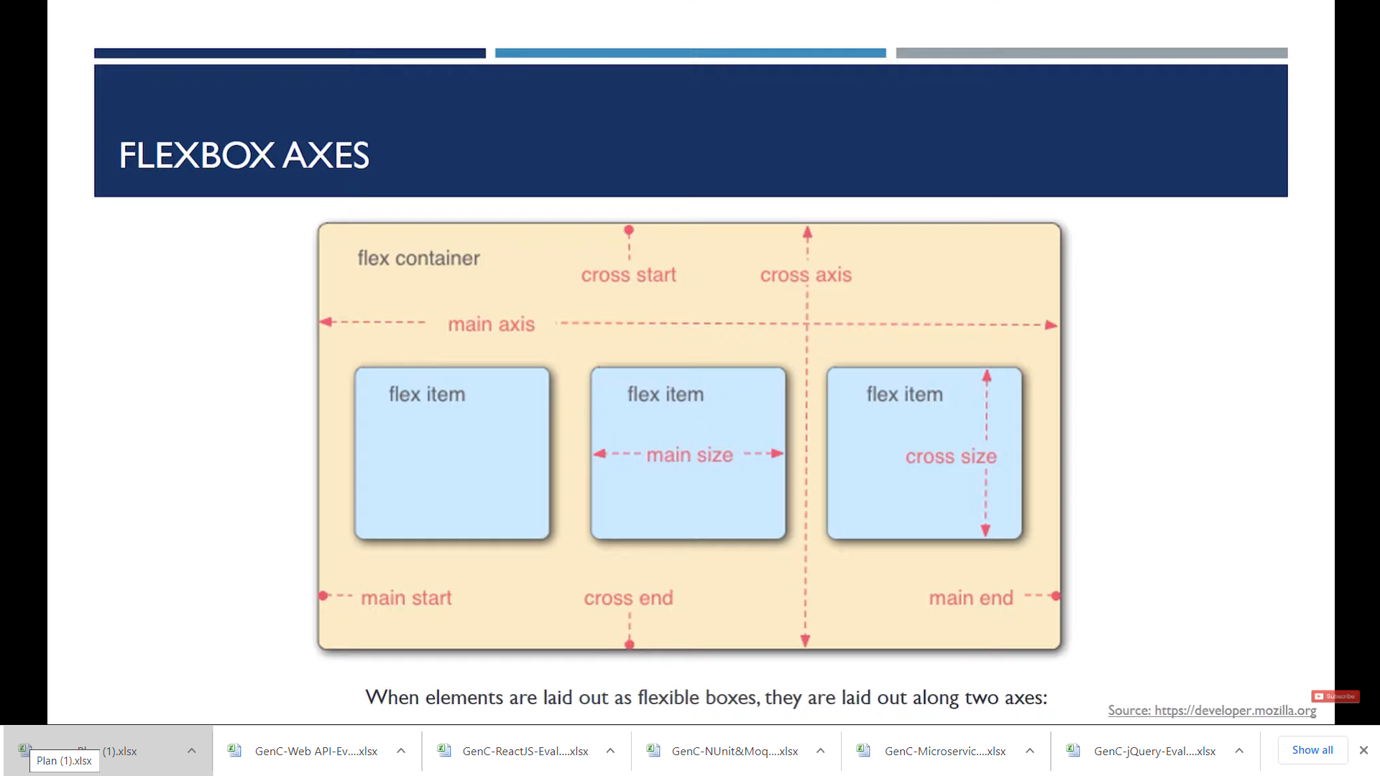

**<!DOCTYPE html>**

**<html>**

**<head>**

**<meta charset="utf-8" />**

**<title>FlexBox Demo</title>**

**<style>**

**.container**

**{**

**height:544px;**

**width:100%;**

**border:2px solid black;**

**display:flex;**

**/* flex-direction:column;*/**

**/* flex-direction:row-reverse;**

**\*/ /* flex-direction:column-reverse;*/**

**/* flex-wrap: wrap;*/**

**justify-content:center;**

**justify-content:space-between;**

**align-items:center;**

**}**

**#item-1 {**

**/* Flex properties for a flex item */**

**/* Higher the order, later it shows up in the container */**

**/* order: 2; */**

**/* flex-grow: 2;**

**flex-shrink: 2; */**

**}**

**#item-2 {**

**order:100;**

**flex-grow: 3;**

**/* flex-shrink: 3 ;**

**flex-basis: 160px;**

**/* when flex-direction is set to row flex-basis: will control width */**

**/* when flex-direction is set to column flex-basis: will control height */**

**}**

**#item-3 {**

**/* flex: 2 2 230px; */**

**align-self: flex-start;**

**align-self: flex-end;**

**align-self: center;**

**}**

**.item**

**{**

**height:100px;**

**width:100px;**

**background-color:tomato;**

**border:2px solid red;**

**margin:10px;**

**padding:10px;**

**}**

**</style>**

**</head>**

**<body>**

**<h1> Flex Demo </h1>**

**<div class="container">**

**<div class="item" id="item-1"> First Box</div>**

**<div class="item" id="item-2"> Second Box</div>**

**<div class="item" id="item-3">Third Box</div>**

**<div class="item" id="item-4">Fourth Box</div>**

**<div class="item" id="item-5">Fifth Box</div>**

**<div class="item" id="item-6">Sixth Box </div>**

**</div>**

**</body>**

**</html>**

<!DOCTYPE html>

<html>

<head>

<meta charset="utf-8" />

<title>FlexBox Demo</title>

<style>

.container

{

height:544px;

width:100%;

border:2px solid black;

}

.item

{

background-color:tomato;

border:2px solid red;

margin:10px;

padding:10px;

}

</style>

</head>

<body>

<h1> Flex Demo </h1>

<div class="container">

<div class="item" id="item-1"> First Box</div>

<div class="item" id="item-2"> Second Box</div>

<div class="item" id="item-3">Third Box</div>

<div class="item" id="item-4">Fourth Box</div>

<div class="item" id="item-5">Fifth Box</div>

<div class="item" id="item-6">Sixth Box </div>

</div>

</body>

</html>

<!DOCTYPE html>

<html>

<head>

<meta charset="utf-8" />

<title>FlexBox Demo</title>

<style>

.container

{

height:544px;

width:100%;

border:2px solid black;

**display:flex;**

}

.item

{

**height:200px;**

**width:200px;**

background-color:tomato;

border:2px solid red;

margin:10px;

padding:10px;

}

</style>

</head>

<body>

<h1> Flex Demo </h1>

<div class="container">

<div class="item" id="item-1"> First Box</div>

<div class="item" id="item-2"> Second Box</div>

<div class="item" id="item-3">Third Box</div>

<div class="item" id="item-4">Fourth Box</div>

<div class="item" id="item-5">Fifth Box</div>

<div class="item" id="item-6">Sixth Box </div>

</div>

</body>

</html>

/* Initializes the container as flex box */

display:flex;

/* Default value of flex-direction is row

flex-direction:column;

flex-direction:row-reverse;

flex-direction:column-reverse;

flex-wrap: wrap;

COMBINATION OF DIRECTION AND WRAP IS

Flex-flow: row-reverse wrap;

justify-content:center;

justify-content:space-between;

excluding corners

justify-content:space-evenly;

including corners

justify-content:space-around;

Adds margins on both sides

align-items:center;

Aligns items center

align-items:flex-end;

<!DOCTYPE html>

<html lang="en">

<head>

<meta charset="UTF-8">

<meta name="viewport" content="width=device-width, initial-scale=1.0">

<meta http-equiv="X-UA-Compatible" content="ie=edge">

<title>Flexbox Tutorial</title>

<style>

.container{

height: 544px;

width: 100%;

border: 2px solid black;

display: flex; /* Initialize the container as a flex box */

/* Flex properties for a flex container */

/* flex-direction: row; (Default value of flex-direction is row) */

/* flex-direction: column;

flex-direction: row-reverse;

flex-direction: column-reverse; */

/* flex-wrap: wrap; (Default value of flex-direction is no-wrap) */

/* flex-wrap: wrap-reverse; */

/* This is a shorthand for flex-direction: and flex-wrap: ;; */

/* flex-flow: row-reverse wrap; */

/* justify-content will justify the content in horizontal direction */

/* justify-content: center; */

/* justify-content: space-between; */

/* justify-content: space-evenly; */

/* justify-content: space-around; */

/* justify-content will justify the content in vertical direction */

/* align-items: center; */

/* align-items: flex-end; */

/* align-items: flex-start; */

/* align-items: stretch; */

}

.item{

width: 200px;

height: 200px;

background-color: tomato;

border: 2px solid green;

margin: 10px;

padding: 3px;

}

#item-1{

/* Flex properties for a flex item */

/* Higher the order, later it shows up in the container */

/* order: 2; */

/* flex-grow: 2;

flex-shrink: 2; */

}

#item-2{

/* flex-grow: 3;

flex-shrink: 3 ; */

flex-basis: 160px;

/* when flex-direction is set to row flex-basis: will control width */

/* when flex-direction is set to column flex-basis: will control height */

}

#item-3{

/* flex: 2 2 230px; */

/* grow shrink flex-basis

align-self: flex-start;

align-self: flex-end;

align-self: center;

}

</style>

</head>

<body>

<h1>This is Flexbox Tutorial</h1>

<div class="container">

<div class="item" id="item-1">First Box</div>

<div class="item" id="item-2">Second Box</div>

<div class="item" id="item-3">Third Box</div>

<!-- <div class="item" id="item-4">Fourth Box</div>

<div class="item" id="item-5">Fifth Box</div>

<div class="item" id="item-6">Sixth Box</div> -->

</div>

</body>

</html>