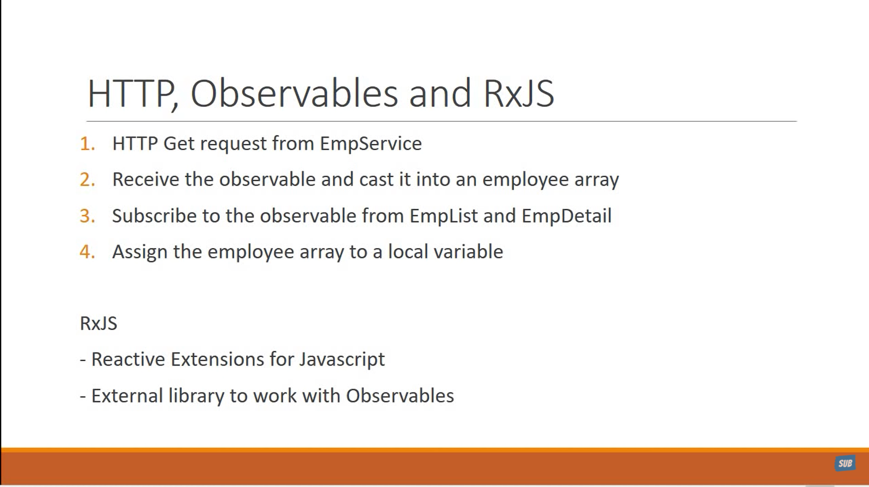

Step 1:

import { HttpClientModule } from '@angular/common/http';

Step 2:

imports: [

    BrowserModule , HttpClientModule

  ],

Add Service also in App.Module.ts

import { StudentService}   from './student.service';

providers: [StudentService],

Do changes in Service

import { HttpClient } from '@angular/common/http';

constructor(private _http: HttpClient) { }

import { rendererTypeName, ThrowStmt } from '@angular/compiler';

import { Injectable } from '@angular/core';

import { HttpClient } from '@angular/common/http';

@Injectable({

  providedIn: 'root'

})

export class StudentService {

   students:  any[];

   private path="/assets/data.employee.json";

   GetStudents()

        {

          return  this._http.get(this.path);

       }

  constructor(private _http: HttpClient) { }

}

export interface  IStudent{

  studentID : number;

  studentName: string;

  gender: string;

  age:number;

  course: string;

  DOB: string;

  grade:  number;

  rating:number;

}

import { IStudent } from './student';

import { Observable } from 'rxjs';

 GetStudents()

        {

          return  this._http.get<IStudent[]>(this.path);

}

StudentListComponent

import { Component, OnInit } from '@angular/core';

import { StudentService } from '../student.service';

import { HelloService } from '../hello.service';

@Component({

  selector: 'app-second',

  templateUrl: './second.component.html',

  styleUrls: ['./second.component.css'],

  providers:[StudentService , HelloService]

})

export class SecondComponent implements OnInit {

  msg :string ="";

  students :  any[];

  constructor(private _studentService : StudentService , private helloService : HelloService) { }

  CallHello()

  {

    this.msg = this.helloService.GetMessage();

  }

  ngOnInit(): void {

    this.students = this._studentService.GetStudents();

  } // ERROR WILL COME HERE NOW

ngOnInit(): void {

   this._httpService.GetStudents().subscribe(data => this.students = data);

}