<https://geeksarray.com/blog/how-to-use-automapper-in-aspnet-core-web-api#:~:text=This%20blog%20explains%20how%20to%20use%20AutoMapper%20in,while%20transferring%20data%20from%20one%20object%20to%20another>.

<https://dotnettutorials.net/lesson/automapper-in-c-sharp/>

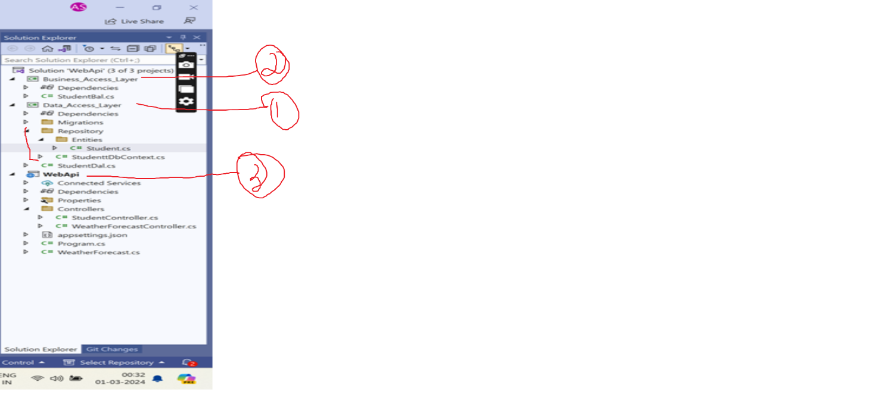

DAL

namespace Data_Access_Layer.Repository.Entities

{

public class Student

{

public int Id { get; set; }

[Required(ErrorMessage ="Name is must")]

[StringLength(10,ErrorMessage ="Max 10 characteres")]

public string Name { get; set; }

public int Marks { get; set; }

}

}

using Data_Access_Layer.Repository.Entities;

using Microsoft.EntityFrameworkCore;

namespace Data_Access_Layer.Repository

{

public class StudenttDBContext :DbContext

{

public StudenttDBContext()

{

}

public StudenttDBContext(DbContextOptions<StudenttDBContext> options)

: base(options) { }

public DbSet<Student> Students { get; set; }

protected override void OnConfiguring(DbContextOptionsBuilder optionsBuilder)

{

if (!optionsBuilder.IsConfigured)

{

optionsBuilder.UseSqlServer("server=ANAMIKA\\SQLSERVER;database=StudentDb;integrated security=true;TrustServerCertificate=true");

}

}

}

}

using Data_Access_Layer.Repository;

using Data_Access_Layer.Repository.Entities;

namespace Data_Access_Layer

{

public class StudentDal

{

private StudenttDBContext _context;

public StudentDal( )

{

_context = new StudenttDBContext();

}

public List<Student> GetStudents()

{

return _context.Students.ToList();

}

public Student GetStudentById(int id)

{

return _context.Students.FirstOrDefault(x => x.Id == id);

}

public Student AddStudent(Student student)

{

_context.Students.Add(student);

_context.SaveChanges();

return student;

}

}

}

BAL

using Data_Access_Layer;

using Data_Access_Layer.Repository.Entities;

namespace Business_Access_Layer

{

public class StudentBal

{

private Data_Access_Layer.StudentDal _dal;

public StudentBal()

{

_dal = new Data_Access_Layer.StudentDal();

}

public List<Student> GetStudents()

{

return _dal.GetStudents();

}

public Student GetStudent(int id)

{

return _dal.GetStudentById(id);

}

public Student AddStudent(Student student)

{

return _dal.AddStudent(student);

}

}

}

Web Api

using Data_Access_Layer.Repository.Entities;

using Microsoft.AspNetCore.Http;

using Microsoft.AspNetCore.Mvc;

namespace WebApi.Controllers

{

[Route("api/[controller]")]

[ApiController]

public class StudentController : ControllerBase

{

private Business_Access_Layer.StudentBal _bal;

public StudentController() {

_bal = new Business_Access_Layer.StudentBal();

}

[HttpGet]

public List<Student> Get()

{

return _bal.GetStudents();

}

[HttpGet("{id}")]

public Student GetStudent(int id)

{

return _bal.GetStudent(id);

}

[HttpPost]

public Student Add(Student student)

{

return _bal.AddStudent(student);

}

}

}

After Adding AutoMapper

using Data_Access_Layer;

//using Data_Access_Layer.Repository.Entities;

using Business_Access_Layer.Models;

using AutoMapper;

using Data_Access_Layer.Repository.Entities;

namespace Business_Access_Layer

{

public class StudentBal

{

private Data_Access_Layer.StudentDal _dal;

private Mapper _mapper;

public StudentBal()

{

_dal = new Data_Access_Layer.StudentDal();

var _config = new MapperConfiguration(cfg => cfg.CreateMap<Student, Business_Access_Layer.Models.StudentModel>().ReverseMap());

_mapper = new Mapper(_config);

}

public List<Business_Access_Layer.Models.StudentModel> GetStudents()

{

//return_dal.GetStudents();

List<Student> students = _dal.GetStudents();

List<StudentModel> list = _mapper.Map<List<Student>, List<StudentModel>>(students);

return list;

}

public Business_Access_Layer.Models.StudentModel GetStudent(int id)

{

//return _dal.GetStudentById(id);

var student = _dal.GetStudentById(id);

StudentModel studentModel = _mapper.Map<Student, StudentModel>(student);

return studentModel;

}

public void AddStudent(StudentModel student)

{

Student student1 = _mapper.Map<StudentModel, Student>(student);

_dal.AddStudent(student1);

}

}

}

DAL will remain same

Web Api

//using Data_Access_Layer.Repository.Entities;

using Business_Access_Layer.Models;

using Microsoft.AspNetCore.Http;

using Microsoft.AspNetCore.Mvc;

namespace WebApi.Controllers

{

[Route("api/[controller]")]

[ApiController]

public class StudentController : ControllerBase

{

private Business_Access_Layer.StudentBal _bal;

public StudentController() {

_bal = new Business_Access_Layer.StudentBal();

}

[HttpGet]

public List<StudentModel> Get()

{

return _bal.GetStudents();

}

[HttpGet("{id}")]

public StudentModel GetStudent(int id)

{

return _bal.GetStudent(id);

}

[HttpPost]

public void Add(StudentModel student)

{

_bal.AddStudent(student);

}

}

}