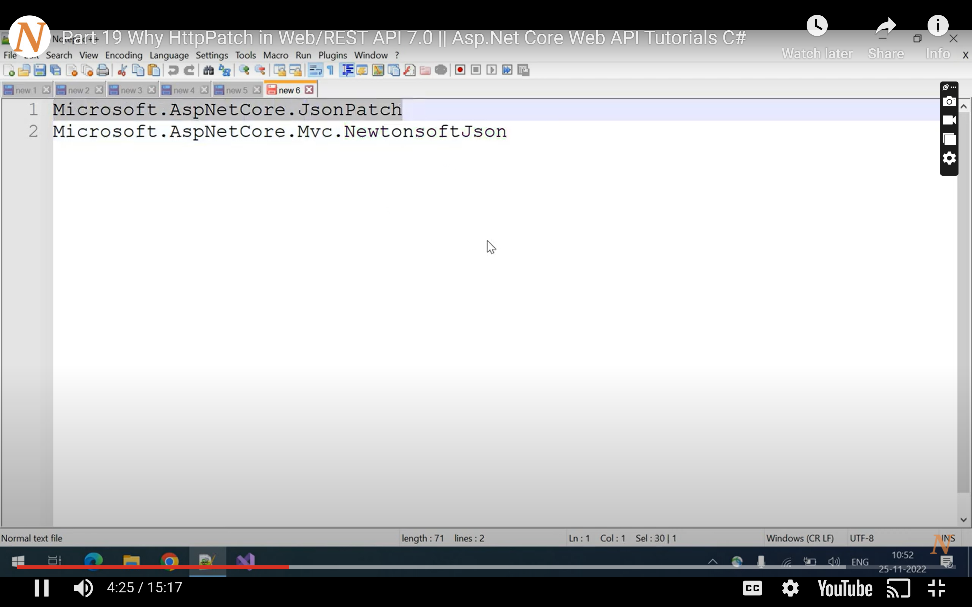

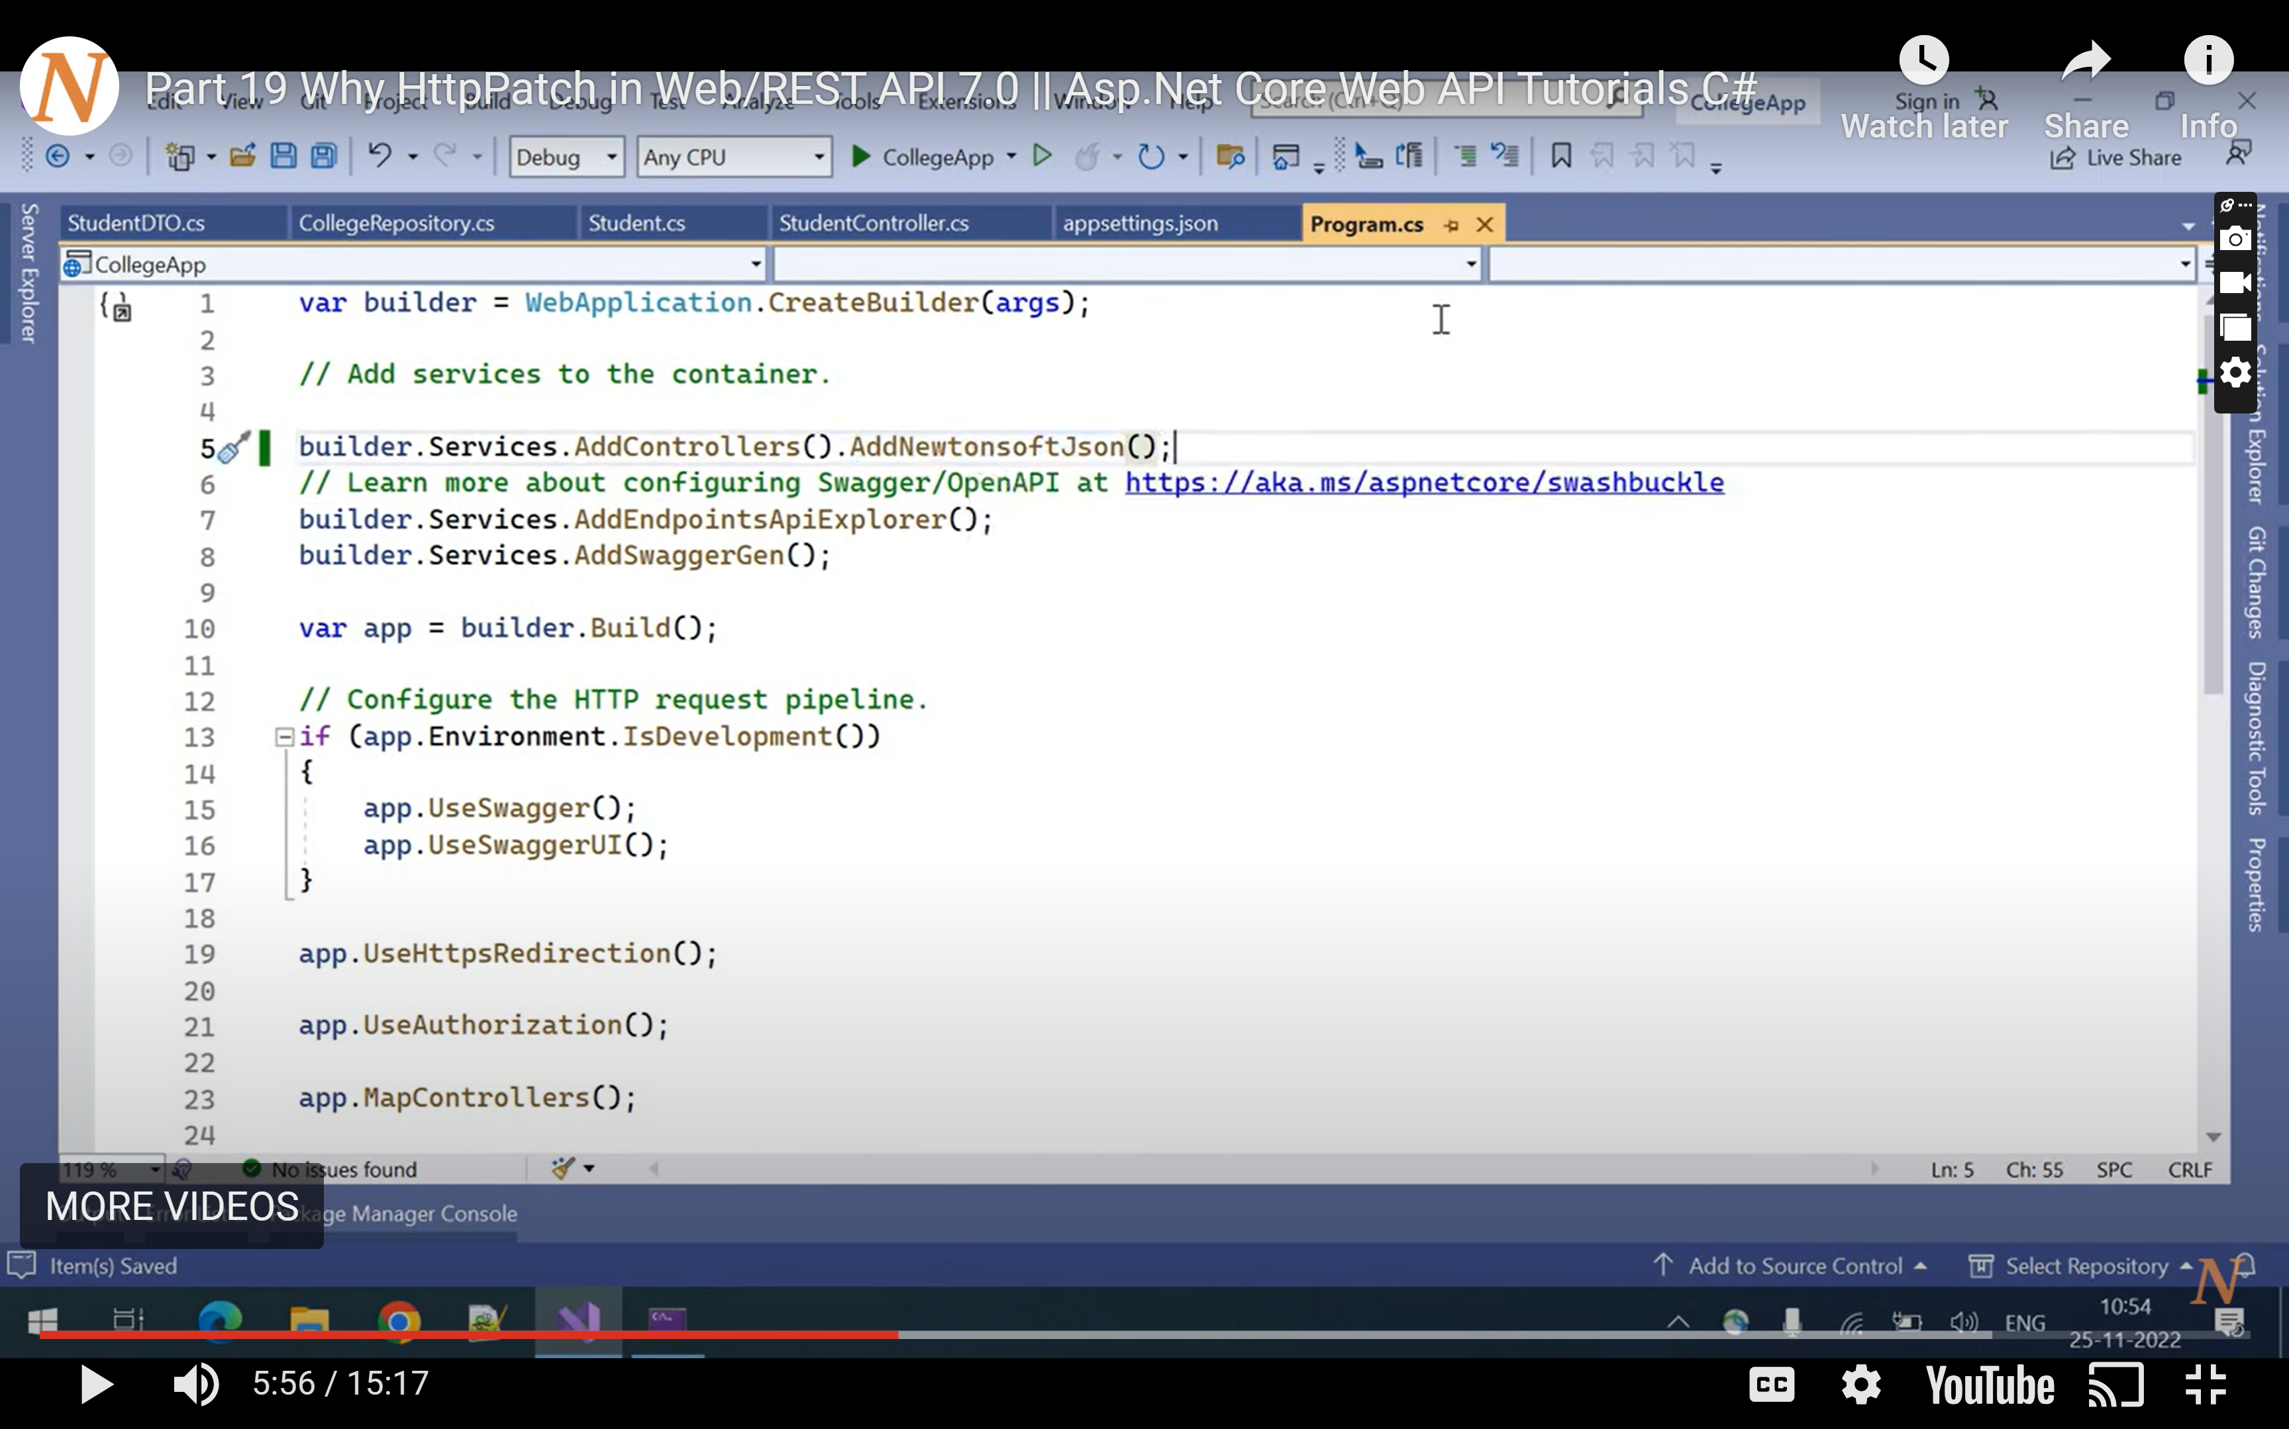

builder.Services.AddControllers().AddNewtonsoftJson();

<https://jsonpatch.com/>

[HttpPatch]

[Route("{id}")]

public IActionResult Edit(int id, JsonPatchDocument<Student> patchDocument)

{

if (patchDocument == null || id < 1) return BadRequest();

Student obj1 = list.FirstOrDefault(x => x.Id == id);

if (obj1 == null) return NotFound();

var student = new Student

{

Id = obj1.Id,

Name = obj1.Name,

Marks = obj1.Marks

};

patchDocument.ApplyTo(student, ModelState);

if (!ModelState.IsValid) return BadRequest();

else

{ obj1.Name = student.Name;

obj1.Marks = student.Marks;

return Ok();

}

//list.Remove(obj);

}