Assignment 8- Network Visualization with Gemini
Course: 6380.003
Name: Anamika Das
Net ID: axd240045

1.
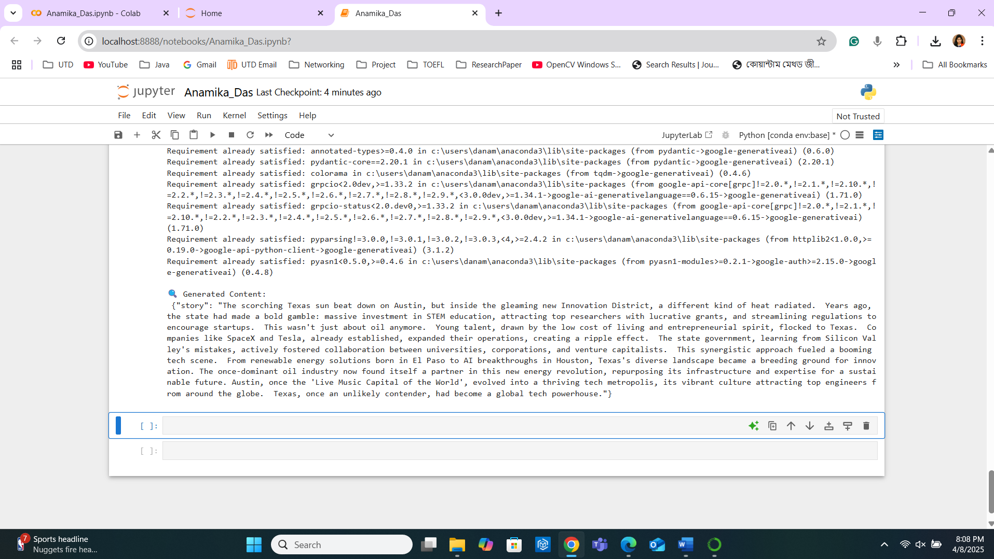

2.
The system prompt instructs the LLM (like Gemini) to act as a network graph maker. It analyzes a given text chunk to extract key entrepreneurs, related entities, and the relationships between them. The output must be structured strictly in JSON format with three fields for each relationship:
- node_1: first entity (person/org/concept)
- node_2: second entity
- edge: a brief description of the relationship
This JSON format allows for easy visualization of relationships as a graph of nodes and edges.

3.
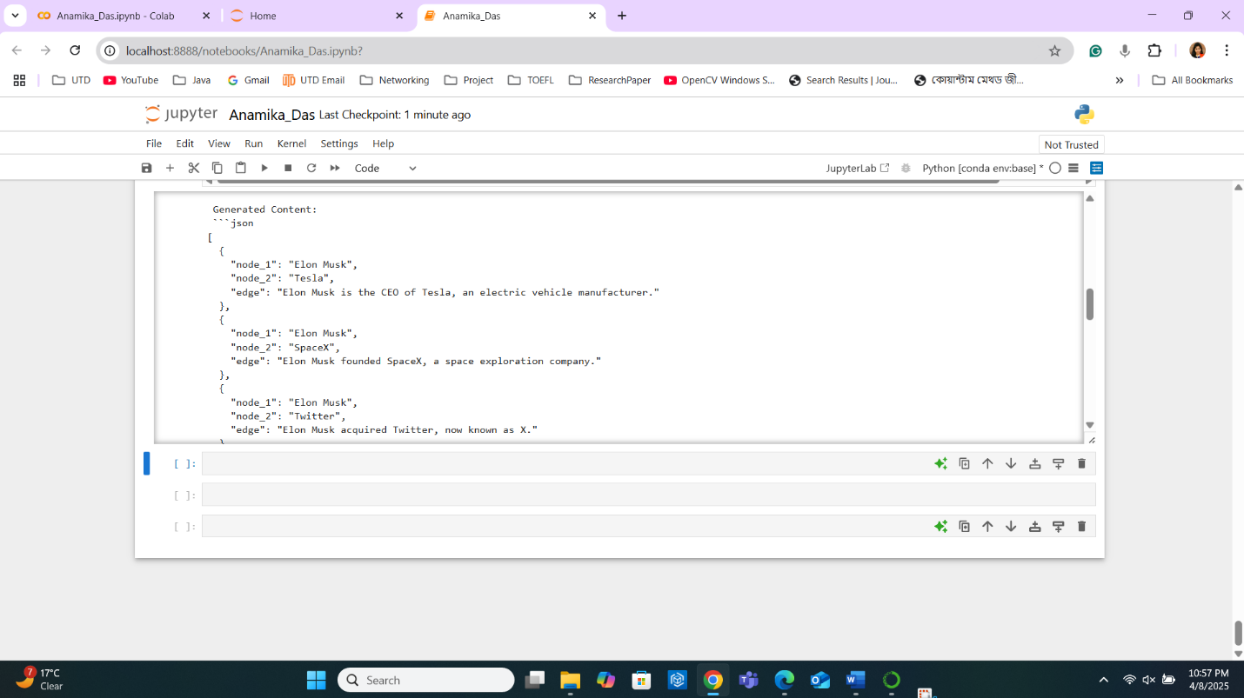

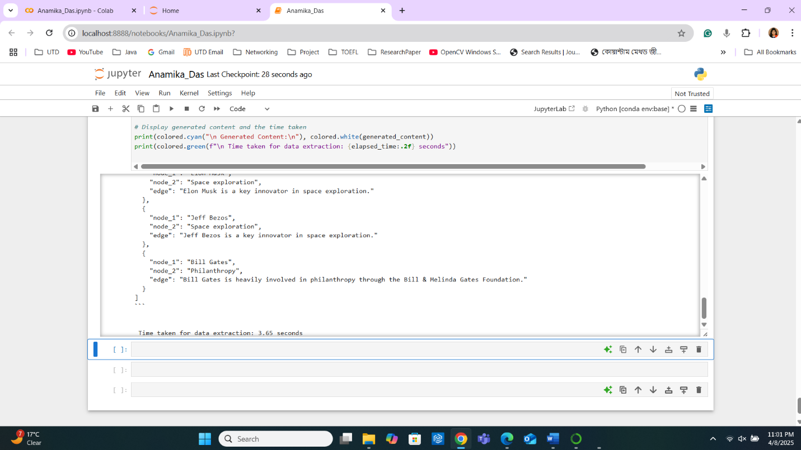

4.
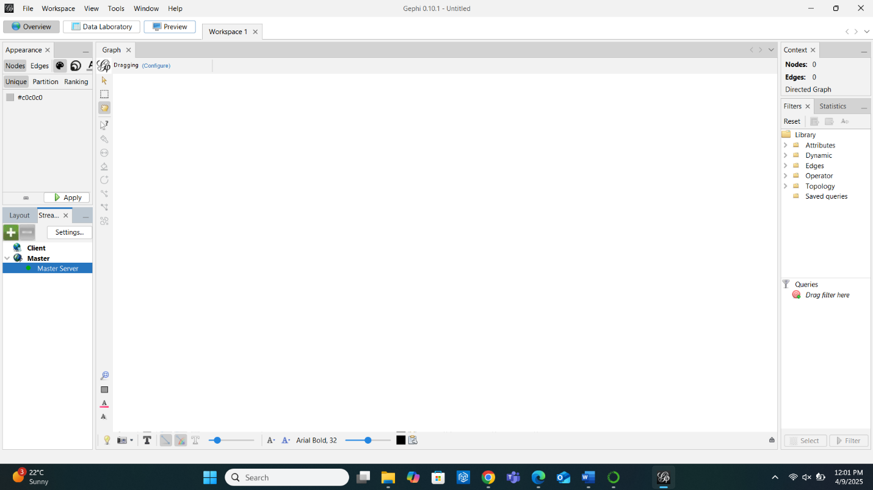

5. Directed
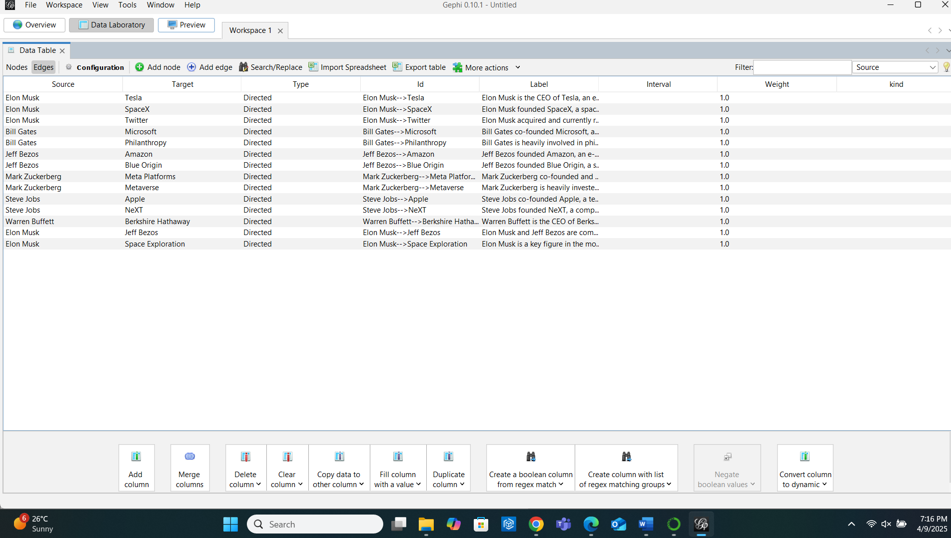

6.
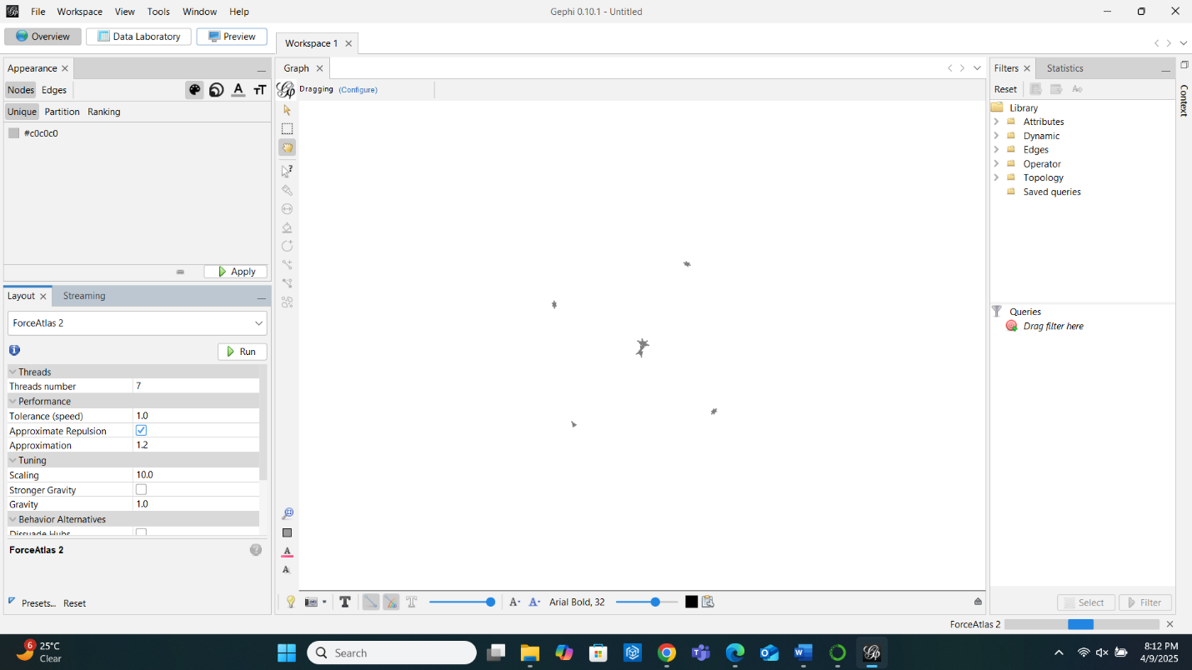

7.
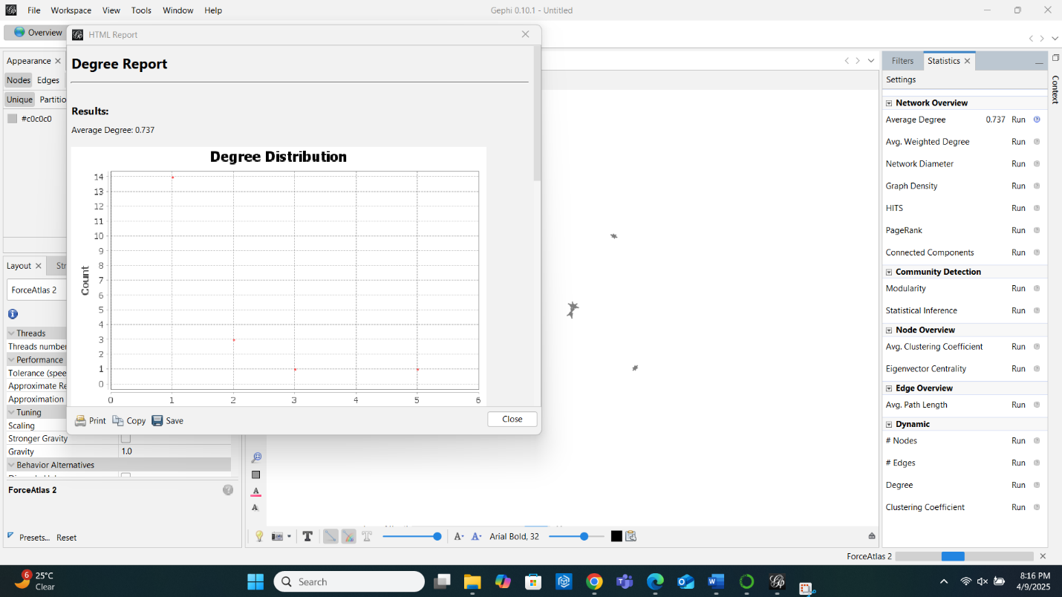

8.
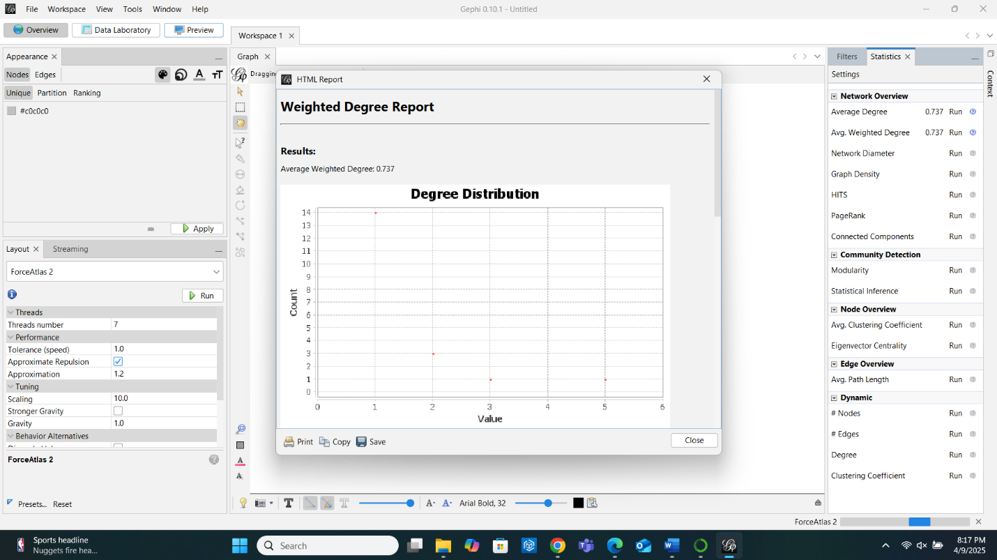

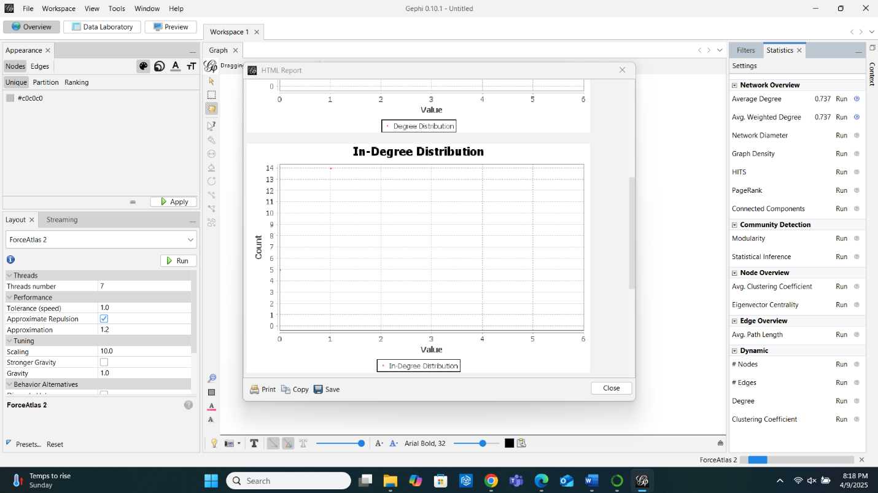

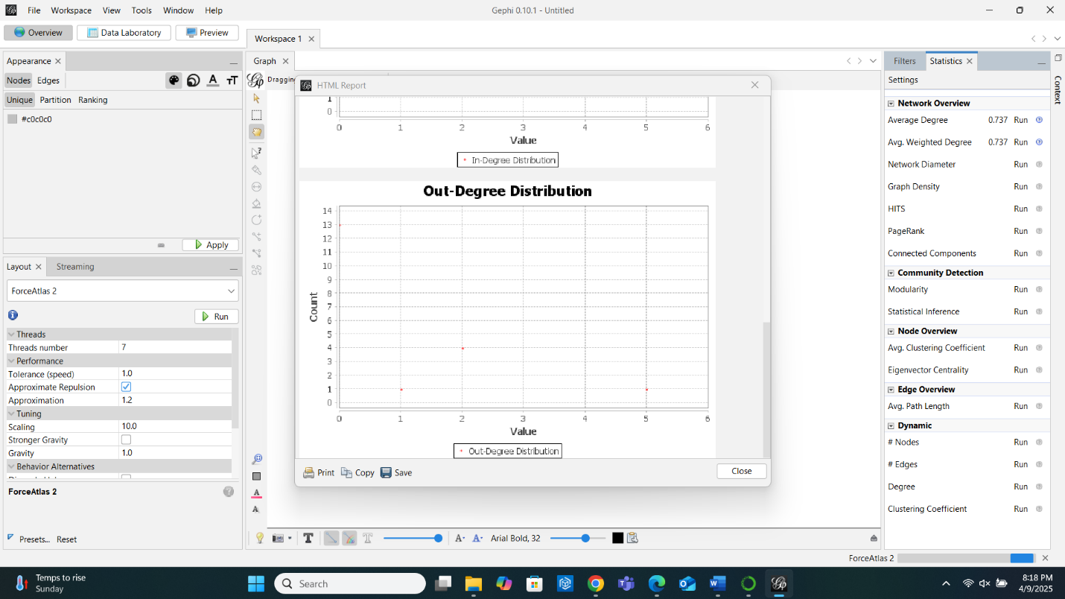

9.
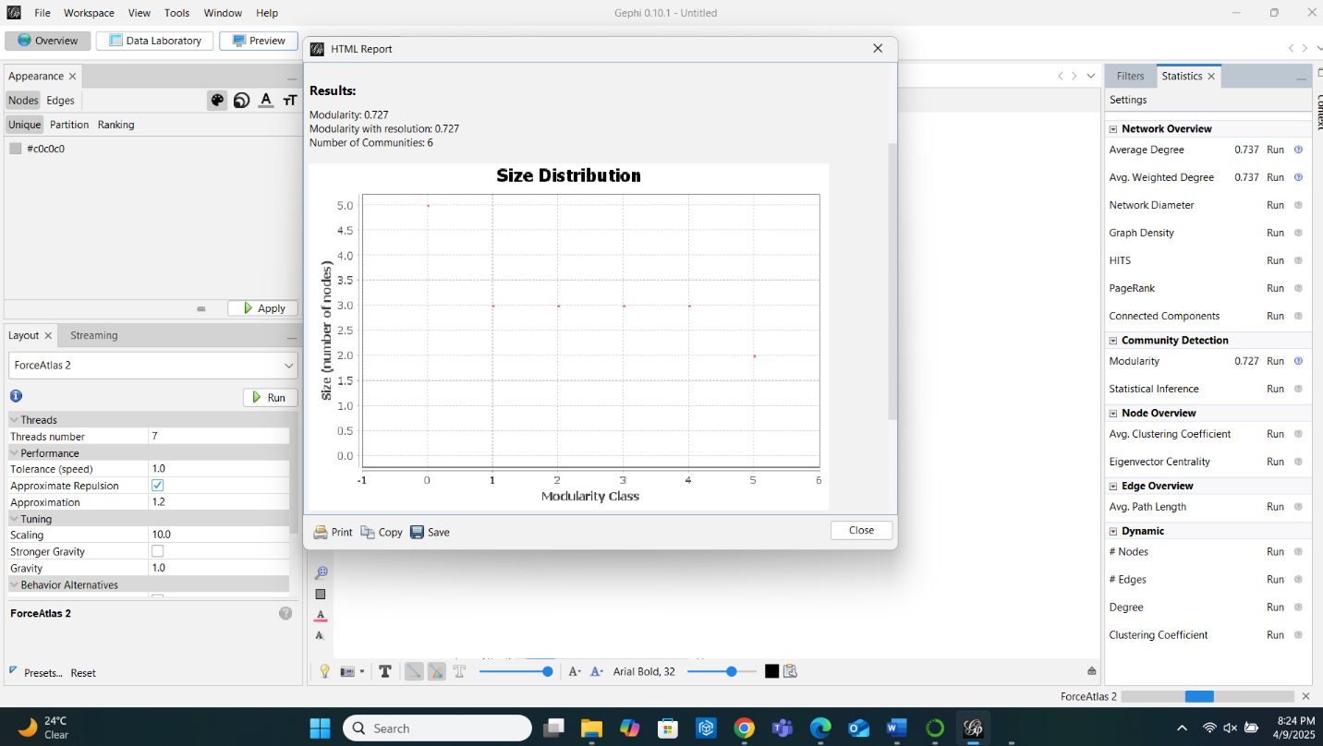

10. As per the above graph, my communities are 7.
11.
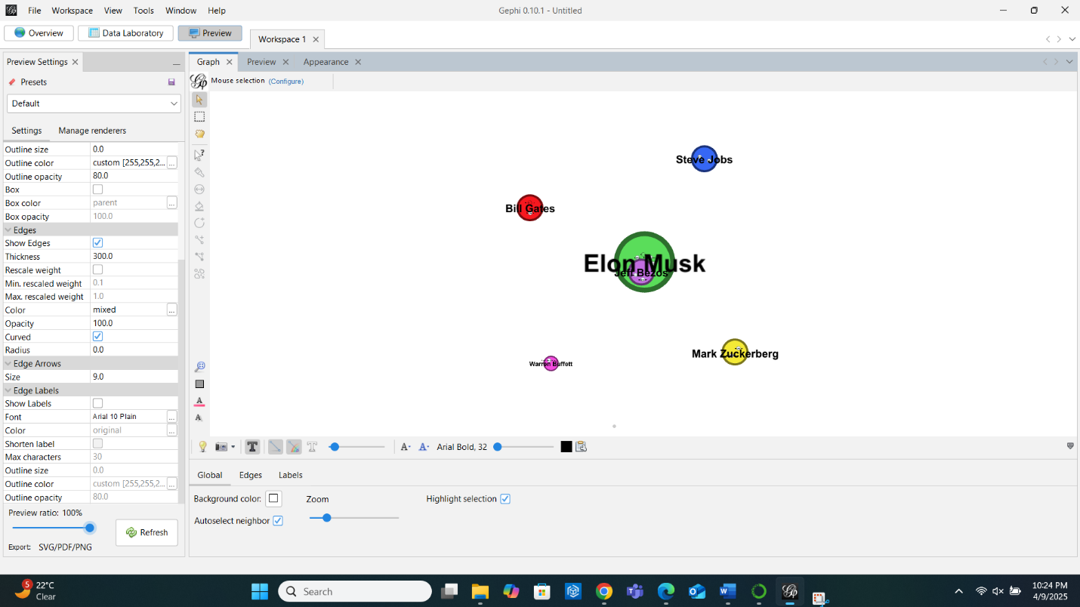

12.
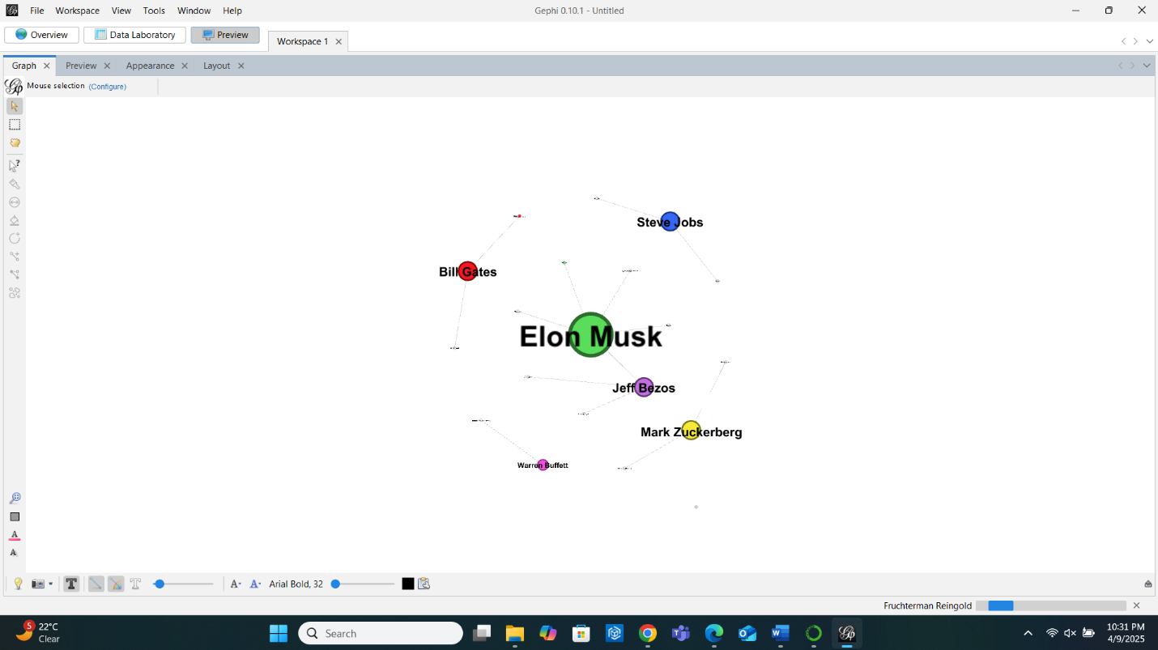
13. Elon Musk.
14. My LLM detected the relationship between Elon Musk and Jeff Bezos instead of any node connecting with other tech leaders. Below is the screenshot:
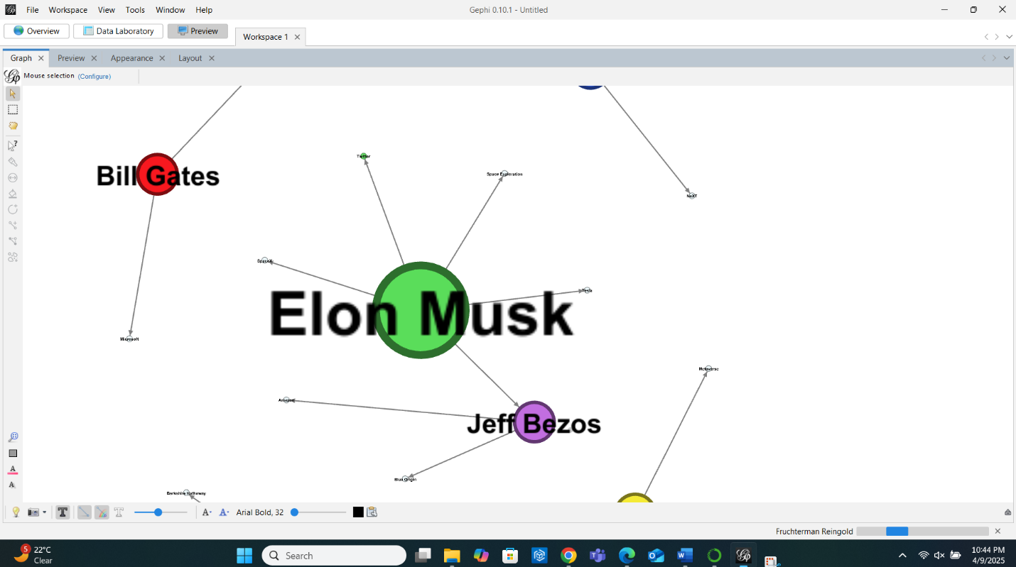

15.
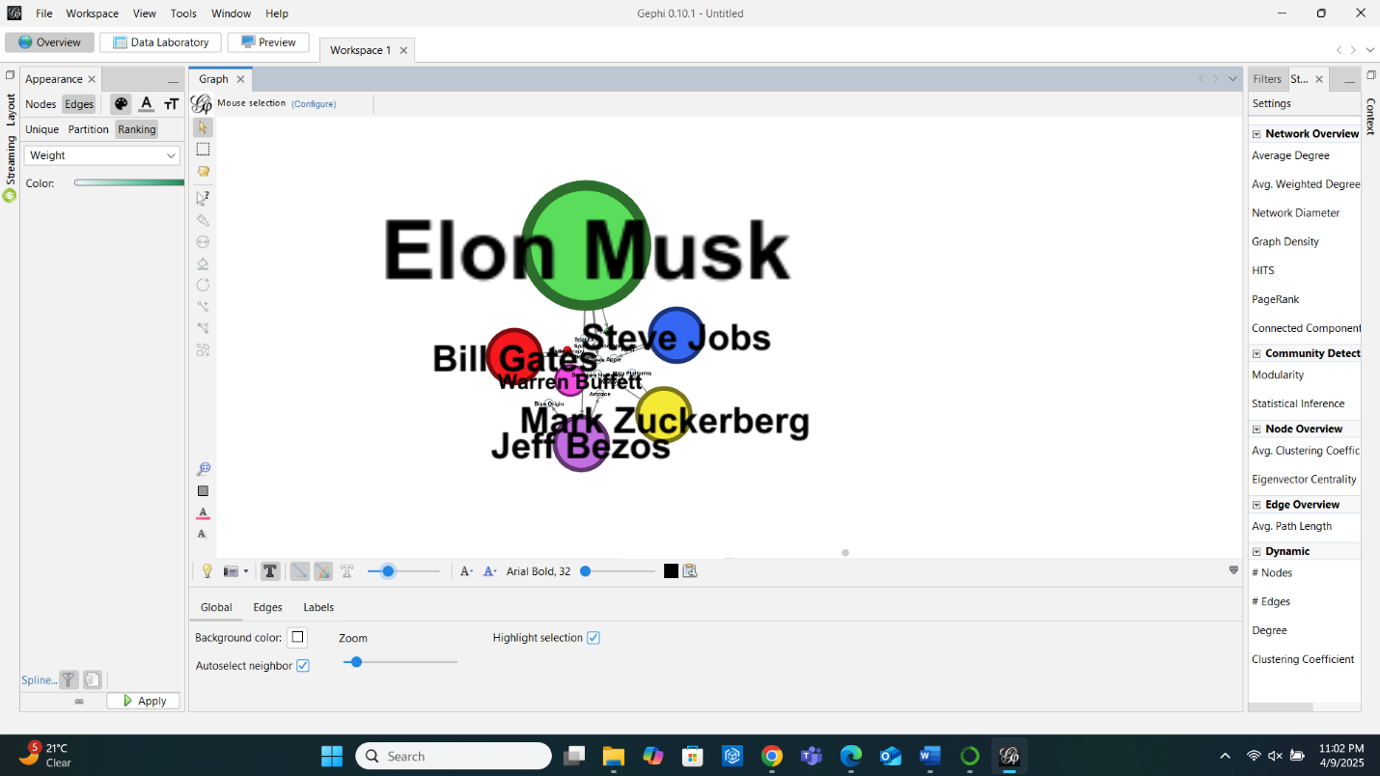
16.
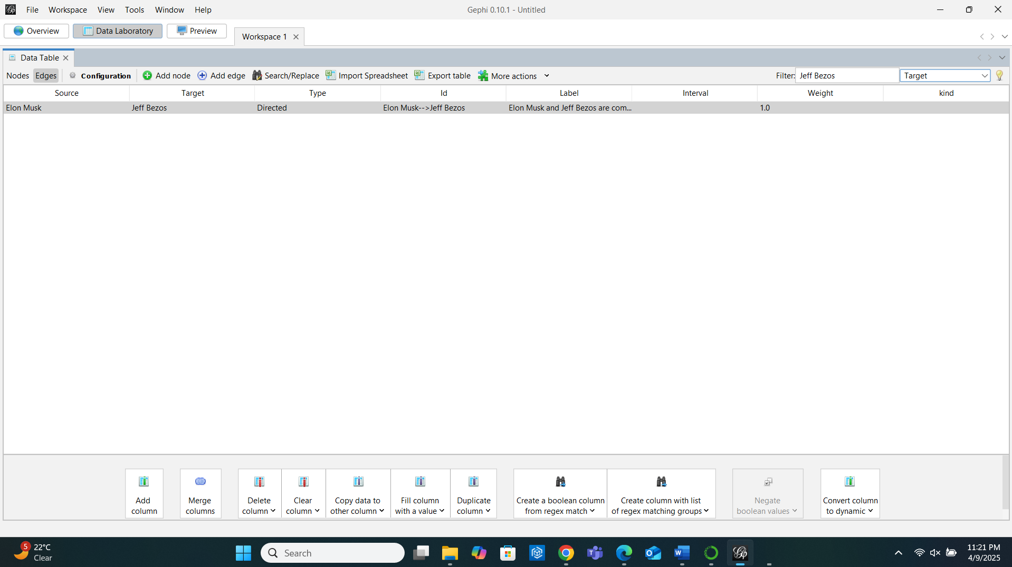

Connection Between Elon Musk and Jeff Bezos:


Observation: Elon Musk and Jeff Bezos are Competing in the Space Industry.
Elon Musk's SpaceX and Jeff Bezos' Blue Origin are leading private space exploration companies focused on revolutionizing space travel but with different approaches.
- SpaceX, under Musk, is focused on affordable, reusable rockets and interplanetary missions, aiming to send humans to Mars.
- Blue Origin, led by Bezos, emphasizes space infrastructure and sustainability, intending to create a permanent human presence in space, including lunar missions.
Their competition drives rapid technological innovation and shapes the future of space exploration, highlighting how rivalry can accelerate progress toward ambitious goals like Mars colonization and lunar settlement.

