Step 1: Download Apache Kafka

Download the latest stable version of Apache Kafka from the official website. At the time of writing, it's 0.9.0.1.

cd ~

wget http://www-us.apache.org/dist/kafka/0.9.0.1/kafka_2.11-0.9.0.1.tgz

Unzip the archive to a preferred location, such as /opt:

tar -xvf kafka_2.11-0.9.0.1.tgz

sudo mv kafka_2.11-0.9.0.1 /opt

Step 4: Start and test Apache Kafka

At this point, Apache Kafka is available on your system. Let's give it a test drive.

4.1: Get into the Kafka directory

cd /opt/kafka_2.11-0.9.0.1

4.2: Start the Zookeeper server

bin/zookeeper-server-start.sh -daemon config/zookeeper.properties

4.4: Start the Kafka server

bin/kafka-server-start.sh config/server.properties

If everything went successfully, you will see several messages about the Kafka server's status, and the last one will read:

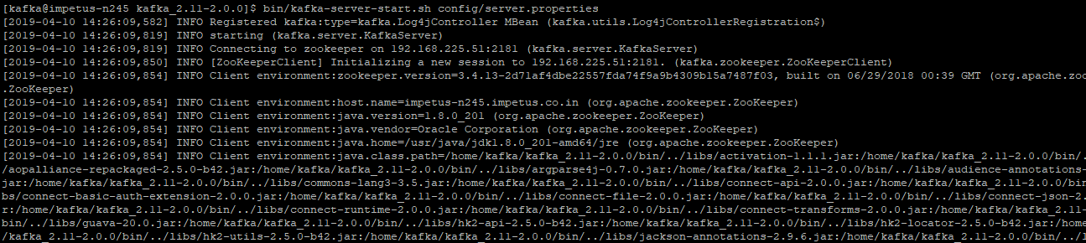

INFO [Kafka Server 0], started (kafka.server.KafkaServer)

This means that you have started the Kafka server.

4.5: Create a topic "aman" in a new SSH connection

Open a new SSH connection, use the following commands to create a topic "aman":

cd /opt/kafka_2.11-0.9.0.1

bin/kafka-topics.sh --create --zookeeper 192.168.225.51:2181 --replication-factor 1 --partitions 1 --topic aman

You can view your topics with the following command:

bin/kafka-topics.sh --list --zookeeper 192.168.225.51:2181

In our case, The output will read:

aman

4.6: Produce messages using the topic "aman"

bin/kafka-console-producer.sh --broker-list 192.168.225.51:9092 --topic aman

Using the command above, you can input any number of messages as you wish, such as:

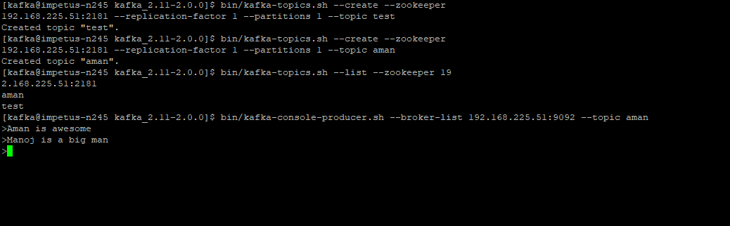

If you receive an error similar to "WARN Error while fetching metadata with correlation id" while inputting a message, you'll need to update the server.properties file with the following info:

port = 9092

advertised.host.name = 192.168.225.51

4.7: Display messages

Open a third SSH connection, and then run the following commands:

cd /opt/kafka_2.11-0.9.0.1

bin/kafka-console-consumer.sh --zookeeper 192.168.225.51:2181 --topic aman --from-beginning

In the consumer side you will get the message from the producer:



