PROJECT REPORT
Karachi Route Advisor
An Explainable, Traffic-Aware Route Recommendation System
for Gulistan-e-Jauhar, Karachi

Prepared by | Project Team
Department | Computer Science
Institution | [Institution Name]
Course | [Course Name]
Date | October 2026
Version | 1.0

ABSTRACT
This report presents Karachi Route Advisor, a prototype decision-support system that recommends transparent, traffic-aware driving routes between verified landmarks in Gulistan-e-Jauhar, Karachi. It combines a custom A* router, a Dijkstra baseline, a forward-chaining expert system, optional Mapbox traffic evidence, and a route-specific machine-learning traffic assessment. The system returns one recommended route and up to two alternatives, each with a plain-language explanation. The report covers architecture, algorithms, data sources, verified results, and limitations, with explicit disclosure of synthetic and external data.
October 2026 · Karachi, Pakistan

1. Introduction

1.1 Background and Problem
Gulistan-e-Jauhar is one of Karachi's most densely populated residential and commercial zones. Its network mixes wide arterials with narrow service lanes, and travel times change with the hour, day, weather, and unplanned incidents. Mainstream navigation apps usually return one fastest route and one ETA with little explanation of why it was chosen, how confident the estimate is, or which evidence was used. That opacity makes it hard for a commuter to judge an alternative, and it hides the engineering problem: how to combine classical graph search, rule-based reasoning, and imperfect external evidence without overstating what the system knows.
This project addresses that problem with a transparent prototype. Routes are computed on a real OpenStreetMap (OSM) drive graph, evaluated by an explicit expert system, optionally enriched with Mapbox traffic evidence, and presented as one recommendation plus up to two alternatives. Each route carries a short, factual explanation of why it was chosen or why it was not.

1.2 Objectives
- Graph: build a drive-only OSM graph for the study area and snap nine verified landmarks.
- Routing: implement a custom A* shortest-time router and an independent Dijkstra baseline over identical weights.
- Alternatives: generate diverse routes with explicit detour and overlap constraints.
- Explainability: add a forward-chaining expert system, preference-aware ranking, and plain-language reasons.
- Evidence: integrate optional Mapbox traffic evidence and a route-specific future-traffic model without double counting.
- Delivery: provide a minimal Streamlit dashboard with a readable map and a clear recommendation.

1.3 Scope and Study Area
The study area is the Gulistan-e-Jauhar bounding box 24.898°–24.944° N and 67.108°–67.168° E. The nine landmarks are Johar Chowk Mosque, Gulistan-e-Jauhar Police Station, Jauhar Inn Banquet Block 1, Block 8 bus stop, Shell Jauhar, Block 7 Decent Houses, NED University, Safari Park, and Karachi Race Club. The graph is a directed drive network filtered to drive highways, and the largest strongly connected component is retained so every landmark pair is mutually reachable. The prototype is an advisory and research system, not a certified navigation device, and it does not claim real-time Karachi traffic accuracy. No observed Karachi route-level traffic dataset was available, so the route-traffic model uses documented synthetic labels calibrated to real external time-of-week profiles. External benchmark models are reported separately and never produce Karachi ETAs.
Table 1. Project at a glance
Item | Value
Study area | Gulistan-e-Jauhar, Karachi (24.898–24.944° N, 67.108–67.168° E)
OSM drive graph | 5,520 nodes; 14,585 edges; largest SCC ratio 1.0
Verified landmarks | 9 drive-accessible landmarks
Routing and decision | Custom A*, Dijkstra, alternatives, expert system R01–R16, policy ai-final-v2
Evidence | Optional Mapbox Directions; route-specific RandomForest traffic band
Verification | 72 route pairs validated; 189 automated tests passing (29 October 2026)
The project combines a reproducible routing stack with an explicitly bounded evidence layer.

2. System Architecture

2.1 Architectural Overview
The system has three cooperating layers. The presentation layer is a Streamlit application with a Folium map; it collects the trip context, displays the recommendation and alternatives, and holds the active selection in session state. The application layer is coordinated by src/service.py, which validates domain input, invokes routing and evidence components, and returns one final recommendation object. The intelligence layer contains the pathfinding package, analytical assessment, expert system, academic ranking, final AI policy, Mapbox evidence matcher, and route-traffic model. Frozen dataclasses in src/contracts.py define the contracts between layers, keeping dependencies one-directional and the pipeline testable in isolation.
OpenStreetMap supplies the road graph and attributes. Mapbox Directions supplies optional, requested-departure traffic evidence. Open-Meteo supplies current weather with an explicit dry-condition fallback. The OSM graph is cached as GraphML, while Mapbox results are transient and are never cached or exported.

2.2 Component Responsibilities
- app.py: Streamlit inputs, map rendering, route cards, selection state, and disclosures.
- src/service.py: orchestration, evidence construction, and final AI invocation.
- src/pathfinding/: custom A*, Dijkstra, alternative generation, and graph helpers.
- src/eta.py and src/expert_system.py: analytical ETA/risk and forward-chaining rules R01–R16.
- src/decision.py and src/ai/optimizer.py: academic ranking and final policy ai-final-v2.
- src/traffic_evidence.py and src/route_traffic_ml.py: Mapbox-to-OSM matching and future-traffic classification.

2.3 End-to-End Workflow
Figure 1 shows the request path from user input to the final recommendation. The path is deterministic for a given input and degrades gracefully: if weather, Mapbox, or a model artifact is unavailable, the system falls back to a disclosed alternative rather than fabricating evidence. Dashed arrows mark where external data and saved model artifacts enter.
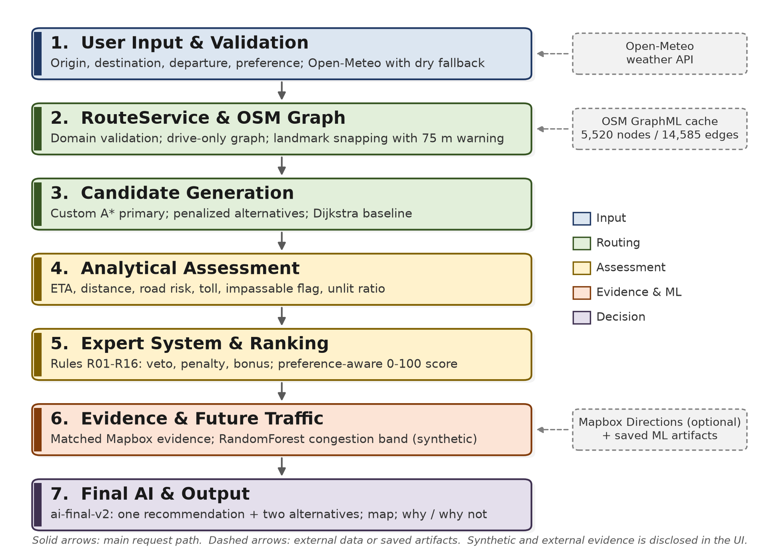
Figure 1. End-to-end system workflow, from Streamlit input to the final recommendation and map.

3. Methodology and Algorithms

3.1 Graph Preparation, Routing, and Alternatives
The graph is a directed drive network filtered to a drive-highway whitelist at build, cache-load, and conversion time. The largest strongly connected component is retained. Edges store length, road type and name, speed, base travel time, surface, lighting, toll, and access; speed comes from maxspeed or highway-type defaults, base time is length divided by speed, and parallel edges collapse to the fastest edge. A* minimizes base travel time: g(n) is accumulated edge time and h(n) is haversine distance to the goal divided by the graph's maximum speed, which makes the heuristic admissible and the search optimal. A counter breaks ties deterministically, and expanded nodes are recorded. Dijkstra is the same search with h(n) = 0 over identical weights, and the service compares path identity and optimal cost. For alternatives, the primary route's edges are penalized and A* is rerun at factors 1.8, 3.0, and 5.0; an alternative is accepted only if it is not a duplicate, is at most 45% slower than the primary, overlaps every accepted alternative by at most 70%, and respects the three-alternative limit.

3.2 Analytical Assessment and Expert System
The analytical ETA combines OSM edge speed, a departure-time factor, a weather factor, minimum-speed clamping, and edge length. Road risk uses highway type, surface, night lighting, and high-speed exposure; toll and impassable flags come from OSM tags, and the unlit ratio is the fraction of unlit edges. The expert system keeps a working memory of route and context facts. Veto rules R01–R03 handle closures, impassable segments, and strict toll violations; soft rules R04–R10 and R16 handle congestion, incidents, risk, rain, night, and slow routes; preference rules R11–R14 add bonuses; and data rule R15 warns about missing live traffic. Rules are ordered by stratum, priority, specificity, and ID, and each fires once. R16 derives a congestion-band fact consumed by R04 and R05 in the same pass, and every firing is recorded in the verdict trace.

3.3 Ranking and Final AI Decision
The academic ranking normalizes ETA, distance, risk, and congestion, applies preference weights, renormalizes when congestion is missing, applies the expert multiplier, adds a confidence penalty, and returns a 0–100 score. The final policy, ai-final-v2, applies hard vetoes and eligibility checks, keeps only OSM candidates, and treats Mapbox routes as evidence. Each provider route is matched to an OSM corridor by two-way overlap at 35 m. Segment congestion is used when at least 40% of the route is matched and annotations align; otherwise the provider departure-to-typical ratio is used only when baselines are comparable, and the absolute provider ETA is never copied. One decision ETA is chosen: matched provider-adjusted OSM ETA, then the future-ML premium, then the analytical ETA. Duplicate and >70%-overlap routes are removed; the expert multiplier 1 + 0.15 × penalty − 0.10 × bonus is applied, floored at 0.75; and a confidence penalty applies only when ML drives the ETA. The policy returns one recommendation and at most two alternatives.

3.4 Mapbox Evidence and Route-Specific ML
Mapbox is optional. When configured, the app requests mapbox/driving-traffic at the selected departure converted to UTC and sent as depart_at. If it fails, ordinary mapbox/driving is used and labelled non-traffic-aware; if both fail, the analytical OSM route remains. Traffic status is annotated, partial_eta_delta_only, no_traffic_evidence, or no_mapbox. A duration delta is not segment congestion, and absent annotations are not claimed as live congestion. Unknown provider risk and toll values are marked unavailable, not zero.
No observed Karachi route-level labels exist, so the route-traffic model learns a documented synthetic target while using real route geometry and external time-of-week calibration. The simulation builds 149 route variants and 500 scenarios each over 2025 (74,500 rows). A BPR-style delay model uses road composition, free-flow speed, segment count, weather, night/weekend/Friday effects, noise, and an accident-incident term. Labels are LOW below 0.18, MODERATE 0.18–0.45, and HIGH at or above 0.45 delay ratio. The classifier uses 34 features with a chronological 70/15/15 split and 24-hour embargo; RandomForest was selected on validation macro-F1. The UCI 492 and UK STATS19 benchmarks are retained as external comparisons only; neither is mapped to Karachi roads or used for Karachi ETAs, and the accident prior is not a crash probability.

4. Results and Evaluation

4.1 Routing Validation
The graph has 5,520 nodes and 14,585 edges, no non-drive edges, and a largest SCC ratio of 1.0. Validation over 72 landmark pairs recorded no failures: 14 pairs had one route, 40 had two, 17 had three, and one had four. ETAs ranged from 1.7 to 18.5 minutes and distances from 0.99 to 8.80 km. A* and Dijkstra matched the optimal cost on 72 of 72 pairs. The maximum A*/Dijkstra expanded-node ratio was 0.9657, so the heuristic reduced search effort without changing the optimum. Alternative generation had zero overlap and zero time violations.

4.2 Traffic and External Benchmarks
The route-traffic RandomForest achieved 0.7928 test accuracy, 0.7112 balanced accuracy, and 0.7179 macro-F1 on the held-out synthetic split. Per-class F1 was 0.8999 (LOW), 0.5964 (MODERATE), and 0.6573 (HIGH). These measure recovery of the simulation policy, not Karachi accuracy; confidence is capped at Medium. The external volume benchmark selected RandomForest with held-out MAE 136.920 vehicles/hour versus 253.252 for a calendar-mean baseline (45.9% improvement), RMSE 216.551, and R² 0.9880. The departure comparison reported traffic classifier accuracy 0.9093 (macro-F1 0.9094) and accident classifier accuracy 0.7182 (macro-F1 0.7158). These are external benchmarks, not Karachi accuracy.

4.3 Dashboard and Test Coverage
The dashboard is deliberately small. The sidebar collects origin, destination, departure, preference, and optional toll avoidance. After a search, the main screen shows a large map, the selected route, and up to two alternatives. Each card shows ETA, distance, traffic-evidence type, incident status, future-traffic band with probabilities, confidence, provenance, and plain-language advice. The selected route is bold green and others are muted and dashed; one banner warns when live traffic is unavailable or stale, and detailed traces stay in an expander. The suite contains 189 passing tests covering graph preparation, A*/Dijkstra equivalence, alternatives, ETA/risk, expert rules, ranking, final-policy deduplication, Mapbox matching and degradation, route traffic, weather fallback, orchestration, and Streamlit AppTest rendering.
Table 2. Verified performance metrics
Evaluation | Metric | Result
Graph integrity | Nodes / edges / largest SCC | 5,520 / 14,585 / 1.0
Route validation | Landmark pairs / failures | 72 / 0
A* versus Dijkstra | Same optimal cost | 72 / 72
A* search effort | Maximum expanded-node ratio | 0.9657
Alternatives | Overlap / time violations | 0 / 0
Route-traffic model | Test accuracy / macro-F1 | 0.7928 / 0.7179
External volume benchmark | Test MAE / RMSE / R² | 136.920 / 216.551 / 0.9880
Automated tests | Passing tests | 189
Metrics are reproduced from verified local artifacts and the current test run (29 October 2026).

5. Discussion

5.1 Strengths
- Transparency: each recommendation exposes the decision ETA, its basis, matched evidence, expert trace, and limitations.
- Reproducibility: the graph cache, model artifacts, evaluation files, and verification commands are stored in the repository.
- Evidence separation: provider evidence and ML predictions are applied once, and provider ETAs are never copied onto OSM routes.
- Graceful degradation: missing weather, Mapbox, or model artifacts produce an explicit fallback rather than a fabricated result.

5.2 Limitations and Data Provenance
- No observed Karachi route-level traffic: the route-traffic model uses synthetic labels; its metrics measure simulation recovery, not real-world accuracy.
- External priors: the volume benchmark is one Minnesota interstate sensor and the accident prior is UK STATS19 data; neither is Karachi-specific or corridor-matched.
- Analytical routing: A* uses OSM-derived travel time, not live traffic; external evidence enters only in the final assessment layer.
- Provider gaps: Mapbox annotations, incidents, and closures may be unavailable, and a duration delta is not segment congestion.
- Prototype status: the recommendation is a transparent policy, not a validated navigation or safety system.

5.3 Responsible AI and Ethical Considerations
The system avoids overclaiming. Synthetic labels are disclosed at every layer, external datasets are named and licensed, and missing evidence is never treated as zero risk or zero toll. Unknown road risk is scored conservatively, and no prediction is fabricated when an artifact is missing. The app does not collect observations automatically or train on user data without explicit opt-in; Mapbox credentials are read from the environment and never logged. The local-observation path stores user-supplied CSV rows only on request and reports that at least 168 observations are needed before a local experiment.

6. Future Work
Future work will collect timestamped Karachi travel-time or speed observations with route or segment identifiers, calibrate external priors to Karachi corridors against GPS traces, align weather to the requested departure, and expand landmark coverage and deployment.

7. Conclusion
Karachi Route Advisor demonstrates that a transparent, evidence-aware recommendation system can be built from open data and classical algorithms without hiding uncertainty. It delivers a verified OSM routing stack, a deterministic expert system, a bounded Mapbox evidence layer, and a route-specific traffic assessment through a minimal dashboard that explains its choices. Verified results confirm the routing and alternative logic, while the limitations show what the prototype does not yet know. The next step is local Karachi data collection and corridor-level validation; until then it remains a reproducible research prototype.

References
OpenStreetMap contributors. OpenStreetMap. https://www.openstreetmap.org (ODbL).
Boeing, G. (2017). OSMnx: New methods for acquiring, constructing, analyzing, and visualizing complex street networks. Computers, Environment and Urban Systems, 65, 126–139.
Mapbox. Directions API documentation. https://docs.mapbox.com/api/navigation/directions/
Hogue, J. (2019). Metro Interstate Traffic Volume [Dataset]. UCI Machine Learning Repository. DOI: 10.24432/C5X60B (CC BY 4.0).
UK Department for Transport. Road Safety Data (STATS19), 2023–2025. https://www.gov.uk/government/statistics/road-safety-data (OGL v3.0).
Open-Meteo. Weather API. https://open-meteo.com/
Pedregosa, F., et al. (2011). Scikit-learn: Machine Learning in Python. Journal of Machine Learning Research, 12, 2825–2830.

