1.Write a NumPy program to change the data type of an array.import numpy as np

import numpy as np

x = np.array([[2, 4, 6], [6, 8, 10]], np.int32)

print(x)

print("Data type of the array x is:",x.dtype)

# Change the data type of x

y = x.astype(float)

print("New Type: ",y.dtype)

print(y)

2.Create a null vector of size 10 and update index 6 with 11

x = np.zeros(10)

print(x)

print("Update sixth value to 11")

x[6] = 11

print(x)

3.Write a NumPy program to find the real and imaginary parts of an array of complex numbers

import numpy as np

x = np.sqrt([1+0j])

y = np.sqrt([0+1j])

print("Original array:x ",x)

print("Original array:y ",y)

print("Real part of the array:")

print(x.real)

print(y.real)

print("Imaginary part of the array:")

print(x.imag)

print(y.imag)

4.Create two arrays of six elements. Write a NumPy program to count the number of instances of a value occurring in one array on the condition of another array.

import numpy as np

x = np.array([10,-10,10,-10,-10,10])

y = np.array([.85,.45,.9,.8,.12,.6])

print("Original arrays:")

print(x)

print(y)

result = np.sum((x == 10) & (y > .5))

print("\nNumber of instances of a value occurring in one array on the condition of another array:")

print(result)

5.Create a 2-dimensional array of size 2 x 3, composed of 4-byte integer elements. Write a NumPy program to find the number of occurrences of a sequence in the said array.

import numpy as np

np_array = np.array([[1, 2, 3], [2, 1, 2]], np.int32)

print("Original Numpy array:")

print(np_array)

print("Type: ",type(np_array))

print("Sequence: 1,2",)

result = repr(np_array).count("1, 2")

print("Number of occurrences of the said sequence:",result)

6.Write a Pandas program to group by the first column and get second column as lists in rows.

import pandas as pd

df = pd.DataFrame( {'col1':['C1','C1','C2','C2','C2','C3','C2'], 'col2':[1,2,3,3,4,6,5]})

print("Original DataFrame")

print(df)

df = df.groupby('col1')['col2'].apply(list)

print("\nGroup on the col1:")

print(df)

**7.Make a 3D scatter plot with randomly generate 50 data points for x, y, and z. Set the point color as red, and size of the point as 50.**

x = np.random.random(50)

y = np.random.random(50)

z = np.random.random(50)

fig = plt.figure(figsize = (10,10))

ax = plt.axes(projection='3d')

ax.grid()

ax.scatter(x, y, z, c = 'r', s = 50)

ax.set_title('3D Scatter Plot')

*# Set axes label*

ax.set_xlabel('x', labelpad=20)

ax.set_ylabel('y', labelpad=20)

ax.set_zlabel('z', labelpad=20)

plt.show()

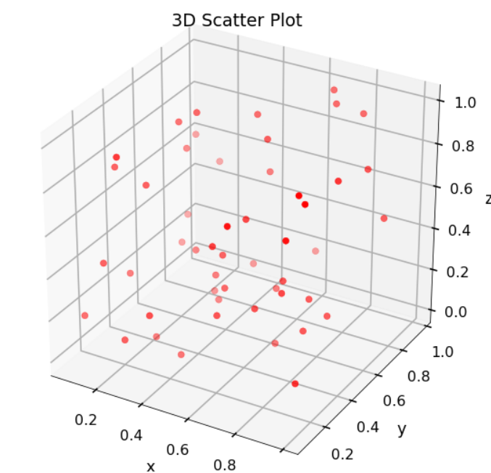

**8.Find wheter the column is present in the dataframe or not**

import pandas as pd

d = {'col1': [1, 2, 3, 4, 7], 'col2': [4, 5, 6, 9, 5], 'col3': [7, 8, 12, 1, 11]}

df = pd.DataFrame(d)

print("Original DataFrame")

print(df)

if 'col4' in df.columns:

  print("Col4 is present in DataFrame.")

else:

  print("Col4 is not present in DataFrame.")

if 'col1' in df.columns:

  print("Col1 is present in DataFrame.")

else:

  print("Col1 is not present in DataFrame.")

**9.Find the number of occurences of sequence 1,2 in array**

import numpy as np

np_array = np.array([[1, 2, 3], [2, 1, 2]])

print("Original Numpy array:")

print(np_array)

print("Type: ",type(np_array))

print("Sequence: 1,2",)

result = repr(np_array).count("1, 2")

print("Number of occurrences of the said sequence:",result)