1.

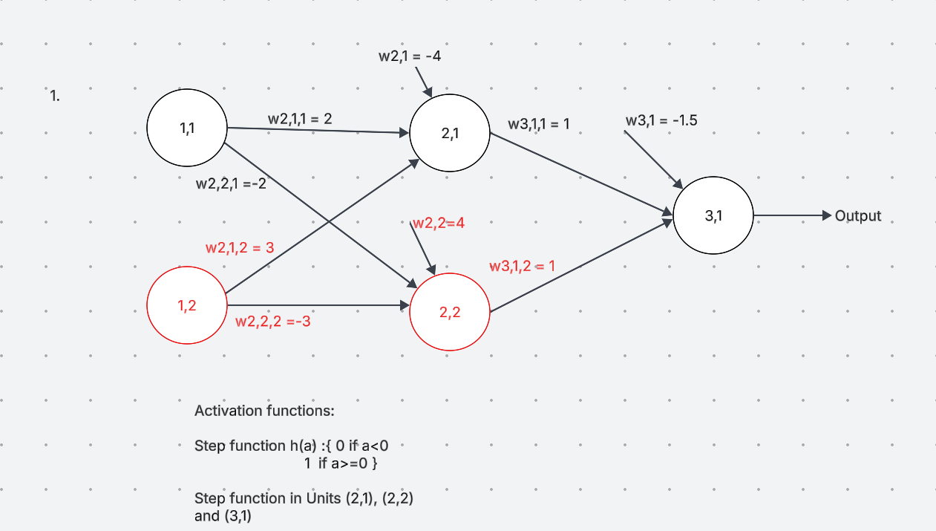

2.

U2,1 = 0.5(1) + 0.1(2) + 0.3 = 1  
U2,2 = 0.2(1) + 0.6(2) - 0.1 = 1.3  
U2,3 = 0.8(1) + 0.3(2) + 0.6 = 2  
  
Output: 1(0.1) + 1.3(0.2) + 2(0.4) + 0.2 = **1.36**