# Introduction

Analysis is to ask how something does what it does why it is as it is. A process of looking at the different part of a topic how they fit together and what action to take and which will be more reliable action. Analysis define the overall direction of the project that will taken while developing the project .

The activities involved in analysis are:

**Brain Storming** : Critical thinking what is needed and necessary in a project . For instance : classes , object ,requirements etc .

**Requirement gathering** : It is the most focused or attracted part of an analysis phase . The process involves four basic step :

* **Elicitation**: I ask question, you talk, I listen
* **Validation**: I analyze, I ask follow up question
* **Specification**: I document, I ask follow up question
* **Verification**: we all agree

**Feasibility study** : It involves some of the basic study such as :

* **Social**

Social factor mainly make an impact to our product because of the people choices ,culture ,religion and many other factors. Usually ,Social implication are seen in marketing campaign from we can gather the information about the people taste and flavor for example : Kathmandu is mostly famous for temple ,religious people could be attract .

* **Economic**

Their would not be more economic influence because the product is more to information factor than the economy. The product is mainly focused to provide information for free . Regarding to cost of developing software : - cost of operation ,cost of resources , cost of deployment .

**Cost Benefits analysis :**

**Benefits**

* Low implementation cost compare to normal individual consortium
* Easy to implement
* Mitigate the communication gap between the traveler and places
* Higher flexibility with number of alternative solution

**COSTS**

**DEVELOPMENTCOSTS**

·         **Hard ware Costs** -

* No need to purchase new hardware. The Personal hardware and existing resources in premises of the users will be used.

·         **Software costs -**

* Free & open source software will be used .

**Initial implementation Costs**

* No initial installation cost. (Free hosting).
* **Political**

Their would be problem on launching a product as an government product due to the political instability a part from that no problem launching as an private product .

* **Legal**

There may be some of legal implication such as restriction of features , some information to publicize which would make impact on our product (i.e lack of information). But mostly we are concerned about the legal and illegal activities.

* **Environmental**

Their wouldn't be any environmental disadvantage of the software .

* **Technical**

Technology has been more advance in 21st century . we will ablel to develop a quality software in a reliable cost . Our time will be saved as well .

I chose object oriented methodology as a development purpose of the software . It provides some of the advantages such as :

* Re-usability of analysis, objects, design and programming
* Improved communication among users, analysts, designers and programmers
* Increased consistency among the models developed
* Easy to understand
* More flexible and easier to make update in response to changing user requirements
* Systems can be developed more rapidly.
* Systems can often be developed at a lower cost.

In analysis we should be able to elaborate what our program is about to do and why rather than how. Analysis states what we need and what is the real scenario. It is about '"what '' and "why". We need to perform analysis because of the following reason :

* Identify man ideas or part of the task
* Describe main ideas on details
* Evaluation of the solution what is good and reliable to
* In order to understand the system , what we are going develop why the system is in that way ..

Tasks which is performed through the analysis process :

* Requirement engineering process: It is defined in a section three of a document which consist of two part functional and non functional requirement . Some of description is described in above topic requirements gathering.
* Use case: It is defined in a section 2 which states the behavior of a system and the user involved in system .
* Architecture: It is defined in section 5 of a document . It consists of two major tasks such as initial class diagram and system architecture.
* Prioritization: It is defined in section 4 . It consist of prioritization techniques such as MoSCoW prioritizing .
* Conclusion: it is defined in section 6

. which show overall summary of an documentation.

## Use Case :

The use case is one of the methodologies for system analysis to clarify , identify the system requirements . It is an behavioral model which show the function of an actor performs .A use case is a set of interaction between the system and the actors which will probably show the behavior of an actor .

Some of the characteristics are :

* Organizes a functional requirements
* Traces the path from trigger events to goals
* Models the system and actor interaction
* Describes the flow of events

It can be used in several stages of developing software such as gathering functional requirements ,testing software , and validating design .

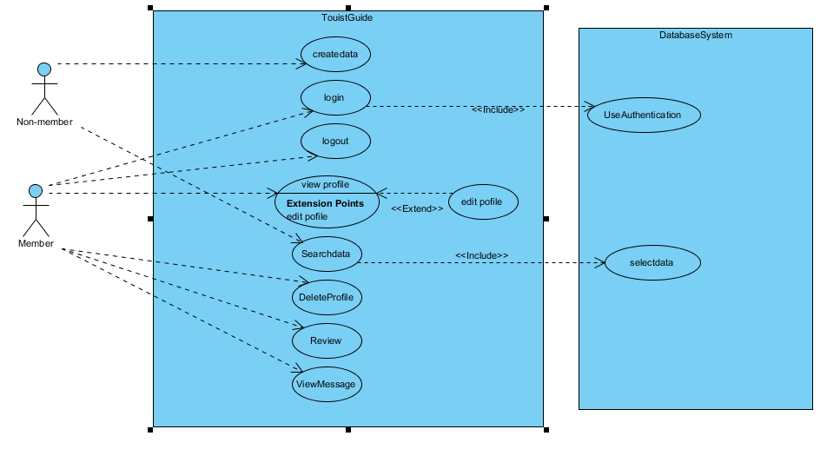

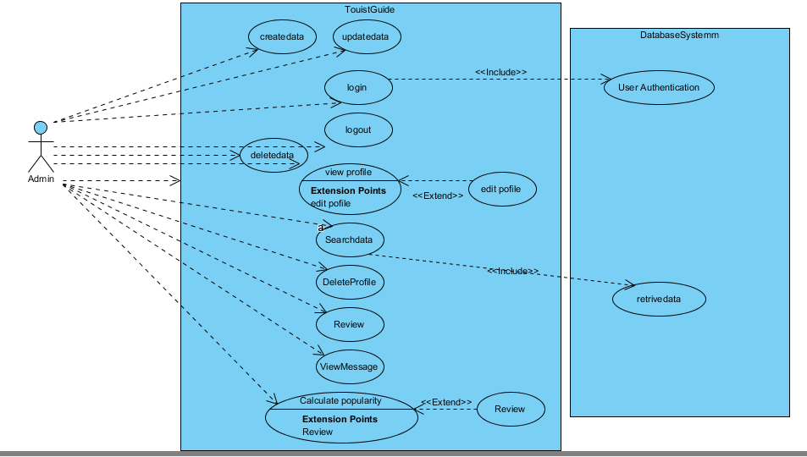

## Requirements Gathering

Functional Requirements :

Functional requirements define the functional activity of system or one of its subsystem . Any requirements which specifies the what system should do .

A fucional requirement will defines a specific behavior of a system when certain condition will be met . For example : send email when new user is register "Open a new account ".

|  |  |  |  |
| --- | --- | --- | --- |
| **ID** | **Title** | **Description** | **Rational** |
| R1 | User Sign up | A new user should be able to register through the web portal . The user must provide username ,password email and location | To acquire user credentials for login credentials . |
| R2 | User authentication | A user should be able to login with his or her existing email and password . Appropriate message shoud be provide to user whether credentials is valid or not | Validation of users whether s/he is valid user or not  To maintain user security and privacy |
| R3 | Review | A user should be able to give a feedback either rate the places or comment or both | To acquire user feedback inorder to calculate the popularity of places |
| R4 | Search data | A user should be able to search data they desire to | To provide easy and fast access of data |
| R5 | Send message | A user should be able t send message .Their should provide email , name and message | To acquire user response towards our site |
| R6 | Create Tourism information | Admin should be able to upload the created information regarding to the places. The information should be authentic | To deliver required information for users |
| R7 | Update Tourism information | Admin should be able to update data in order to maintain data integrity | To maintain data confidentiality |
| R8 | Update profile | User should be able to update profile | To recreate user profile |
| R9 | View Message | Admin should be able to view message sent by users | To analyze the user response and impact of the site |
| R10 | Delete | User should be able to delete their profile and admin should be able to delete the unauthentic data | Accountability and non repudiation |

**Non functional requirements** :

In any information system , non functional requirement will as wel play the vital role to determine the success of that particular information system .The non-functional requirement will provide environment and atmosphere to achieve the functional requirement successfully . We have identified several non-functional requirements , which is essential to our information system .

* **User Friendliness**

User friendliness is most important part of our system because the system is generally focus on public either could be technical person or non-technical person . So , it is most essential to be maximum user friendly(easy to use) .Our goal is to provide comfortable and flexible system .

* **Secure**

Security is an one of the major concern about every information system . Without the proper implementations of security ,we will be unable to provide the information system product to the users . We are planning to develop user logins , user authentication and system logbooks and many other features to make our system more secure and maintain our privacy .

* **Accuracy**

The information system should be very rigorous because we have to build a trust relationship between the user and our system . For example : if we provide false information about the places , cost of living then the traveler may get into some trouble like lack of money , lack of information about the place .Therefore , we are expecting to provide accurate system at the end of project .

* **Reliability**

Most crucial matter of a system is reliability .The system should able to evolve its reliability along with the mature system by providing rigorous solution and details which enhances the user satisfaction .

* **Availability**

The should be easily and freely accessible at any moment to all the users .

## Prioritization

MoSoW prioritization is a technique for helping to understand the priorities . The letters stand for

* **Must have**
* **Should have**
* **Could have**
* **Wont have the time**

In a project where time is fixed , understanding the relative importance of thing is vital to making progress and tracking the deadlines .

The reasons we use MoSCoW prioritization is for problem characterizing with simply saying that the requirements are of low , medium and high importance .The priorities will be specific if we use MoSoW prioritization .

|  |  |  |  |
| --- | --- | --- | --- |
| Must Have | Should Have | Could Have | Won't have |
| User Sign up | Send message | Bar chart |  |
| User authentication | Delete tourism data | Map navigation |  |
| Create tourism data | Delete profile |  |  |
| Update tourism data | Search tourism data |  |  |
| Update profile | View message |  |  |
|  | Report |  |  |
|  |  |  |  |

## Architecture

The art or practice of designing or building . We can describe an archecture as a type of model which shows off why the system is being build what system going to do and how it is going to do it .

The purpose of architecture is to :

* Clarify the system
* Overview of system how the system's going to work

### System Architecture

System architecture is a generic adhere to handle the objects called "systems" in a way which supports the structural properties of those objects . It describes three aspects :

* Why ? = sense
* What ? = function
* How ?= composition

I chose MVC architecture to handle my project as a model, view and controller which will segregate the business logic and the client logic part . There is more of loose coupling rather than tight coupling which make the system more reusable and maintainable , testable .

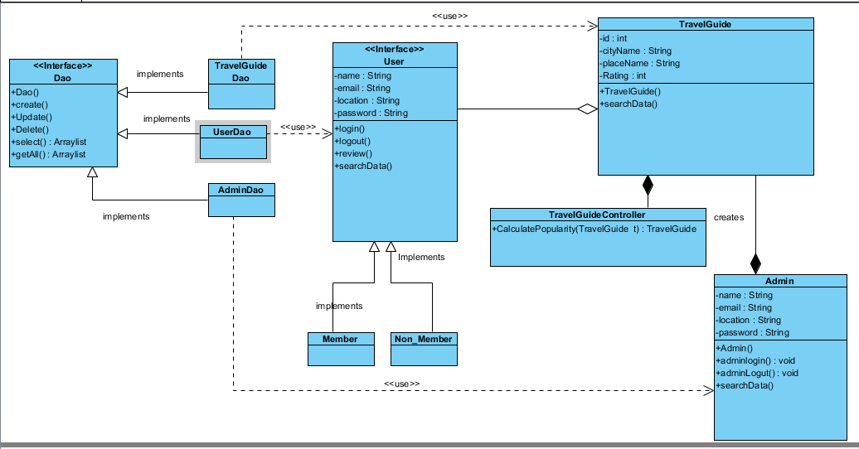

### Initial class Diagram

Class diagram is a static diagram . it represents the static view of the sytem . It is not only just for describing or visualizing or documenting the different state of the system but also to construct the executable code for the system .Class diagram shows the collection of classes , interfaces assocation and constraint .It is also known as well structural diagram

The purpose of class diagram :

* Analysis and design of static vie of the system
* Elaborate responsibilities of system
* Reverse and forward engineering

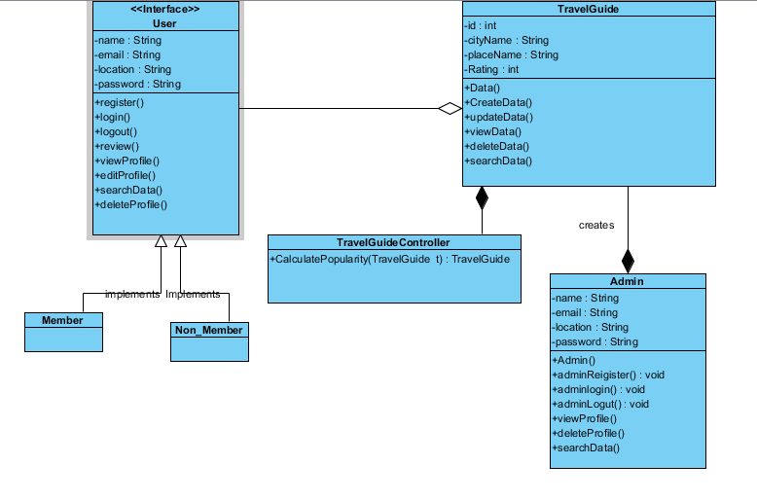

# Conclusion

As per the proposal is presented with the requirements of the project .In analysis is done in more technical way through segregation of the analysis in varies part . As a need of the project the analysis is provided in the above section .