Project Proposal on

<Tourist Guide>

<Anan Karki>

<00164083>

Computing Project

Level 5 Diploma in Computing

Softwarica College of IT & E-Commerce

Kathmandu, Nepal

<2017 July 14th >

Table of Contents

Abstract 3

Chapter 1 3

1 Introduction : 3

1.1 Problem Identification : 3

Chapter 2 4

2 Scope 4

1.2 Aims 4

2.2 Objectives 5

1.3 Development methods 5

Chapter 3 6

2 Project plan 6

3.1 Work Breakdown Structure (WBS) and Time Estimate 6

3.2 Milestones 7

3.3 Schedule 7

Chapter 4 10

4 Risk Management 10

Chapter 5 11

5 Configuration Management 11

Chapter 6 12

6 Conclusion 12

Bibliography 13

# Chapter 1

# 1 Introduction :

The project tourist guide will provides the various information about the place a person desire to such as living expenses , transportation cost , location etc. The software will help people who are wanting to visit but have no idea , by providing some of the information about places they are desiring to it can be about culture and market . The software is basically focuses to the country Nepal which have been being one of the best market of tourism and priority for the foreigners to visit ,it can be use by domestic tourist there is no constraint . The software also allows users to share their knowledges about the places which have to be a rigid such as about history , culture , tradition and so others . The project is being developed for the development and growth of a tourism industry in our country facing the major crisis such as lack of transportation ,health care , food etc.

The proposed software is an web based application which required an internet access. Users have to sign up in order to user of the application .Login is for authentication purpose which provide certain level of security and maintain confidentiality .

## Problem Identification :

* Lack of advertisement of places
* Lack of communication
* Unable to evaluate the benefits of tourism
* Less priorities sector

The application will help in minimizing the lack of advertisement and communication gap acting as an mediator between the places and the visitor. Will help to evaluate the benefits and importance of tourism through analyzing the number of users using application some of the tools can be use such as statistical analysis and others .

Monetary Cost

* Start up fees
* License
* Data Storage
* Server
* Internet
* Materials

Non Monetary Cost

* Time Factor
* Customer satisfaction
* Reputation
* Communication Factor

# Chapter 2

# 2 Scope

**Main Features of the application :**

* User will be allowed to create their profile and login to the application
* User will be allowed to view the contents and information they want to
* User will be allowed to share knowledge relating to culture , tradition and places
* Users will be allowed to provide their opinion and feedback.

Php (object oriented language) programming language will be used to develop the application .Some of the tools will be used for analyzing such as Data Flow Diagram , Rich picture and use cases etc and for designing such as UML diagram (class diagram ,Activity diagram , Sequential diagram ).

Some of the task will be performed in technical perspective such as :

* Brainstorming
* Problem statement
* Requirements gathering
* Problem solving
* Critical thinking

The tools which will be used to develop the application :

* MySql for database purpose
* Apache server
* Php platform
* Laravel framework
* Html/css (Front end )
* Notepad

## Aims

Some of the goals or aims of an application :

- Eradicate the communication gap between visitor and place

- Publicize the natural beauty ,biodiversity and places .

## 2.2 Objectives

Some of the technical objectives:

* Built an international relationship
* Customer satisfaction
* Increase in revenue
* Make an diverse society

Some of the personnel objectives:

* Gain experience
* Learn the development methodology and different programming language
* Understand the working environment
* Time management

Some of the academic objectives are:

* To be competence and skilled
* Understanding different method and approaches

## Development methods

There are many development methodology such as :

* Agile Methodology
* Spiral Methodology
* Waterfall Model

I chose the waterfall model to develop my overall project which is a type of hard approach. It has an Standard to be followed while applying the approach . It provides some of features such as :

* Structural process
* Every process should be done through step by step procedure which make less chance of mistake
* Has it own standard
* Rigid Control
* Graphically representation of overall project For example DFD Data Flow Diagram

As Object Oriented method is an type of the waterfall model the development process will be done through the object oriented methodologies because the approaches is suitable for every medium to large scale project . It views models as an set of interacting objects . Provides some of the advantages such as :

* Reusability of analysis ,design , objects and programming
* System can be developed more rapidly
* Improved the consistency among the models developed
* Easy to understand
* Improved communication users and project development team

The development of the application is as well in object oriented programming language . Some of tools will used in development methods are :

- Data Flow diagram

- Use case diagram

- UML Diagram

- ER diagram

- Normalisation

Some of design pattern will be used are :

* MVC pattern (Model View and Controller) and Observer Pattern

# Chapter 3

# Project plan

The project is done through the tools such as

- Work BreakDown Structure

- Project scheduling with the help of Ghant Chart (Through Project Libre)

- Milestones tracking

## 3.1 Work Breakdown Structure (WBS) and Time Estimate

The purpose of WBS is : (https://www.projectsmart.co.uk/, 2017)

- To show which work elements have been assigned to organizational units.

- To ensure that all work within a project is identified and defined within a common framework.

- To show the organizational structure of a program.

- All of the other alternatives apply

|  |  |  |
| --- | --- | --- |
| WBS | Task Name | Days |
| 0 | Tourist Guide | 86 |
| 1 | Project Management | 10 |
| 1.1 | Scoping | 5 |
| 1.2 | Planning | 5 |
| 2 | Analysis | 18 |
| 2.1 | Brain Storming | 2 |
| 2.2 | Requirements gathering | 4 |
| 2.3 | Feasibility study | 4 |
| 2.4 | Use cases | 4 |
| 2.5 | Architecture | 4 |
| 3 | Design | 22 |
| 3.1 | Structural | 6 |
| 3.2 | Behavioural | 6 |
| 3.3. | Sequential | 6 |
| 4 | Coding | 24 |
| 5 | Testing | 22 |
| 5.1 | Unit testing | 11 |
| 5.2 | Integration testing | 11 |
| 6 | Reporting | 10 |
| 6.1 | User manual | 3 |
| 6.2 | Final report | 3 |
| 6.3 | Presentation material | 4 |

Table 1 : work BreakDown structure

## 3.2 Milestones

|  |  |
| --- | --- |
| **Milestones** | **Date** |
| Project proposal | July 14 , 2017 |
| Analysis Specification | August 1 , 2017 |
| Design specification | August 23 , 2017 |
| Coding | September 17 , 2017 |
| Testing | October 9 , 2017 |
| Final report | October 22 , 2017 |

Table 2 : Project Milestones

## 

## 3.3 Schedule

The task are divided according to the deadline of a particular task . Each of the tasks are divided into the sub tasks . The details scheduling is shown in the below Chart known as a Ghant chart .

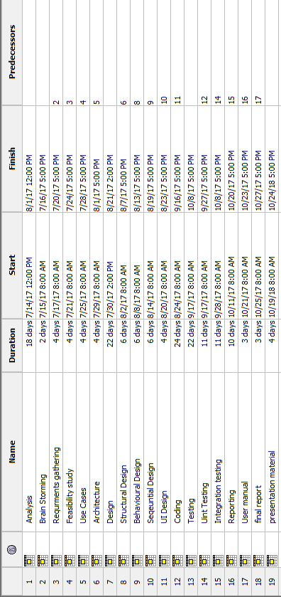

Figure 1 : Task schedule

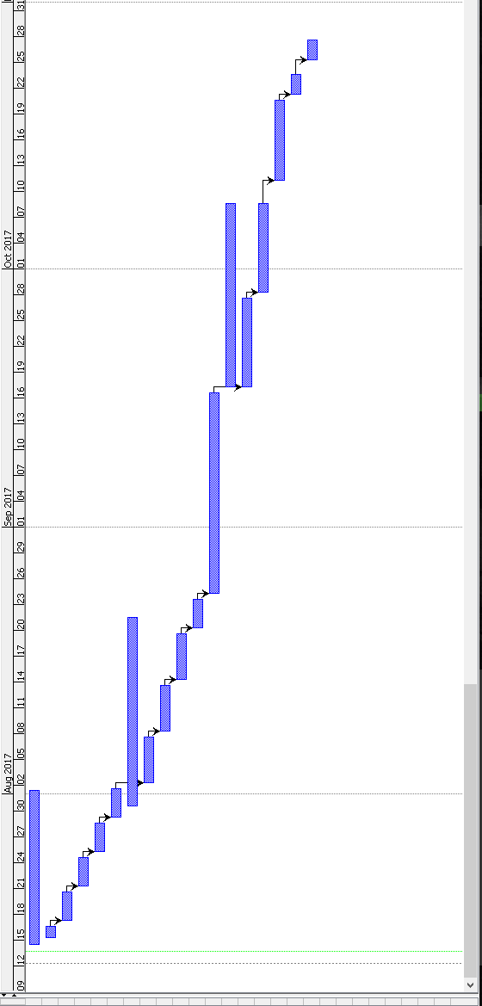

Figure 2 : Ghant Chart

# Chapter 4

# 4 Risk Management

The risk may introduce before and after application developed :

* Hard disk crashed
* Human error
* Unrealistic scheduling
* Low storage
* Server failure to response

|  |  |
| --- | --- |
| **Likelihood** | **Value** |
| Low | 1 |
| Medium | 2 |
| High | 3 |

|  |  |
| --- | --- |
| **Consequences** | **Value** |
| Very low | 1 |
| Low | 2 |
| Medium | 3 |
| High | 4 |
| Very High | 5 |

|  |  |  |  |  |
| --- | --- | --- | --- | --- |
| **Risk** | **Likelihood** | **Consequence** | **Impact** | **Action** |
| Hard disk crash | 2 | 4 | 8 | Investigate cost and prepare reliable |
| Human error | 2 | 4 | 8 | Proper and critical analysis before work |
| Low Storage | 1 | 3 | 3 | Free the space ,use of external devices |
| Server failure to response | 2 | 3 | 6 | Investigate the bias |
| Unrealistic scheduling | 2 | 3 | 6 | Critical and pragmatic thinking |

# Chapter 5

# 5 Configuration Management

The configuration management refer to governance and system engineering process that ensures the accounting of an configuration attributes and relation between them in an operation environment. (WhatIs.com, 2017)

The project is divided into different phases and allocated a different schedule with a different deadlines which will help in time management in our project .

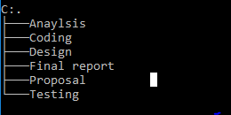

Figure 3 : Task Directories

# 

# Chapter 6

# 6 Conclusion

As per above definition about the project the user will have to create their own profile to use the application . The application will provide certain privileges such as login system, view and share the information about their culture , places and others . The project will be developed through the waterfall and object oriented methodology.

The main purpose is improve the tourism industry of our Country and built an international relation , to publicize the places , biodiversity , culture etc .

# Bibliography

https://www.projectsmart.co.uk/, 2017. *work-breakdown-structure-purpose-.* [Online]   
Available at: https://www.projectsmart.co.uk/work-breakdown-structure-purpose-process-pitfalls.php  
[Accessed 13 7 2017].

WhatIs.com, D. f., 2017. *What is Configuration Management.* [Online]   
Available at: searchitoperation.techtarget.com  
[Accessed 13 7 2017].