Datu bāzes dokumentācija
Vārds: Aanastasija
Uzvārds: Kizika
Studenta apliecības numurs: st240459
DB nosaukums: nba_db
Īss apraksts: nba_db datu bāze glabā informāciju par NBA (national basketball association) spēlētājiem, viņu balvām, treneriem, tiesnešiem, komandām, spēlēm un playoff sērijām. Tajā ietilpst 11 tabulas, kas organizētas ap personu, komandu un spēlēm. Dati strukturēti hierarchiski - no vispārīgas personas informācijas līdz specifiskām spēlētāju, treneru un tiesnešu detaļām. Sistēma uzglabā gan regulārās sezonas, gan izslēgšanas (dažu playoff sēriju) spēļu datus. Tabulas satur arī fiziskos spēlētāju, arēnu raksturlielumus un finansiālos aspektus (algas, biļešu cenas). Visas tabulas savstarpēji saistītas (18 relācijas). Ieraksti: Person - 206, Arena - 20, Team - 20, Referee - 15, Coach - 31, Player - 160, PlayerAwards - 240, Game - 190, GameReferees - 250, PlayoffSerie - 7, PlayoffSerieGame – 43.
datu bāzes shēmas diagramma (tabulas ar attiecībām):
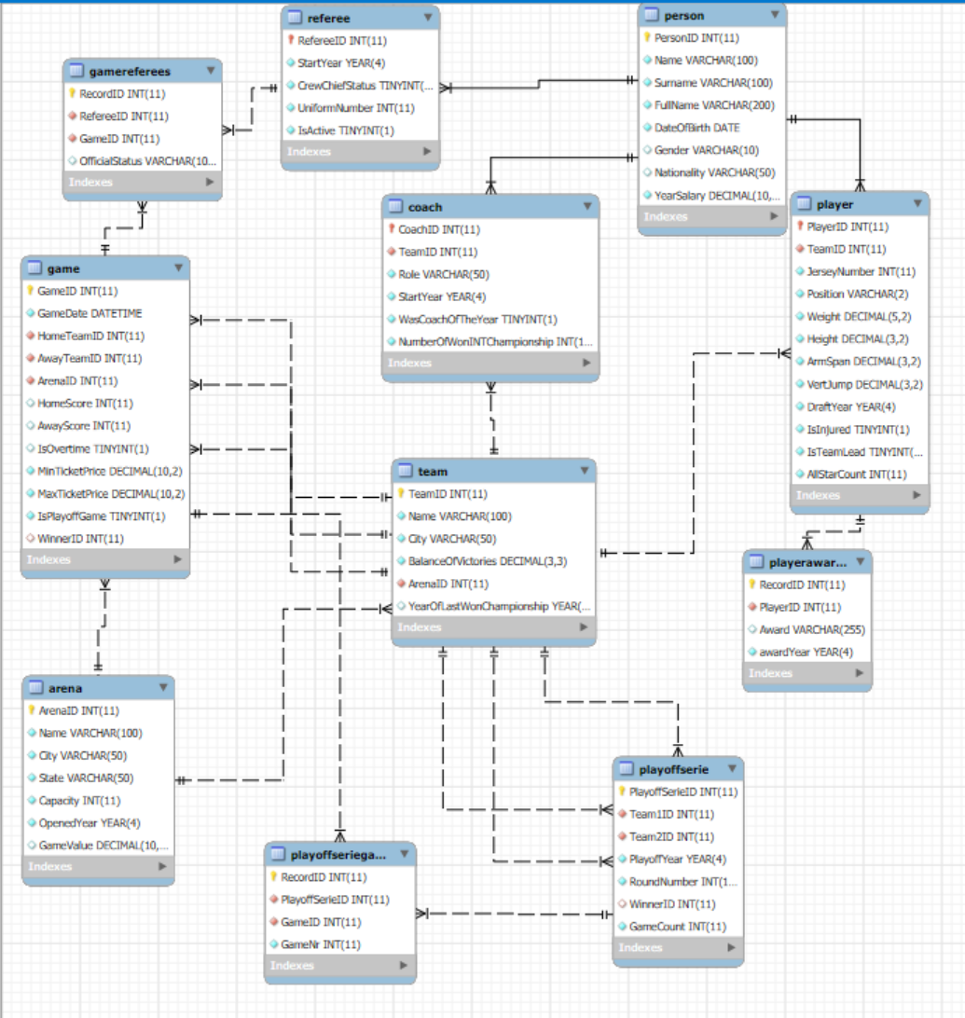

datu ER diagramma (lai viss ielīstu tabulām nav pievienoti visi atribūti):
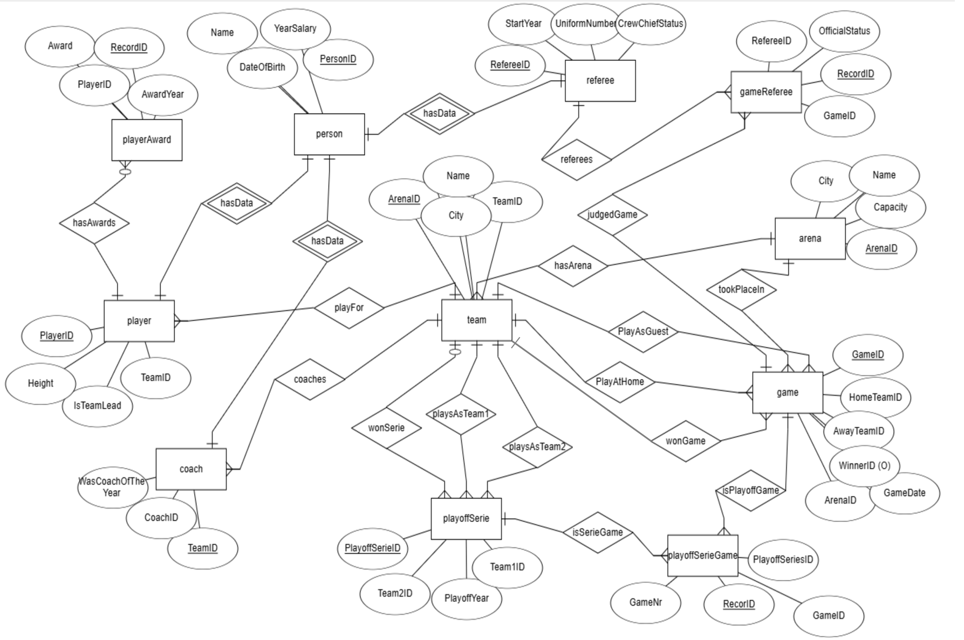

USE `nba_db`;
-- 1.
SELECT person.fullname, team.name, NumberOfWonINTChampionship as ringCount FROM coach
INNER JOIN person ON coach.CoachID = person.PersonID
INNER JOIN team ON coach.TeamID = team.TeamID
WHERE NumberOfWonINTChampionship >= 1;
-- 2.
SELECT
concat(per.FullName, " ", per.Nationality) as nameAndNation,
t.name as team, t.city, pl.jerseyNumber, pl.Position, per.yearSalary
from team as t, player as pl, person as per
WHERE pl.teamId = t.teamId
AND pl.playerID = per.PersonID
AND t.name = "Los Angeles Lakers";
-- 3.
SELECT
p.FullName,
t.Name AS TeamName,
pl.Height
FROM Player pl
JOIN Person p ON pl.PlayerID = p.PersonID
JOIN Team t ON pl.TeamID = t.TeamID
ORDER BY pl.Height DESC;
-- 4.
SELECT
g.GameID,
ht.Name AS HomeTeam,
gt.Name AS GuestTeam,
g.HomeScore,
g.AwayScore
FROM Game g
JOIN Team ht ON g.HomeTeamID = ht.TeamID
JOIN Team gt ON g.AwayTeamID = gt.TeamID
WHERE g.HomeScore - g.AwayScore > 7;
-- 5.
SELECT
p.FullName,
p.yearSalary,
COUNT(gr.GameID) AS GamesOfficiated
FROM Referee as r
JOIN Person as p ON r.RefereeID = p.PersonID
JOIN GameReferees gr ON r.RefereeID = gr.RefereeID
GROUP BY r.RefereeID
HAVING COUNT(gr.GameID) > 0;
-- 6.
SELECT DISTINCT
p.FullName,
pa.Award,
pa.AwardYear
FROM PlayerAwards pa
JOIN Person p ON pa.PlayerID = p.PersonID
WHERE pa.Award LIKE '%MVP%';
-- 7.
SELECT
ps.PlayoffYear,
ps.RoundNumber,
t1.Name AS Team1,
t2.Name AS Team2,
tw.Name AS Winner
FROM PlayoffSerie ps
JOIN Team t1 ON ps.Team1ID = t1.TeamID
JOIN Team t2 ON ps.Team2ID = t2.TeamID
LEFT JOIN Team tw ON ps.WinnerID = tw.TeamID;
-- 7.
SELECT
t.Name AS TeamName,
AVG(pl.Height) AS AvgHeight,
AVG(pl.Weight) AS AvgWeight
FROM Team t
JOIN Player pl ON t.TeamID = pl.TeamID
GROUP BY t.TeamID
ORDER BY AvgHeight DESC, AvgWeight ASC;
-- 8.
SELECT
p.FullName,
t.Name AS TeamName,
pl.Position
FROM Player pl
JOIN Person p ON pl.PlayerID = p.PersonID
JOIN Team t ON pl.TeamID = t.TeamID
WHERE pl.IsInjured = TRUE
AND pl.IsTeamLead = TRUE;
-- 9.
SELECT
a.Name AS ArenaName,
g.MaxTicketPrice
FROM Arena a
JOIN Game g ON a.ArenaID = g.ArenaID
WHERE g.MaxTicketPrice = (
SELECT MAX(g2.MaxTicketPrice)
FROM Game g2
WHERE g2.ArenaID = a.ArenaID
);
-- 10.
-- teams main coach, won championship sum, with teams average salary for coach and player
SELECT team.name AS TeamName, city,
SUM(NumberOfWonINTChampionship) as wonChamp,
CONCAT('$', fORMAT(AVG(p_player.YearSalary), 0)) AS PLayerAverageSalary,
CONCAT('$', fORMAT(p_coach.YearSalary, 0)) AS coachSalary
FROM team
INNER JOIN player ON team.TeamID = player.TeamID
LEFT JOIN person p_player ON player.PlayerID = p_player.PersonID
INNER JOIN coach ON team.teamID = coach.teamID
INNER JOIN person p_coach ON coach.coachID = p_coach.PersonID
group by team.TeamID;
-- 11.
-- Compare team success (BalanceOfVictories) with total player salary expenditure
SELECT
t.TeamID,
t.Name AS Team_Name,
t.City,
t.BalanceOfVictories AS Win_Percentage,
ROUND(t.BalanceOfVictories * 100, 1) AS Win_Percentage_Pct,
COUNT(p.PlayerID) AS Player_Count,
CONCAT('$', FORMAT(SUM(per.YearSalary), 0)) AS Total_Player_Salary,
CONCAT('$', FORMAT(AVG(per.YearSalary), 0)) AS Avg_Player_Salary,
CASE
WHEN t.BalanceOfVictories > 0.5 AND AVG(per.YearSalary) > 18000000 THEN 'High Cost, High Success'
WHEN t.BalanceOfVictories > 0.5 AND AVG(per.YearSalary) <= 18000000 THEN 'Low Cost, High Success'
WHEN t.BalanceOfVictories <= 0.5 AND AVG(per.YearSalary) > 18000000 THEN 'High Cost, Low Success'
ELSE 'Low Cost, Low Success'
END AS Efficiency_Category
FROM Team t
LEFT JOIN Player p ON t.TeamID = p.TeamID
LEFT JOIN Person per ON p.PlayerID = per.PersonID
GROUP BY t.TeamID
ORDER BY t.BalanceOfVictories DESC, Total_Player_Salary DESC;
Skripti vaicājumiem

