1.

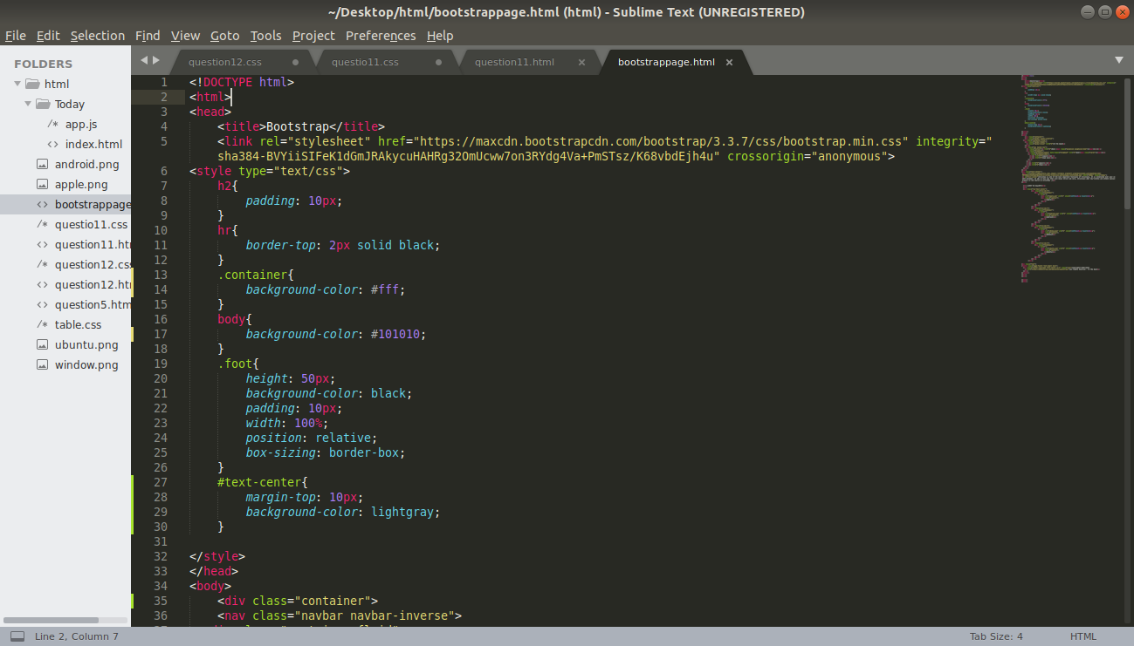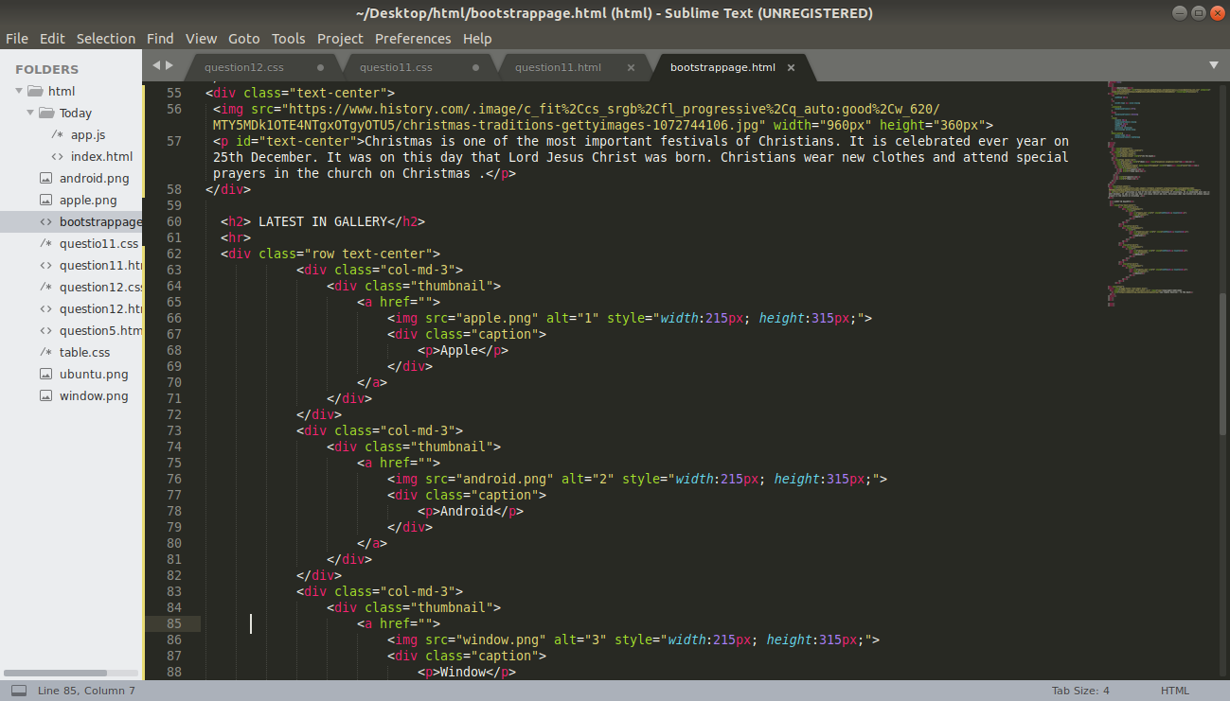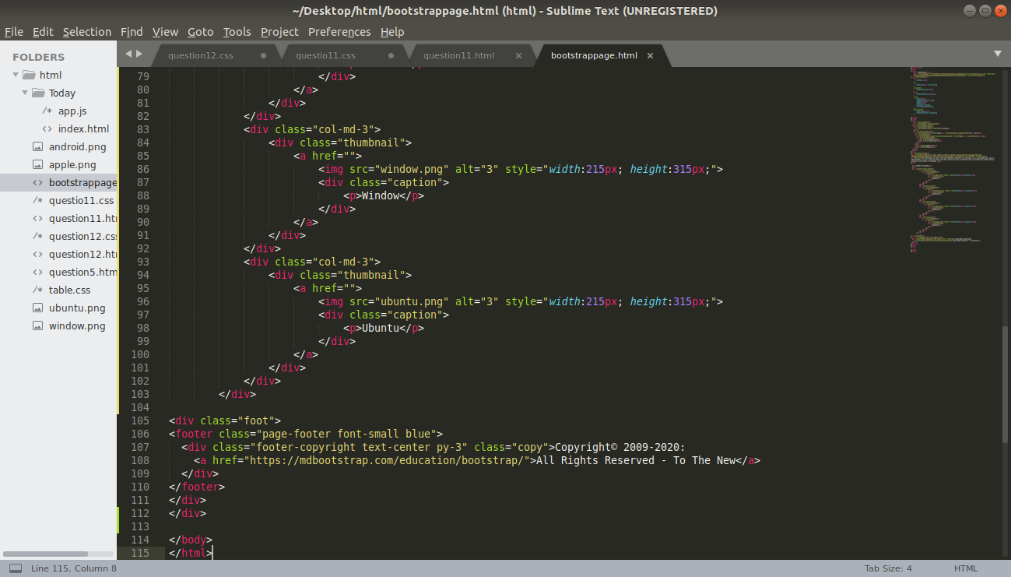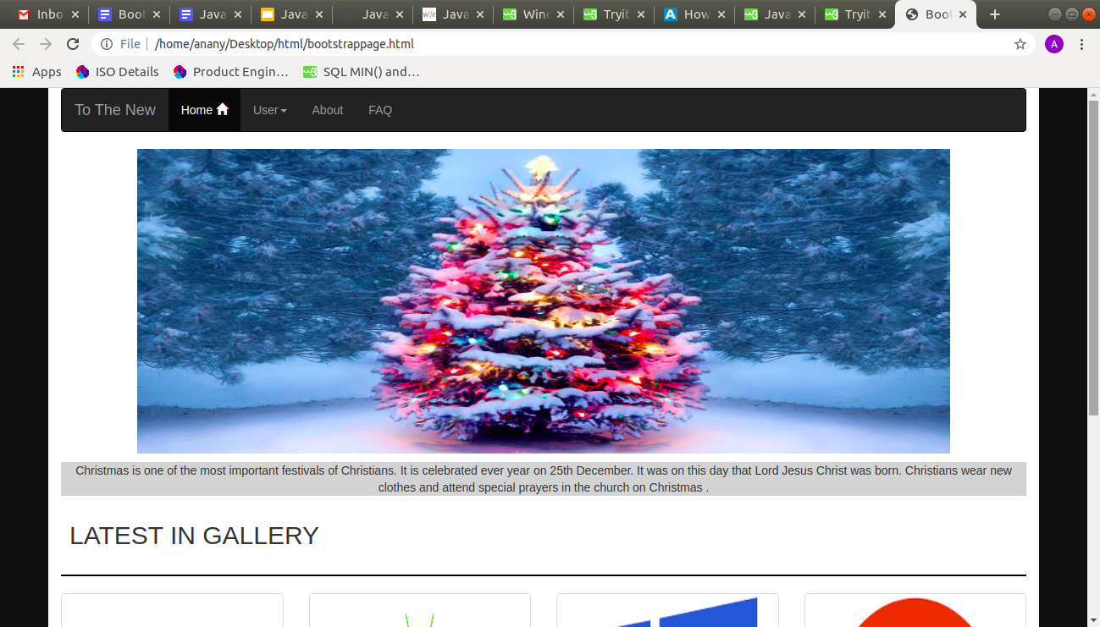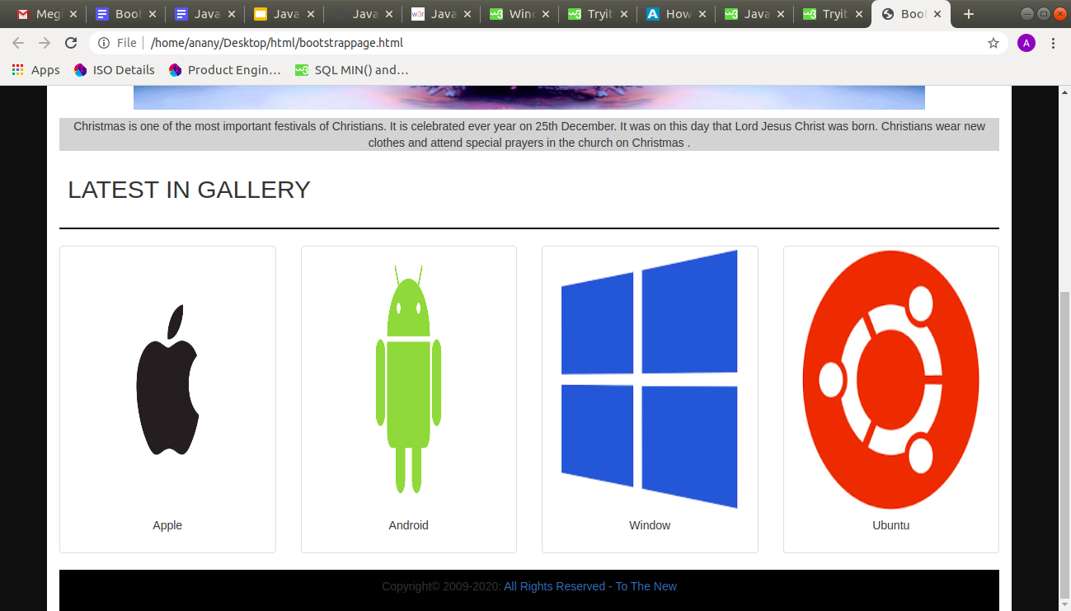

2.

<!DOCTYPE html>

<html lang="en">

<head>

<title>Bootstrap Example</title>

<meta charset="utf-8">

<meta name="viewport" content="width=device-width, initial-scale=1">

<link rel="stylesheet" href="https://maxcdn.bootstrapcdn.com/bootstrap/3.4.1/css/bootstrap.min.css">

<script src="https://ajax.googleapis.com/ajax/libs/jquery/3.4.1/jquery.min.js"></script>

<script src="https://maxcdn.bootstrapcdn.com/bootstrap/3.4.1/js/bootstrap.min.js"></script>

<style>

#os,

#product,

#severity {

background-color: #5bc0de;

border: 1px solid #46b8da;

color: #fff;

font-weight: 700;

}

.textfree {

margin-right: 200px;

}

form {

margin-left: 30%;

}

#header {

background-color: #5bc0de;

border: 1px solid #46b8da;

color: #fff;

font-weight: 700;

padding: 10px 10px;

}

#sendbutton {

background-color: #F2F2F2;

border: 1px solid #46b8da;

color: #fff;

font-weight: 700;

border-radius: 4px;

}

.titlepage{

color: #5bc0de;

}

</style>

</head>

<body>

<div class="container">

<span class="titlepage">

<h2>To The New</h2>

</span>

<form action="/action_page.php">

<div class="form-group row">

<div class="col-xs-6">

<h3 id="header">Bug Report</h3>

<label for="Title">Title:</label>

<input type="text" class="form-control" id="title" placeholder="Enter title" name="title">

</div>

</div>

<div class="form-group row">

<div class="col-xs-6">

<label for="desc">Description:</label>

<input type="text" class="form-control" id="desc" placeholder="Enter Description" name="desc">

</div>

</div>

<div class="form-group row">

<div class="col-xs-6">

<label for="os">Operating System:</label>

<select class="form-control" id="os" name="os">

<option>Windows XP</option>

<option>Windows 7</option>

<option>Windows 10</option>

</select>

</div>

</div>

<div class="form-group row">

<div class="col-xs-6">

<label for="product">Product:</label>

<select class="form-control" id="product" name="product">

<option>Formoid</option>

<option>ABC</option>

<option>DEF</option>

</select>

</div>

</div>

<div class="form-group row">

<div class="col-xs-6">

<label for="Version">Version:</label>

<input type="text" class="form-control" id="Version" placeholder="Enter Version" name="Version">

</div>

</div>

<div class="form-group row">

<div class="col-xs-6">

<label for="License">License:</label><br>

<input type="radio" name="remember" checked><span class="textfree"> Free</span>

<input type="radio" name="remember"> Premium

</div>

</div>

<div class="form-group row">

<div class="col-xs-6">

<label for="severity">Severity:</label>

<select class="form-control" id="severity" name="severity">

<option>Critical</option>

<option>Non Cricitcal</option>

<option>Other</option>

</select>

</div>

</div>

<div class="form-group row">

<div class="col-xs-6">

<div class="input-group input-file" name="fileupload">

<span class="input-group-btn">

<button class="btn btn-default btn-choose" type="button">Choose</button>

</span>

<input type="text" class="form-control" placeholder='No files selected...' />

<span class="input-group-btn">

<button class="btn btn-info btn-upload" type="button">Upload</button>

</span>

</div>

</div>

</div>

<div class="row">

<div class="col-xs-6">

<div class="form-group text-right" id="sendbutton">

<button class="btn btn-info btn-lg" type="submit">Send</button>

</div>

</div>

</div>

</form>

</div>

</body>

</html>

